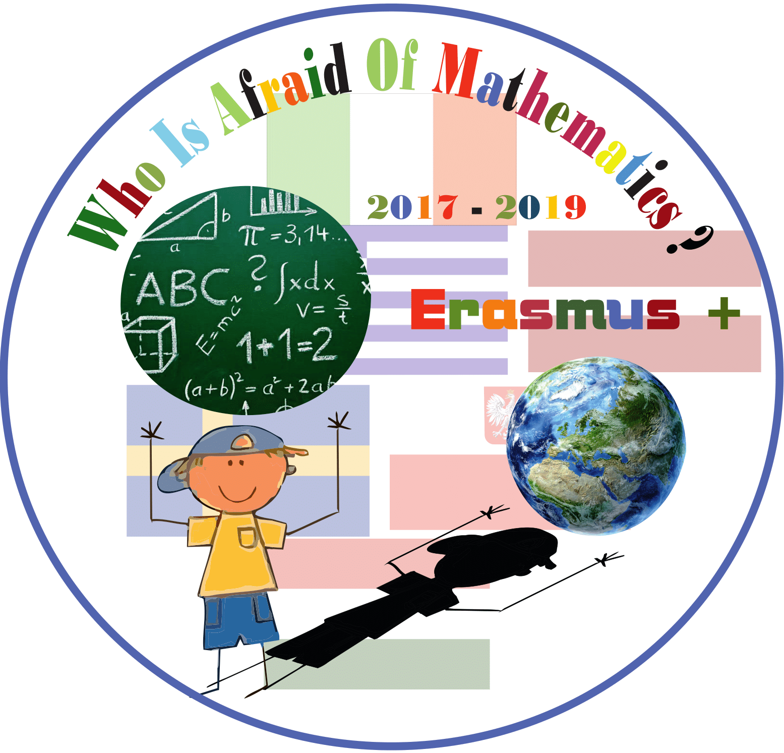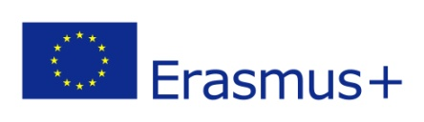

**Category : MATHS IN HISTORY**

**Title of the activity: Ancient mass and length measures in Latvia**

**Year Group: Grade 5 (10-11 years old)**

**Learning Objectives:**

**-To acquire ancient measures in Latvia;**

**-To increase students interest about mathematics;**

**-To review the rules for rounding off numbers;**

**- To get new knowledge through practical work.**

**Resources:**

**Student’s presentations- Ancient measures in Latvia- A poster or PowerPoint;**

**Tape measure;**

**Scales;**

**Worksheet-** **Convert measurements!**

**A3 paper for Footprint;**

**Pen, pencil, marker.**

**Success Criteria:**

At the end of activity students are more familiar with ancient mass and length measures used in Latvia until 1924.

Students are ready to collaborate and practically use ancient measures practically as well as modern ones.

**Lesson Description (including context) : Lesson helps to understand the historical value of ancient mass and length measures in Latvia. Students learn through practical work and cooperate for getting better results.**

**Introduction:**

**Before the main lesson, students prepare a presentation about ancient mass and length measures in Latvia.**

**Teacher asks students to express their ideas why it is important to know old measures in nowadays. In case students don’t mention it, teacher points out that it is our historical and cultural value and still there are some regions (usually countryside) where these terms are used not only by old people.**

**Differentiation:**

Students are encouraged to help each other during the group work.

Teacher’s assistance is needed during the individual work to ensure that everyone is involved.

Students make their presentations according their abilities to use modern technologies for finding information and using PowerPoint.

**Main Lesson:**

1 Students present their PowerPoint presentations and posters to their classmates.

2 During student’s presentations, teacher writes down on the board the most common used measures, those which students will need for converting at the later stage of the lesson. For mass: kilogram-pods (pfund)-mārciņa (libra) and 3 for length: centimetres- colla(inch)-pēda (foot)-olekts (ell).

3 Teacher gives a table with kilograms and centimetres converted to these units of measure (example

pfund was equal to 0.419 kg 1 elle = 0.537 m ). Together review the rules for rounding off numbers and invite some students to write the results on the board.

Teacher gives handouts with kilograms and centimetres converted to these units of measure. Students stick them in Notebooks for further use.

Highlighting the importance of these measures in history teacher asks to name objects which would be suitable to measure with these units in nowadays.

3 Pupils in groups measure each other length and weight and records the results of measurements in the worksheets in centimeters and kilograms at first.

4Students work in pairs or small groups of 3 to collaborate on converting measurements into the old ones.

Teacher monitors students while they are working, and assist students who need extra support.

Students write down the results of their calculation in the worksheets.

5 At the final part of the lesson teacher asks students to draw and cut out 1 foot (about 31 centimetre) and check their calculations. Children measure each other using the paper footprints.

**Plenary : At the end of the lesson teacher encourage students to share what they learned in the lesson.**

**Homework for revision of new knowledge- ask students at home to write down measurement results in ancient measures at least for 5 everyday objects.**

