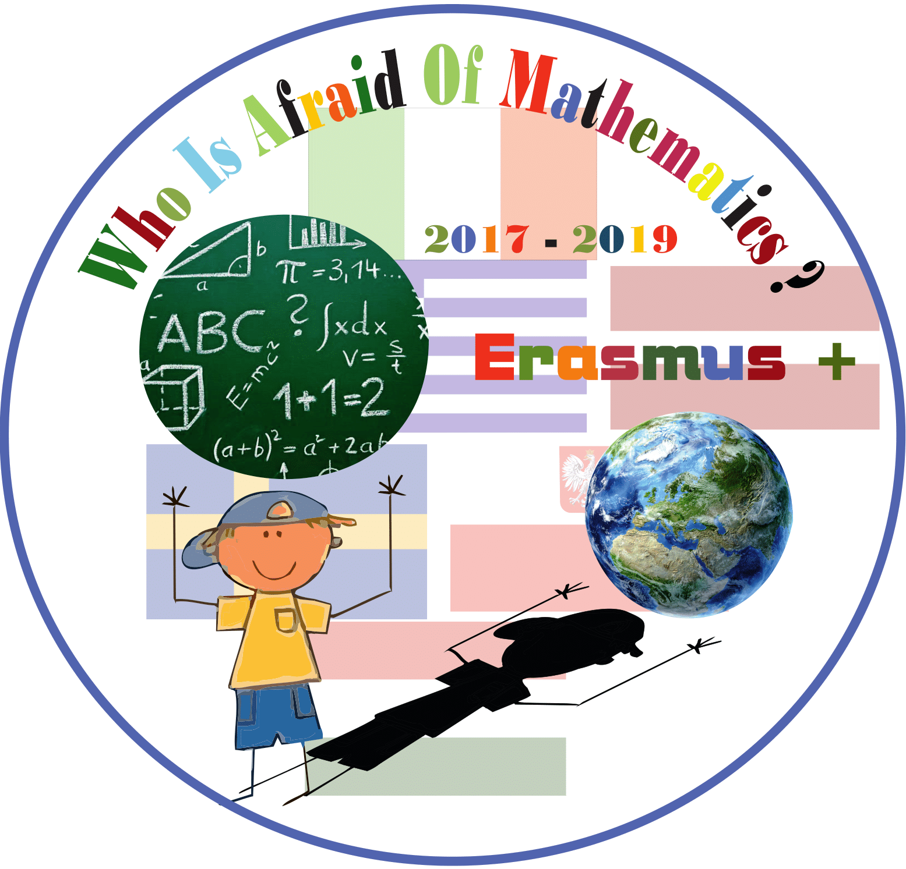

**Category : MATHS IN HISTORY**

**Title of the activity: ROMAN NUMBERS**

**Year Group: Grade 5 (10 years old) – N.Costa Primary School**

**Teacher:** **Lucia Guino**

**Learning Objectives:**

* to familiarise with a different code number
* to compare ancient Roman numbers System with Decimal System
* to investigate about nowadays use of Roman Numbers

**Success Criteria:**

* to learn using concrete resources from familiar context, as the town where pupils live and their homes
* to learn mathematical contents using a foreign language (English)
* to learn using creativity and TPR (Total Physical Response) activities
* to integrate IWB (Interactive White Board) in the teaching practice

**Resources:**

* Pictures, taken from local area, showing Roman Numbers
* Google Slides
* IWB
* Worksheets
* School textbook
* Paper
* Crayons and pencils

**Differentiation:**

* CLIL (Content Language Integrated Learning) approach in the topic development
* Integration of ICT in the main lesson

**Introduction:**

Activate pupils’ pre-knowledge:

1. “Listen and write” activity in English: children choose five different pencil-crayons and write the following letters scattered on a sheet of paper: I - V - X - L - C – D – M
2. Children are informed that each letter has a value and correspond to the figures in a Number System belonging to the Ancient Roman Civilization.
3. Match letters with numbers written in English

**Lesson Description (including context):**

The activities take place in the classroom but with different organization of work: plenary activity, individual activity, pair/group activity.

Children will learn how the Roman Numbers System works, in which context it is still used and that is part of a historical process that has brought to the use of Decimal System in maths.

**Main Lesson:**

- After the Tune-In activities to activate pupils’ pre-knowledge, children have a plenary conversation to share their experience about Roman Numbers: where they have already seen them, in what context and situations.

- Quiz on Google Slides Presentation: pupils look at the pictures and choose A-B-C-D answer

<https://docs.google.com/presentation/d/1N6LughY5_kdDohcG2j1DKDCmR9T0Qvf9gMUIggBqgqE/edit#slide=id.g30dc45b1a9_0_46>

- Children

discuss about the solutions and discover the nowadays contexts where Roman Numbers are used;

compare the roman numbers system with the decimal system;

collect more information about the ancient Romans way to write big numbers by visiting a website;

reflect about the importance of “Zero” figure;

practice the value of Roman Numbers figures by doing exercises to convert numbers from a system to

another

collaborate to create Roman Number Figures with their bodies

design a presentation sheet with the integration of the Roman numbers figures

**Plenary :**

1. Pupils collaborate in performing Roman number Figures using their bodies.
2. Pupils create their own personal presentation card using mathematical datas linked to their body and familiar contest.

