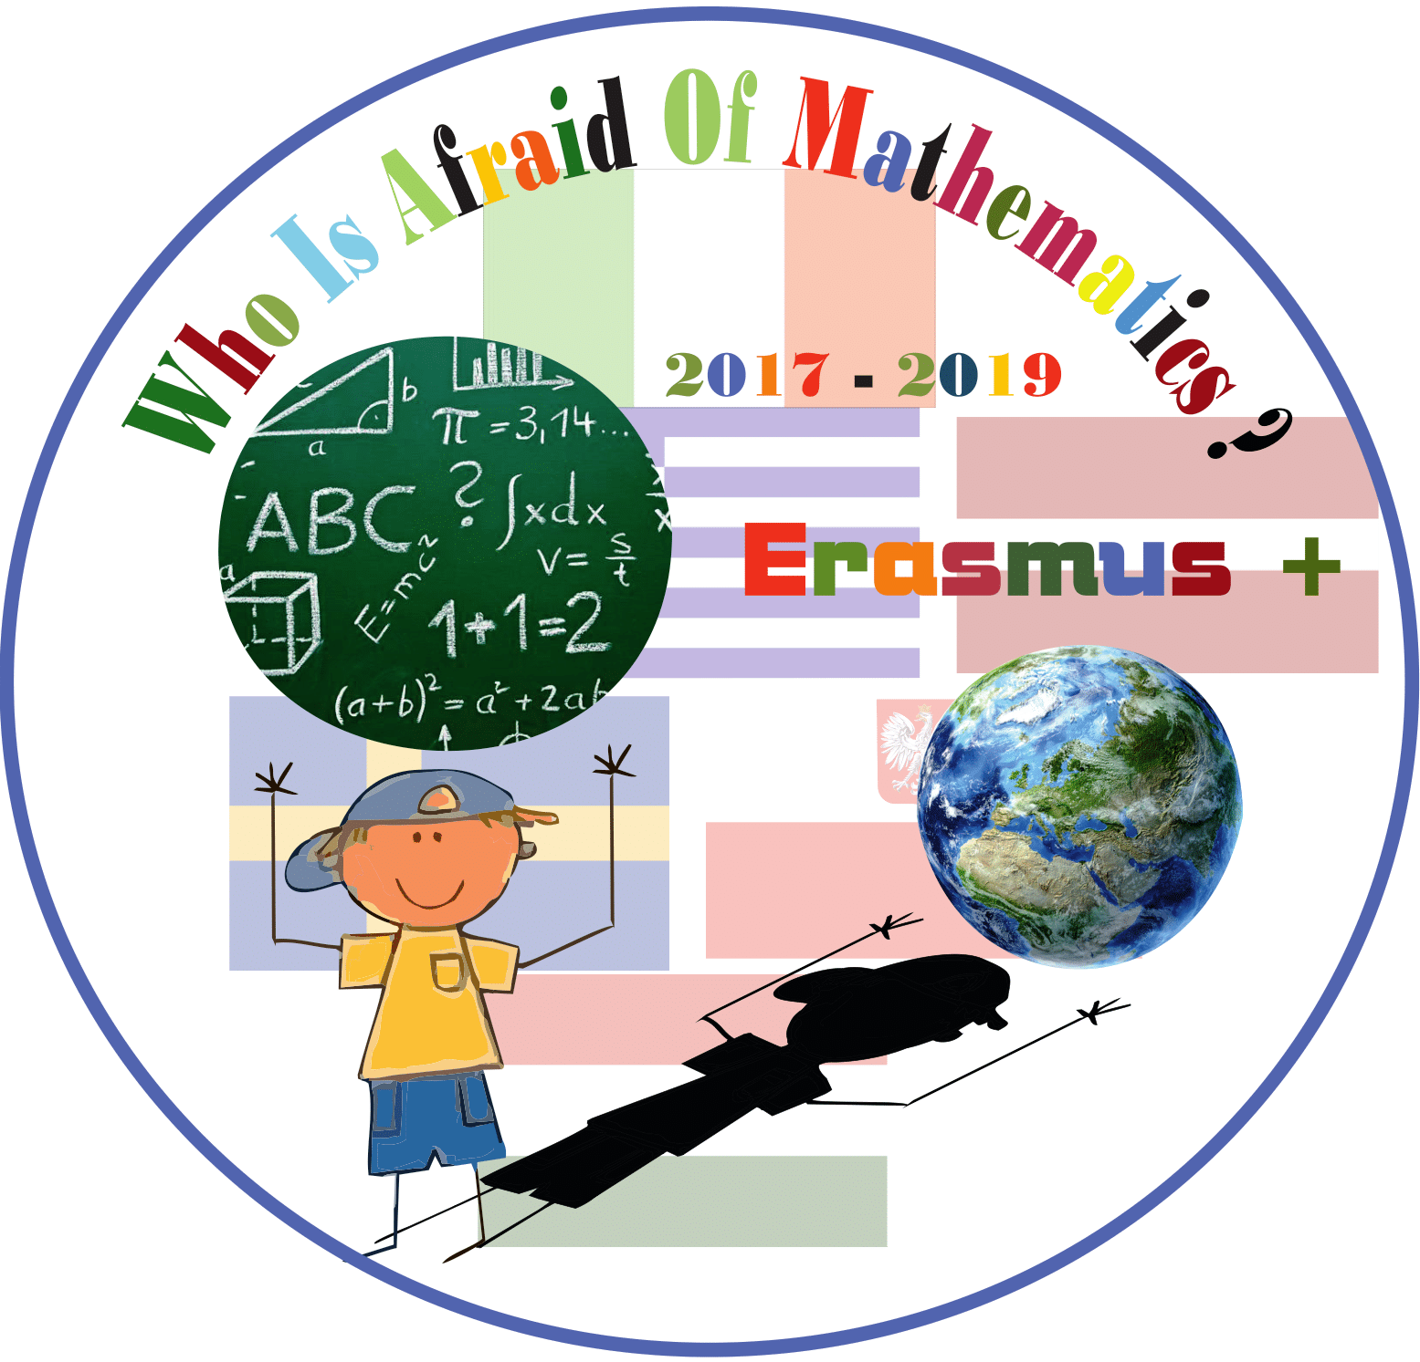

Category: MATHS IN HISTORY

Title of the activity: Playing with Archimede

Year Group: Grade 5 (10-11 years old)

Teacher: Lucia Guino

Learning Objectives:

- to get more familiar to the importance of Archimedes in the history of Maths
- to get knowledge of most relevant Archimedes’ facts and their importance starting from his
historical period till nowadays
- to discover properties of regular polygons
- to develop the concept of same area in different shapes
- to compare areas and perimeters of polygons

Success Criteria:

- Children can afford problem solving using their creativity skill
- Children share their ways and strategies to sort out the different tasks in their groups (groups of 4).

Resources:

- Sheets of paper
- Pencils
- Crayons
- Scissors
- Worksheets
- IWB
- History Book

Lesson Description (including context):

This group of activities takes place in the classroom.
After the introduction to the figure of Archimedes, children will do two creative activities related to two different concepts in geometry:
- “regularity” in polygons: drawing several polygons in one circle
- “area”: Stomachion game
The activities are organized mainly in groups, with the teacher’s monitoring and support.

Differentiation:

Children work individually, in mixed ability groups and altogether to discuss and compare the observations and reflections done in groups.

Introduction:
- In a plenary discussion in class, children share what they already know about Archimede, according to the historical knowledge they have.
- Using websites suggested by the teacher, children get more information about this historical mathematician.
http://ilpiccolofriedrich.blogspot.it/2014/03/archimede-e-il-gioco-del-mal-di-stomaco.html

http://progettomatematica.dm.unibo.it/ARCHIMEDE/invenzioni.htm

Main Lesson

How to draw polygons in a circle by folding it:
Children follow the teacher’s instructions to draw four regular polygons (a dodecagon, a hexagon, a square and an equilateral triangle, in a circle. First they have to draw the circle on a white sheet of paper using a compass and then they have cut it out. Next they have to fold it in a sequence of 4 steps, draw small dots on the circumference in correspondence of the folds.
With different crayons children will draw the polygons by connecting all the dots, or connect them skipping some dots.
Afterwards, in groups, children discover names and properties of these flat figures and collect them in a chart.
In a plenary section, work groups’ results will be compare and conclusions are written in a final report.

Stomachion Game: in groups children have to build as many polygons as possible using the picture of a square made of a set of 14 flat figures. This picture is called Stomachion, it is very similar to Tangram but with more pieces. At the beginning children cut the basic figures and then in groups they create other polygons. Afterwards they investigate about the possible similarities and differentiations between the area and the perimeter of the polygons created in groups.

Plenary
At the end of each activity, children discuss together how and what they have learnt in their groups. All the reflections are reported on their copybooks and pictures are collected on a poster displayed in classroom.

