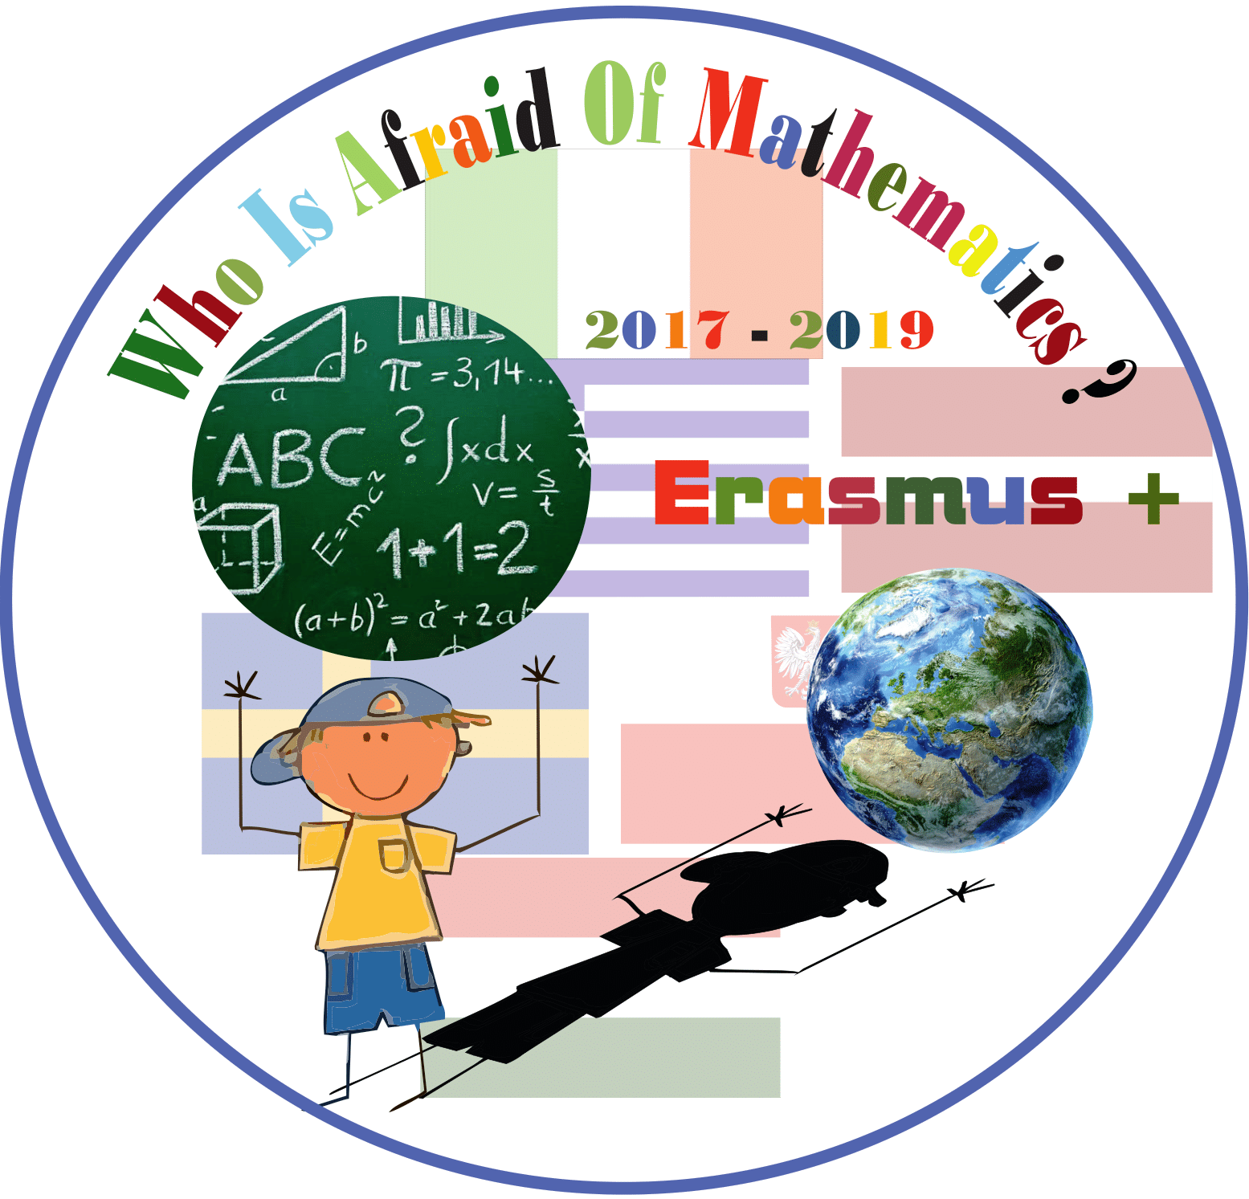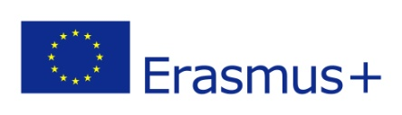

**Category : MATHS IN HISTORY**

**Title of the activity: History through coins**

**Teachers: Buslowska Ewa, Litwinczuk Ewa, Czekaj Danuta, Kowalska Mariola**

**Year Group: Grade6- 7 (12-14 years old)**

**Learning Objectives:**

Pupils

* Acquire time line of ancient times and learn about historical events in dates
* learn the time line as way of displaying the chronological order of events
* Learn historical events themselves

**Success Criteria:**

Pupils will:

* Realize the epochs of world history from Monolit times through Egypt history till the birth of Jesus
* Acquire time line of ancient times and learn about historical events in dates
* learn the time line as way of displaying the chronological order of events
* Learn historical events themselves
* Search and choose important events the past
* Create the graphic time line of Monolit era till the beginning of Anno Domini.

**Introduction:**

We show several time lines in various historical books about ancient times as well as Anno Domini period.

We discuss the main reasons of inventing such technique, what information is needed to create a time line

**Resources:**

* Images of historical events all over the world (archeological pictures/ images of pharaons etc)
* The books about history/the internet/ dictionaries/translating softwares
* Printed materials (imagies of historical events, A2 paper, glue, other staff needed to make the graphic presentation (a poster)
* Pencils, salt clay crayons, scissors

**nnnnnnnnnnn**

**Lesson Description (including context) :**

Lesson “Time line in history” consists of 2 parts: gathering the collection of historical facts and translating them and making the graphic presentation of chronological orders of facts displayed on time line. Pupils are searching historical events and translate them, discuss the content of history in BC period, watch historical pictures and images. The lesson provides knowledge about ancient history and pupils analyze the idea of time line presentations. The last part is producing one big poster with dates, events and images according to the periods (every student takes part in the process of producing the poster)

**Main Lesson:**

1. Students are asked to bring history books from home (they can be any kind of book concerning BC history ). Together with teacher they analyze the crucial events. They discuss historical importance of wars and achievements. The teacher introduced the time line as a technique of displaying the chronological order of what happened in the BC period

2. Students are divided into groups of three to four students. They are provided with images of historical events as well as sets of names of historical events. Groups discuss.

3. Students are told to translate their events from Polish into English using dictionaries and translators..

4. Students type the names, print them and cut them separately.

5. Students start placing them in chronological order on the time line on the blackboard.

6. After that the decorate the timeline with appropriate images and pictures.

**Differentiation:**

Pupils get the tasks according to their abilities and possibilities. Students are encouraged to help each other during the group work.

Teacher’s assistance is needed during the individual work to ensure that everyone is involved.

Students make their presentations according their abilities to use modern technologies for finding information and using PowerPoint

**Plenary** :

At the end of the lesson teacher encourage students to share what they learned in the lesson.

Homework for revision of new knowledge- ask students at home to write down 5 extra ancient events that they wish.

