FESTIVALS AROUND EUROPE:
“The December newspaper” from The Netherlands
NEW YEARS EVE  Firework shop “”STARS IN HEAVEN”  For all your firework: cheap and colourful!!  Opening hours December 27th until 31st  10.00 am-17.00 pm.  ********************************  SAINT NICOLAS  On December 5th Saint Nicolas visited our school. All the pupils became a nice little present. And of course some sweets. Typical sweets in the Netherlands are spiced ginger nuts.  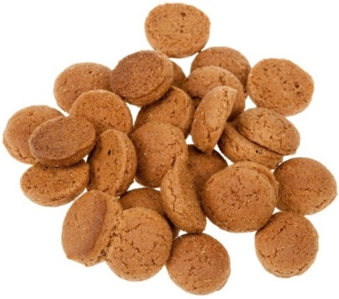  ***********************************  X-MAS Musical  On December 14th we will show our  X-masmusical. All pupils of our school will participate in the musical. Everybody is invited to be there. Free entrance. After the show time for a cup of coffee.  WELCOME TO ALL OF YOU!!! | ICE FEAST  On Monday December 7th all the pupils of school are invited for the “ICE FEAST”. If you do not have skates of your own, no problem, there will be skates for all of you! Enjoy the feast!!!!  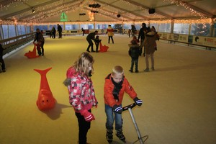  *****************************************  X-MAS HOLIDAY  This year the X-mas holiday is from december 19th until January 3rd .  If you go to the mountains for wintersport: enjoy it and….. don’t break a leg!  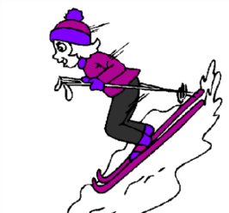  ********************************  Hi colleague, have a nice ride!  