***Dodenherdenking***

***Remembrance of the Death*** *(May 4th)*



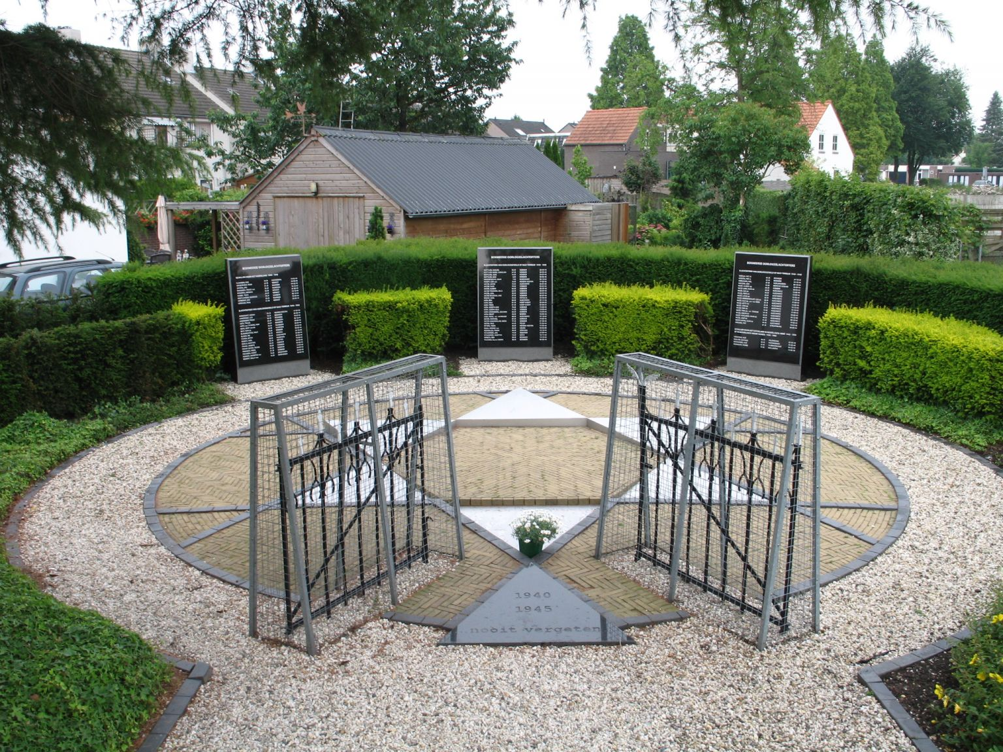

**Second world war monument in Boxmeer**

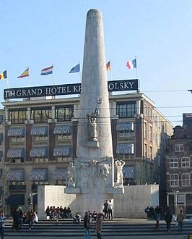

**National monumet in Amsterdam**

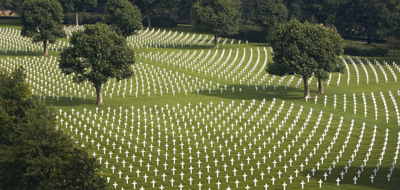

**American cemetery in Margraten, over 8.000 graves**

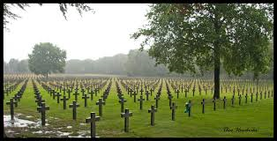

**German war cemetery in Ijsselsteijn. Over 32.000 graves for German soldiers**

Remembrance of the Dead is held annually on 4 May in the Netherlands. It commemorates all civilians and members of the armed forces of the Kingdom of the Netherlands who have died in wars or peacekeeping missions since the outbreak of World War II. The number of Dutch Second Worldwar victims is almost 200.000. Among these are a bit more then 100.000 Jewish persons.