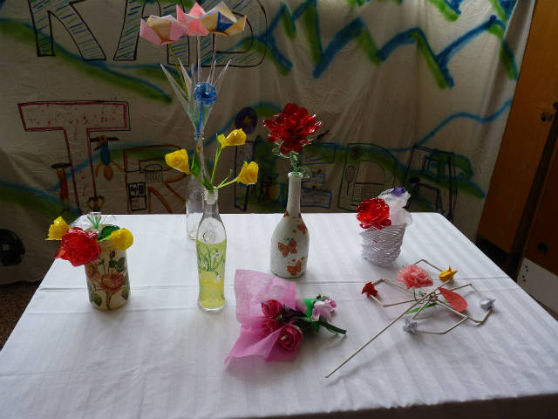

In May we celebrate the Mother´s Day. Children prepared nice flowers for their Mums.

