***Pasen (Easter)***

(most in April, sometimes in March)

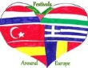

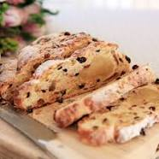

Easter bread  
(Paasbrood)

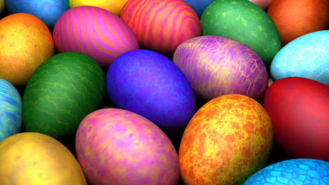

Easter egg  
(Paasei)

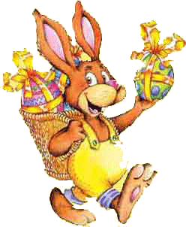

Easyter bunny  
(Paashaas)

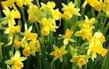

Easter flowers  
(Paasbloemen)

Easter is popular in The Netherlands because of:

* Two days holiday (Sunday-Monday)
* It feels like beginning of Spring
* A lot of activities in schools, cities and villages

It is not so important or popular as a religious celebration. Only about 10% of the Dutch population is active Christian. For instance in our town Boxmeer we had two catholic churches until a few years ago. Nowadays we just have one catholic church. And this church is big enough.....

On Maundy Thursday and Good Friday we have our lessons as usual but we also celebrate Easter and Spring in school. We have an Easter breakfast in school and an Easter celebration in a chapel wih music, songs, stories about Easter and Spring.

How we celebrate Easter in The Netherlands?

* Some people (about 10%) go to a catholic church.
* In school we have a celebration for all pupils and parents.
* We paint easter eggs.
* We hide these eggs in our gardens.
* Young children is told that the easter bunny did hide the eggs.
* The youngest children go outside to search for the eggs.
* We enjoy the easter flowers as a sign of beginning of Spring season.
* We eat easter bread (the same as for Christmas....)
* And...........A lot of Dutch people visit the big shopping centres and furniture boulevards, just for fun, not for buying things....