***Bevrijdingsdag (Liberation day)***

(May 5th)



**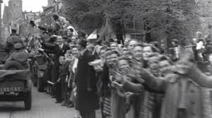  
Liberation of the Netherlands by the allied forces**

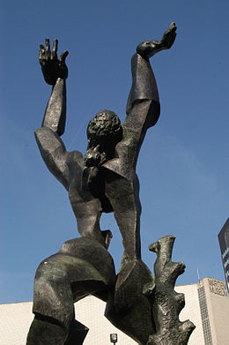

Rotterdam  
„The destroyed city”  
by Zadkine



Parade

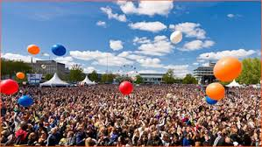

Festivals everywhere

In the Netherlands, Liberation Day is celebrated each year on May the 5th to mark the end of the occupation from The Netherlands by Nazi Germany during World War II.

  
National war and resistance museum  
in Overloon (Community Boxmeer