This year the theme of our kites was the flags of the countries of our eTwinning project! It was an interesting way to involve children to the project, and to learn the flags of the countries! Boys knew the flags of Italy, Spain and Netherlands –from the football matches of course!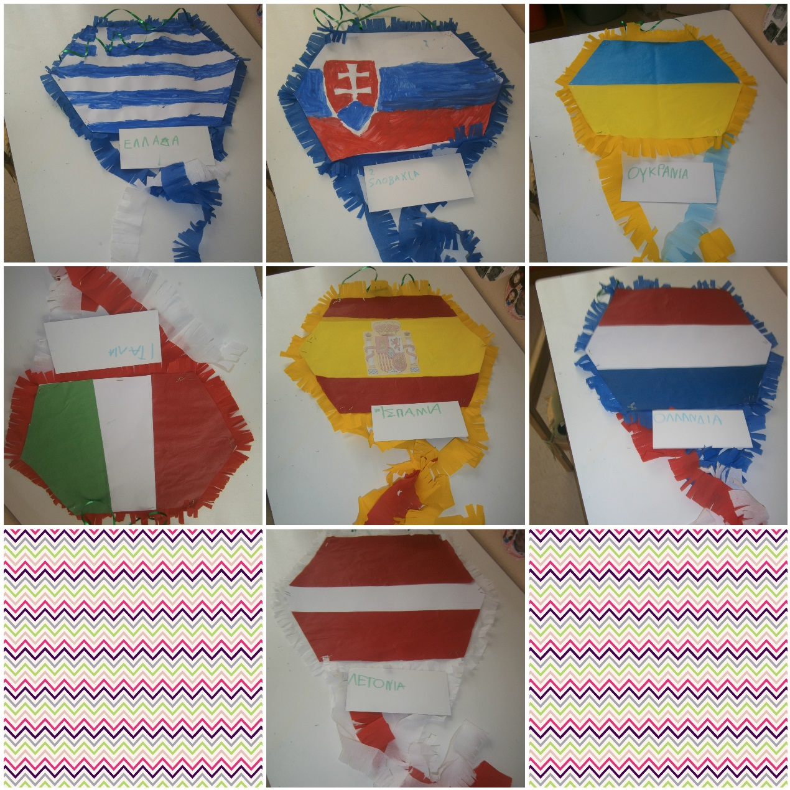
We had to wait for two days before we get outside and fly them! The weather was very bad!
But today we did it!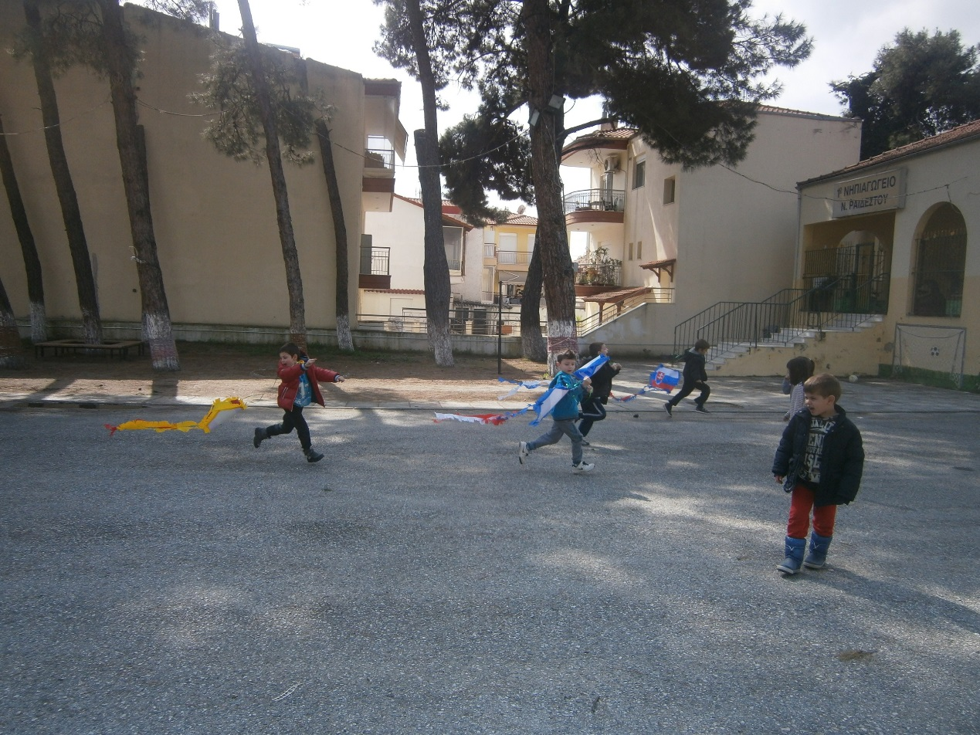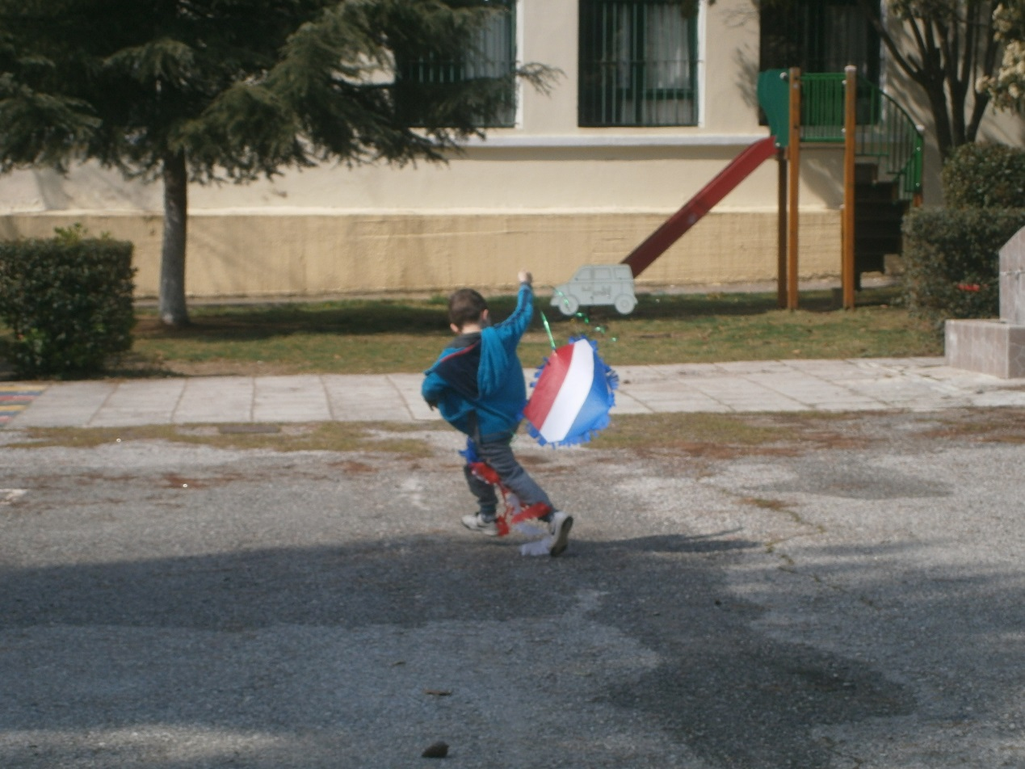
After all we put the kites inside to decorate our school!