Easter

 

Easter egg  
Easter bunny  
Paschal candle  
Looking for Easter eggs

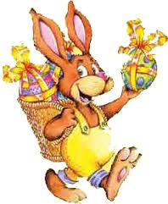

Easter

Easter egg  
Easter bunny  
Paschal candle  
Looking for Easter eggs

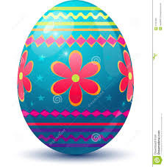

Easter



Easter egg  
Easter bunny  
Paschal candle  
Looking for Easter eggs

Easter egg  
Easter bunny  
Paschal candle  
Looking for Easter eggs

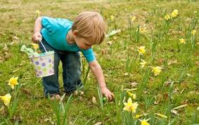

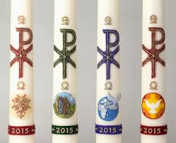

Easter

Easter