Easter

[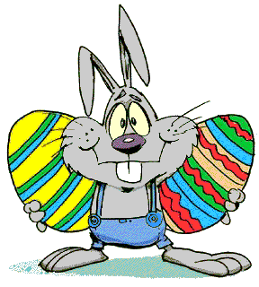](http://www.animatieplaatjes.nl/paashaas.html)

Easter eggs

Easter Bunny

Easter chick

Egg painting

Easter

[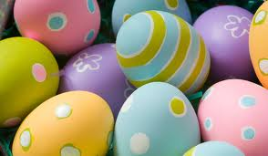](http://www.google.nl/url?sa=i&rct=j&q=&esrc=s&frm=1&source=images&cd=&cad=rja&uact=8&ved=0ahUKEwiXhdGIuKvKAhUIQBoKHYCJD2AQjRwIBw&url=http://www.beautynailsfun.nl/2012/04/vrolijk-pasen/&bvm=bv.112064104,d.d2s&psig=AFQjCNED3sTR9C04A-ZuIfVb_fL9cj4Njw&ust=1452934254940719)

Easter eggs

Easter Bunny

Easter chick

Egg painting

Easter

[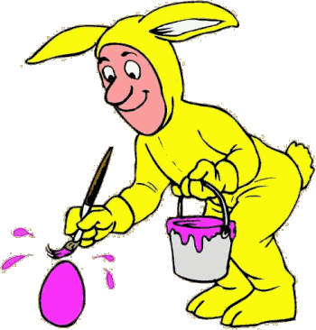](http://www.google.nl/url?sa=i&rct=j&q=&esrc=s&frm=1&source=images&cd=&cad=rja&uact=8&ved=0ahUKEwid-sGm2bXKAhUHqg4KHQB3BFcQjRwIBw&url=http://www.pasen.paintingfun.nl/Eieren%20schilderen/Eierenschilderen2.htm&bvm=bv.112064104,d.ZWU&psig=AFQjCNGMaman2tsZ_oIfHIXNGXwxIKAGWQ&ust=1453286756150214)

Easter eggs

Easter bunny

Easter chick

Egg painting

Easter

[](https://www.google.nl/url?sa=i&rct=j&q=&esrc=s&frm=1&source=images&cd=&cad=rja&uact=8&ved=0ahUKEwjLlby5u6vKAhVLbRQKHdkDBHQQjRwIBw&url=https://www.kaartje2go.nl/paaskaarten/paaskuiken-happy-easter&bvm=bv.112064104,d.d2s&psig=AFQjCNGoW8qAa-NhM7qUeghvSsDL0KwcTQ&ust=1452935164075483)

Easter eggs

Easter bunny

Easter chick

Egg painting

[](https://www.google.nl/url?sa=i&rct=j&q=&esrc=s&source=images&cd=&cad=rja&uact=8&ved=0ahUKEwi_pOaDhr3KAhVDvhQKHQ1uD9MQjRwIBw&url=https://nl.wikipedia.org/wiki/Zwarte_Piet&psig=AFQjCNFKDdQ9h4D35ZHstbkhqrDNwyqWgw&ust=1453539288816686)[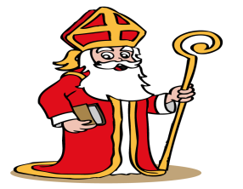](http://www.google.nl/url?sa=i&rct=j&q=&esrc=s&frm=1&source=images&cd=&cad=rja&uact=8&ved=0ahUKEwiRuoHl2LrKAhWEig8KHTy6CmEQjRwIBw&url=http://www.rkvvdem.nl/1/2317/sinterklaas-nodigt-je-uit/&bvm=bv.112064104,d.ZWU&psig=AFQjCNGgbc8V64OeEq5a5BIsRxtOzZFq2w&ust=1453458444325364)[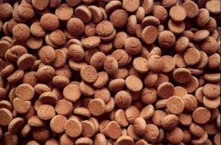](http://www.google.nl/url?sa=i&rct=j&q=&esrc=s&frm=1&source=images&cd=&cad=rja&uact=8&ved=0ahUKEwia07Tx1LrKAhVEcg8KHerNCRMQjRwIBw&url=http://www.jumbojetje.nl/tutorials/sinterklaas-jezelf&bvm=bv.112064104,d.ZWU&psig=AFQjCNGoi6jyY5saBiTXeisevu1KNfRi9w&ust=1453457394925660)easterea

St. Nicolas

[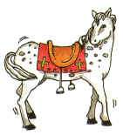](https://www.google.nl/url?sa=i&rct=j&q=&esrc=s&source=images&cd=&cad=rja&uact=8&ved=&url=http://www.gifplaatjes.nl/sinterklaas-gifs/paard-amerigo/1/&bvm=bv.112454388,d.d24&psig=AFQjCNGqAbtmA-A8U-4dzadzAgDhjZw9zA&ust=1453539581107193)

Pepernuts

St. Nicolas

Black peter

Amerigo

St. Nicolas

Pepernuts

St. Nicolas

Black peter

Amerigo

St. Nicolas

Pepernuts

St. Nicolas

Black peter

Amerigo

St. Nicolas

Pepernuts

St. Nicolas

black Peter

Amerigo

[](http://www.metworst.nl/)[](https://www.google.nl/url?sa=i&rct=j&q=&esrc=s&frm=1&source=images&cd=&cad=rja&uact=8&ved=0ahUKEwiIs8Pyz8zKAhWFVhQKHZ1uBukQjRwIBw&url=https://www.kaartje2go.nl/uitnodigingen/party-time-vrolijke-uitnodiging-sterren&bvm=bv.112766941,d.ZWU&psig=AFQjCNFEtpdQLWcSgdel7N8gMaRCzaWCcw&ust=1454074524723386)[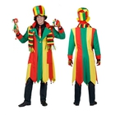](http://www.google.nl/url?sa=i&rct=j&q=&esrc=s&frm=1&source=images&cd=&cad=rja&uact=8&ved=0ahUKEwjzvMSRz8zKAhWGDQ4KHeVvCnQQjRwIBw&url=http://www.koopkeus.be/a/lijst_product/idx/9999999/mot/Heren_jas/lijst_product.htm&bvm=bv.112766941,d.ZWU&psig=AFQjCNE3lorrZHhfTeSfaKsh9e661u3v7A&ust=1454074320909886)[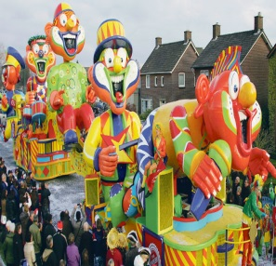](http://www.google.nl/url?sa=i&rct=j&q=&esrc=s&frm=1&source=images&cd=&cad=rja&uact=8&ved=0ahUKEwjgls6XzczKAhUGdw8KHVDPCO8QjRwIBw&url=http://www.corsonetwerk.nl/wvttk-mei-2014-6961&bvm=bv.112766941,d.ZWU&psig=AFQjCNFuZ8wHEdlerCZbveAespukPrkKxA&ust=1454073805215958)[](http://www.google.nl/url?sa=i&rct=j&q=&esrc=s&frm=1&source=images&cd=&cad=rja&uact=8&ved=0ahUKEwjpsIKzmszKAhWCFQ8KHeUuCQQQjRwIBw&url=http://www.hskrant.nl/evenementen/19009/kerstman-bezoekt-boswijk-in-sappemeer/&psig=AFQjCNGfVlvyfNwQvGCb7KlqkRBC1ljr-A&ust=1454060126380712)[](https://www.google.nl/url?sa=i&rct=j&q=&esrc=s&source=images&cd=&cad=rja&uact=8&ved=0ahUKEwjZqJTZiL3KAhVCNxQKHYT7AOwQjRwIBw&url=http://deweijerhof.nl/&bvm=bv.112454388,d.d24&psig=AFQjCNFoewUBjjqeP7LbuyRlSSi7cAJHeA&ust=1453539843301633)

Carnival

Party

Cars

Costume

Metworst

Carnival

Party

Cars

Costume

Metworst

Carnival

party

Cars

Costume

metworst

Carnival

Party

Cars

Costume

Metworst

Christmas

[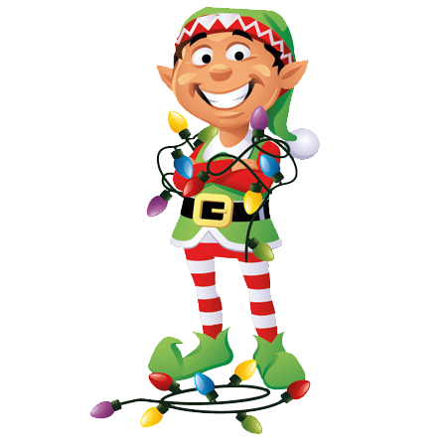](http://www.google.nl/url?sa=i&rct=j&q=&esrc=s&frm=1&source=images&cd=&cad=rja&uact=8&ved=0ahUKEwiMn9uYnszKAhUCxxQKHVvzBJMQjRwIBw&url=http://www.christmaselves.com.au/lightup-elf/&psig=AFQjCNEqqnUVZc5d_913FBQ_MAevnGvHnA&ust=1454061139501914)

Santa

Reindeer

Christmas tree

Elves

Christmas

[](http://www.google.nl/url?sa=i&rct=j&q=&esrc=s&frm=1&source=images&cd=&cad=rja&uact=8&ved=0ahUKEwjN09aAnczKAhWHXRoKHapPCjAQjRwIBw&url=http://happyholidays2016.com/christmas-tree-poster/&bvm=bv.112766941,d.ZWU&psig=AFQjCNHCxdQolGXomgh2BKnMsliAfaMNIQ&ust=1454060827772562)

Santa

Reindeer

Christmas tree

Elves

Christmas

[](https://www.google.nl/url?sa=i&rct=j&q=&esrc=s&frm=1&source=images&cd=&cad=rja&uact=8&ved=0ahUKEwj79c-YnMzKAhWLsxQKHSDNAHcQjRwIBw&url=https://www.etsy.com/market/reindeer_head&bvm=bv.112766941,d.ZWU&psig=AFQjCNFa2pit1SDbPk7ZBWx_4v97kRMWZA&ust=1454060654837010)

Santa

Reindeer

Christmas tree

Elves

Christmas

Santa

Reindeer

Christmas tree

Elves