 

The holy family  
The stable  
The angel  
The Christmas tree

The holy family  
The stable  
The angel  
The Christmas tree

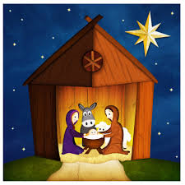

Christmas

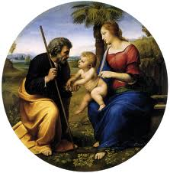

Christmas



The holy family  
The stable  
The angel  
The Christmas tree

The holy family  
The stable  
The angel  
The Christmas tree



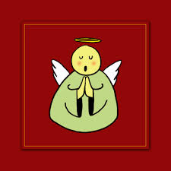

Christmas

Christmas