***Koningsdag (Kingsday)***

(April 27th )

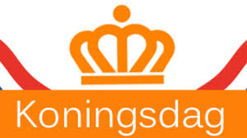

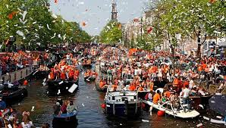

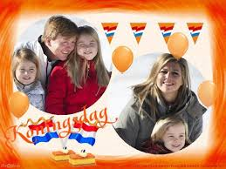

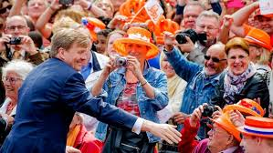

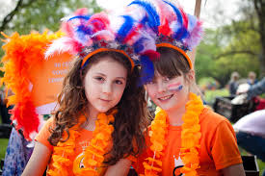

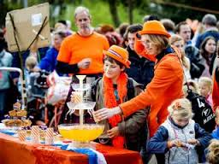

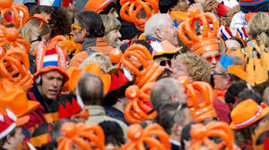

On August 31st 1885 we celebrated our first so called „Princess day”, the anniversary of princedss Wilhelmina. In 1990 „Princess day’ was changed into „Queensday” on the anniversary of the queen. In 1948 Juliana became queen , her anniversary was on April 30st, so that was the new date. Het daughter Beatrix, quee from 1980 until 2013 did not change the date. But her son, Willem-Alexander, who is our king now, celebrates his birthday, and so also „Kingsday” on April 27th.

Kingsday is an official holliday in The Netherlands. All over the country we have performances, party’s, free markets for children , concerts etc. And everything and everybody is coloured orange, our national colour.

In our primary schools we organise „Kings games” for all the pupils. Our king isvery sports minded.

The king and his family celebrate kingsday every year in another city.