Epiphany

 

Caspar  
Melchior  
Balthasar  
Bean in the pie

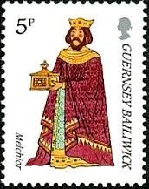

Epiphany

Caspar  
Melchior  
Balthasar  
Bean in the pie

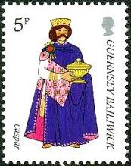

Epiphany



Caspar  
Melchior  
Balthasar  
Bean in the pie

Caspar  
Melchior  
Balthasar  
Bean in the pie

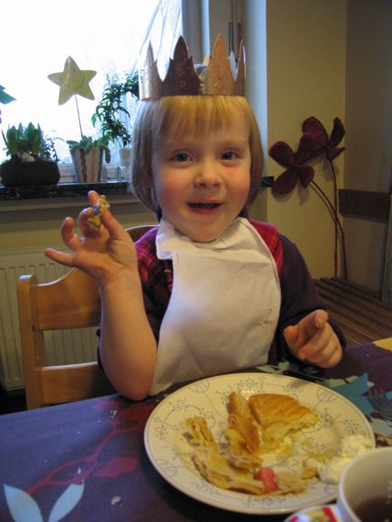



Epiphany

Epiphany