Saint Martin

 

Roman soldier  
Beggar  
Cut his coat in two parts  
Chinese lanterns

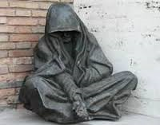

Saint Martin

Roman soldier  
Beggar  
Cut his coat in two parts  
Chinese lanterns



Saint Martin



Roman soldier  
Beggar  
Cut his coat in two parts  
Chinese lanterns

Roman soldier  
Beggar  
Cut his coat in two parts  
Chinese lanterns



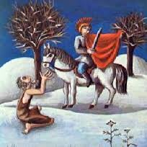

Saint Martin

Saint Martin