The March bracelet

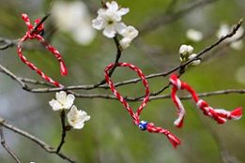
In the first day of March children and whoever has the child inside him (like us, teachers) put in the wrist a bracelet made of red and white yarn.
It is a custom that comes from the ancient Greece and it is common in the Balkan countries. The white color is for good luck and the red for love!
Also this bracelet protects us from the sun of March that can burn us!
The last day of March we cut it and hang it on a tree. The swallow can find it and put it in its nest!
This is the photo of our hand wearing the March bracelet in the 1st of March!
