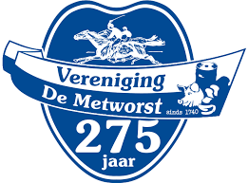

**February: De Metworst race**

**(Horse race De Metworst)**

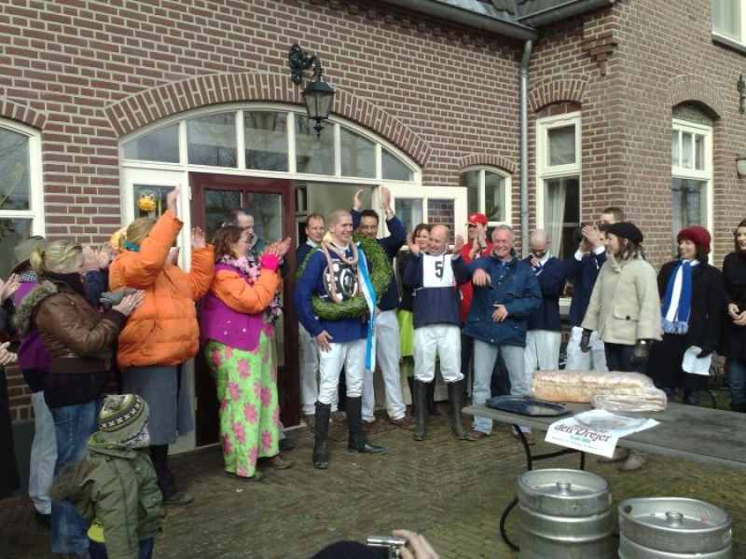

Photos

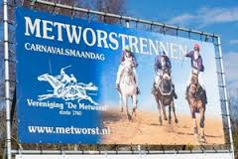

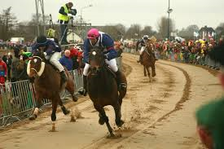



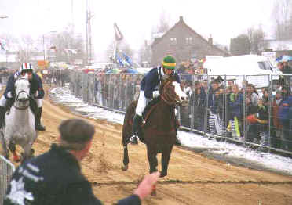

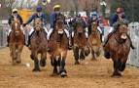

Photos can be inserted around the text

The History of "De Metworst

A “metworst” is a type of sausage, but it is also the name of an event held every year in Boxmeer

The “Metworstrun” originated in the Middle Ages.   
One day, a rich noble lady (lady of noble birth) was riding in her carriage near Boxmeer. Suddenly the axle of the carriage broke off. The driver fell from the carriage. The horses were very frightened, broke free and escaped. Fortunately, a few young man saw what happened. They saw the lady and rescued her. She rewarded them with almost five metres of sausage. That was the story of the “Metworst”. The lady in the story is called Aleida. All this happened to her and that is why the people of Boxmeer celebrate DE METWORST HORSE RACE each year on the Monday of the Carnival festival.

Winning the race is quite a difficult job! The person who manages to win the final, is the new "King of the Metworst". Important rules are that participants have to be unmarried and that they are at least twelve years old. You also have to be an inhabitant of Boxmeer. And of course you need a lot of courage If you manage to win three years in a row, you can call yourself "keizer of the metworst" (emperor). This does not happen very often. If it happens, however, you will understand that this emperor is the hero of Boxmeer.

For the winner: a barrel beer, one meter sausage and the head of a pig.

Description