Saint Nicholas

 

Saint Nicholas  
Black Peter  
Horse Amerigo  
Steamer

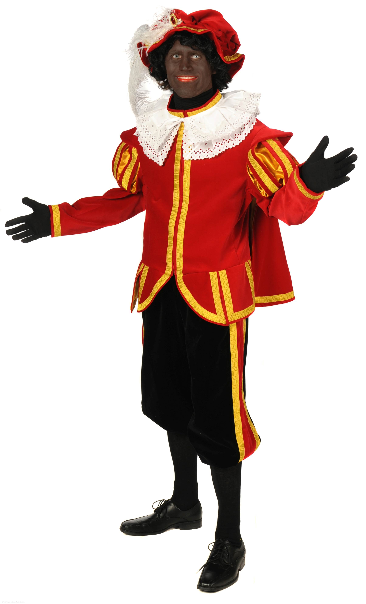

Saint Nicholas

Saint Nicholas  
Black Peter  
Horse Amerigo  
Steamer

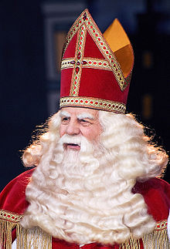

Saint Nicholas



Saint Nicholas  
Black Peter  
Horse Amerigo  
Steamer

Saint Nicholas  
Black Peter  
Horse Amerigo  
Steamer

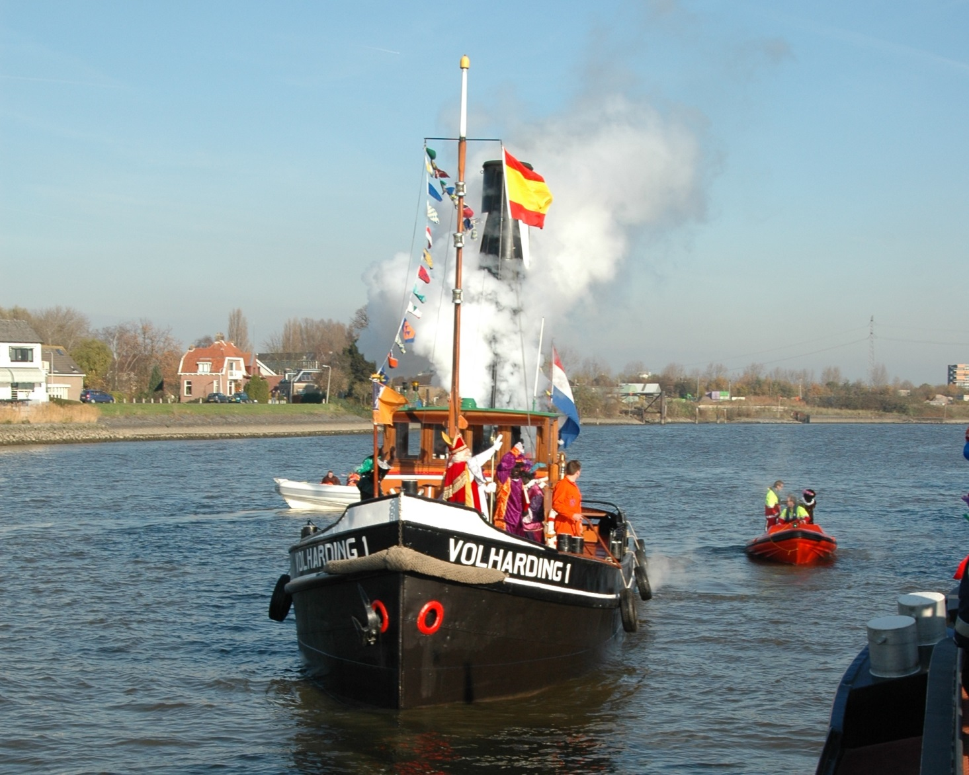

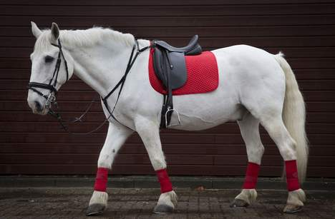

Saint Nicholas

Saint Nicholas