**The Spanish Constitucion**

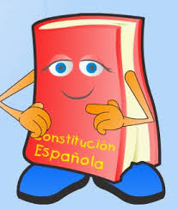

The 6th of December all the Spanish citizens celebrate about our rights and duties. It’s a national festival and nobody works in that day.

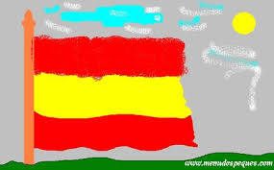

At schools, our pupils represent it through songs, theatre, rithms and having a tipical Spanish breakfast.



**INMACULADA** **CONCEPCIÓN FESTIVAL**

It’s also a national party, whose Catholic features mean that Virgin Mary was conceived with no original sin. As this festival is very closed to the Spanish Constitucion festival, we usually enjoy a bank holiday and it’s a great time to prepare Christmas at home: decorate our Christmas tree, purchase presents, prepare some food…

Now, it’s time to both decorate all the school with drawings, posters, Christmas tree, and the Christmas theatre as well, which will be performance the last day of the school. Our pupils not only are very excited but also happy since all their parents will come to watch them.

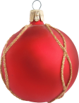

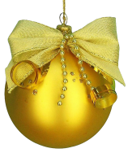

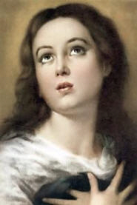







Christmas holidays from the 22nd OF DECEMBER to the 7th of JANUARY



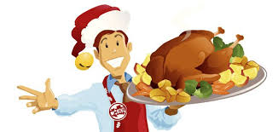

Every Christmas Eve families meet to have the tipical dinner: soup, turkey, chicken, shellfish…but they can’t be late since the “Midnight mass” starts at 24.00. There, people feel very comfortable admiring the nativity scene and singing Christmas carols together.

