 

Reveille  
The race   
The king  
Metworst monument

Reveille  
The race   
The king  
Metworst monument



Carnival De Metworst

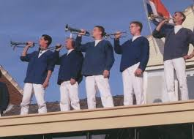

Carnival De Metworst



Reveille  
The race   
The king  
Metworst monument

Reveille  
The race   
The king  
Metworst monument

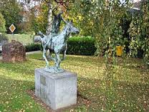



Carnival de Metworst

Carnival De Metworst