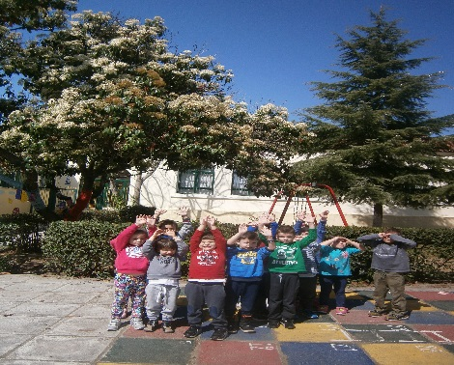

The weather is fine! No jackets, not even a cloud in the sky and a warm sun that blinds us!

**Newspaper wrote today:**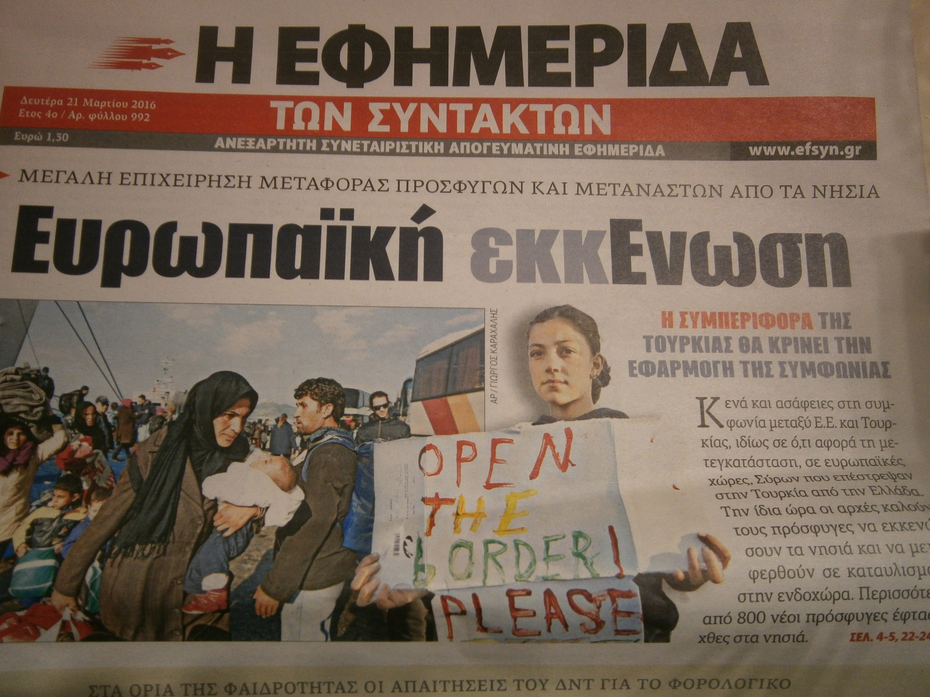

The refugees are the major problem in Greece. Εnclaved in a country that can’t provide them dignified conditions of living. Greek people and charity organizations try to provide all that is necessary especially for babies and children. Every day new refugees come…and no solution!!!!!

1st day of Spring- World Day of Poetry

We combined the first day of spring and the day of Poetry working on a poem called “They come”. 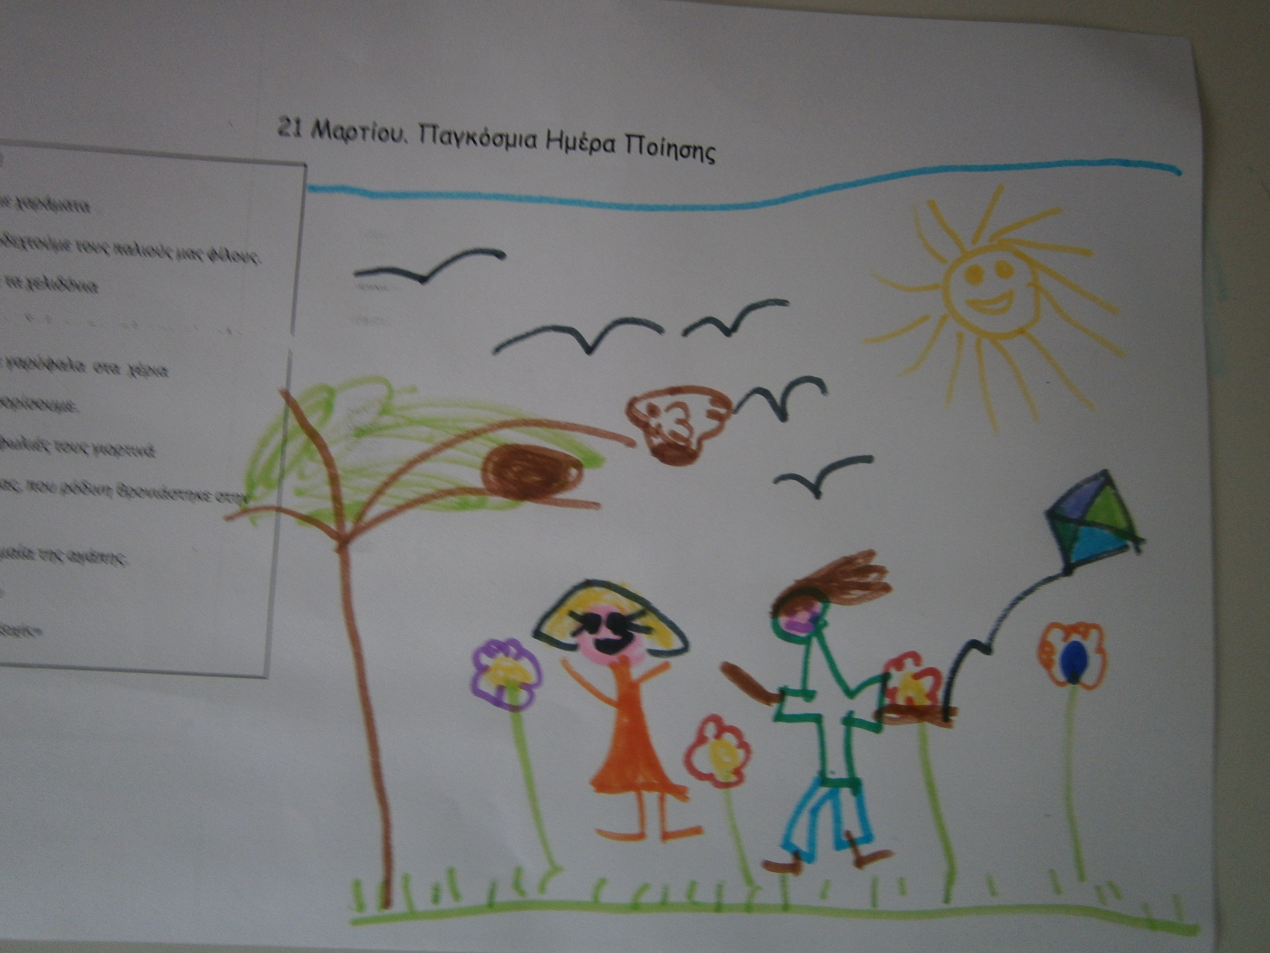

We got up at dawn to welcome our old friends.

We are waiting for the swallows in the edge of the road.

We are holding red carnations to welcome them.

We decorated their nests with festive mood, like our joy which sat on the front door, under the flag of love!

R. Arvanitidou

**SPRING IS IN THE AIR**

1st Kindergarten of Nea Redestos