 

The billy goat  
Reveille  
The Metworst race  
 Light Parade

The billy goat  
Reveille  
The Metworst race  
The Light Parade

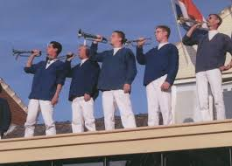

Carnival Boxmeer

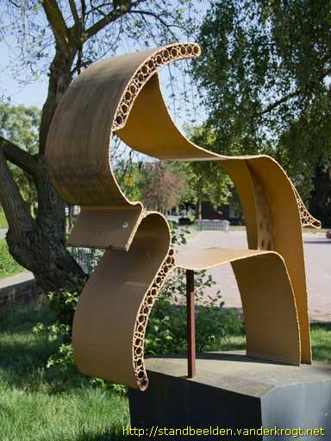

Carnival Boxmeer



The billy goat  
Reveille  
The Metworst race  
The Light Parade

The billy goat  
Reveille  
The Metworst race  
The Light Parade

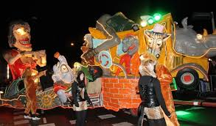

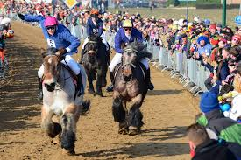

Carnival Boxmeer

Carnival Boxmeer