Greek Christmas

**1st Kindergarten of N. Raidestos**

CHRISTMAS IS….

Children said….

* Taking presents
* Making crafts
* Snowing
* Warm house, dad watching TV, mum preparing traditional sweets, children helping her!

THE DECORATION OF OUR CHRISTMAS TREE

Friday 4th December a Christmas party happened in our school! Playground! Parents and children gathered in order to decorate our Christmas tree! Every child had prepared a handmade ornament and put it in the tree!

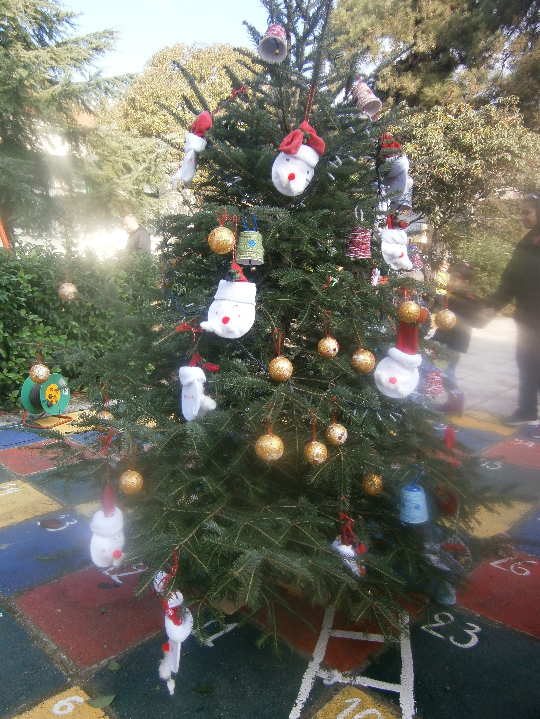

All the trees in our yard were dressed in a Christmas mood! We also decorated the big fir in a very original way, by throwing fireworks of ribbons!!!

The pie of santa Claus

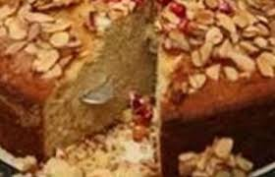

At 12 o’clock in the New Year’s Eve, just after the changing of the year, all the family gathers around the pie of Saint Basil (Santa Claus). The oldest male (grandpa or father) cut a piece for everybody. The pie has a coin inside! Whoever finds the coin will be the “lucky” of the year.

In school we cut the pie in the 8th January, the day we return from Christmas holidays!

Here is the recipe:

*250gr. Butter*

*2 spoonful of orange zest*

*1 ½ spoonful baking soda dissolved in 2 spoonful of cognac*

*6 cups flour*

*2/3 of the cup orange juice!*

*We mix all the ingredients together, we put the dough in a pan. We anoint egg yolk for getting a nice color !*

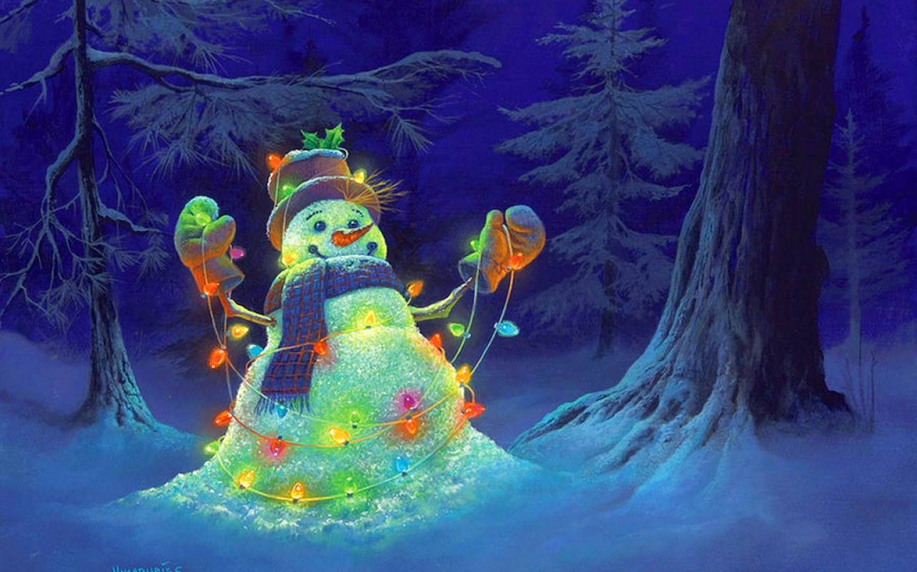

Christmas holidays…

From 23/12 till 7/1 !!!

There is no snow yet…we hope for it!!! Till then...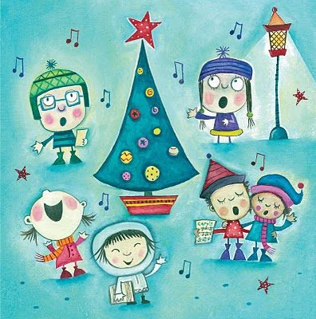

Feel the Christmas spirit!!!

**R E M E M B E R...**

**Those who lack of something (food, clothes, presents, home, love)! *BE GENEROUS*** the whole year!!!!****

WHY IN GREECE WE DECORATE A BOAT

Greece from the ancient years was a naval country! Greeks loved the sea, since the sea provided them with food and work!

Many many years ago, especially in the islands, it was usual that the father and the sons were away from the house travelling and working in the ships for sending money to the family. The children during Christmas constructed boats from wooden sticks and decorated them with coloured papers. They were inspired by the travels of their beloved and they wanted to express their nostalgia for them.

So the family decorated a small boat in the house. It was the symbol of the expectation and a sign of welcoming home for those who were away!

Passing the time, the decoration of the boat was replaced by the decoration of the Christmas tree!

But even now in the many places of Greece the local authorities decorate boats, such as in Thessaloniki, in the Square of Aristoteles, a huge boat shines besides the Christmas tree! 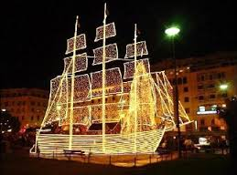

COME TO OUR CHRISTMAS EVENT!

Thursday, 17 December the parents of our students are invited to our Christmas event! The students are going to present a Christmas fairy tale named «The two sisters and the kalikantzari»! 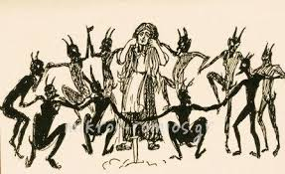

The parents are kindly requested to bring with them their festive mood because they are not only going to watch!!!!!!!!!