
Project Erasmus+ KA229 - School Exchange Partnerships
I AM MY LIFE HERO

SMART Hero Week in Poland
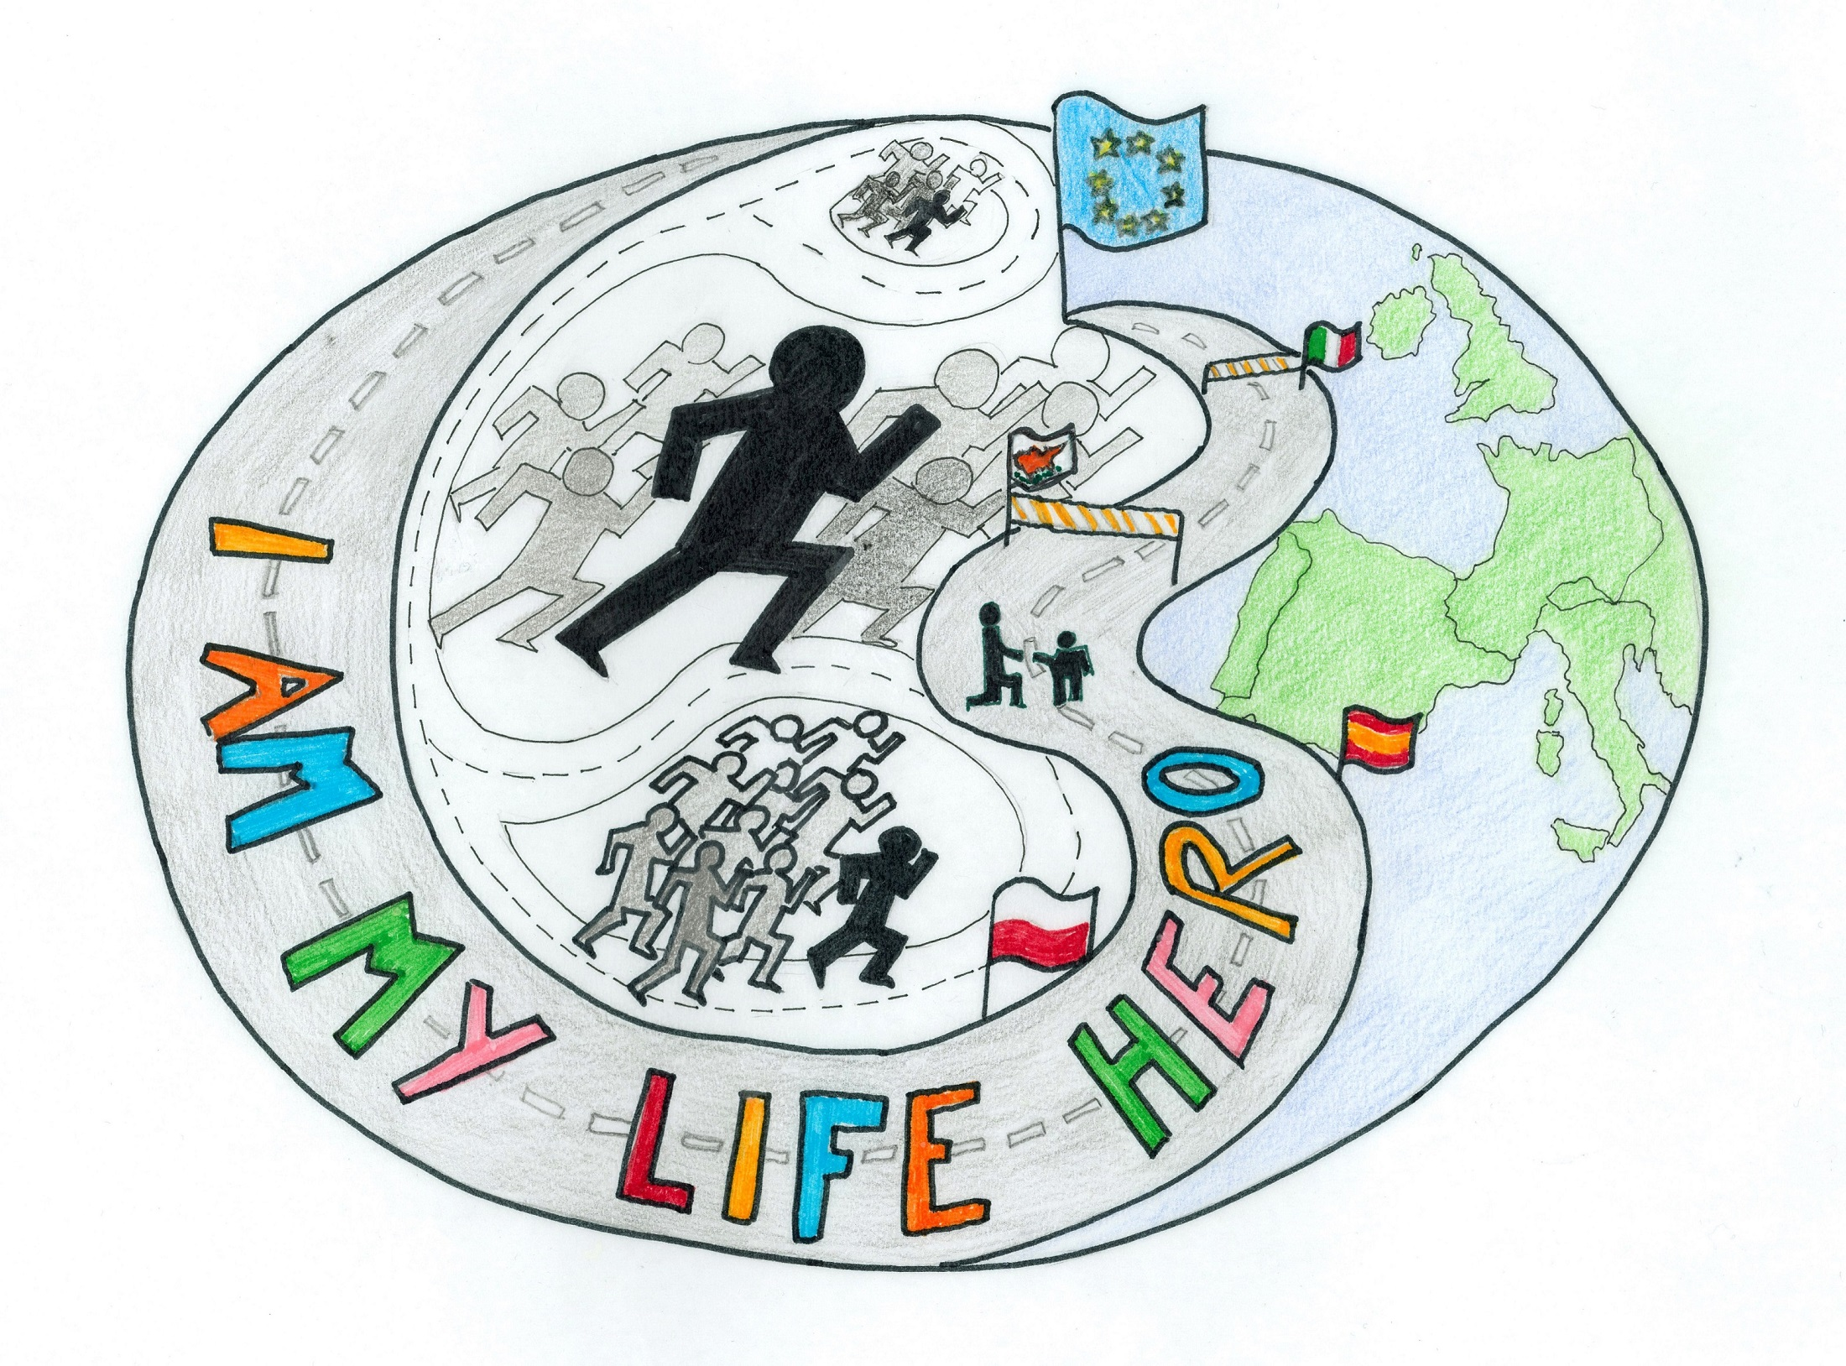
June 2020

Partner schools:
Poland – Primary School no 12 in Elbląg
Cyprus- Konstantinoupoleos Gymnasioum in Nicosia
Italy- Civitella -Torricella Istitute in Civitella DEL TRONTO in TERAMO
Spain- Spain Escola Circell in Moja (Olèrdola), Barcelona

AIMS
As the coordinator the Polish partner is to organise Smart Hero Week to present our educational ideas based on modern technology. We are to show how to introduce programming into Maths, art and a foreign language studies. The Erasmus partners will participate in active work of newest applications and Ozobots. Students will have opportunities to see experiments, playing with robots, the use various apps and programmes and the newest ICT tools. We offer activities which develop a positive identification as a hero of modern learning styles and show everyone how the cooperation and exchange of good experiences is valuable and important in life. For the teachers participants the event will give a chance to broaden their competences, study methods, and school system. For all the partners the venue is a challenging event to share the ICT methodology knowledge and skills to introduce them in their own teaching.
We'd like to invite the partners to take part in the visits around Elblag and the area sightseeing the unique cruise on grass along the Channel and the Malbork castle as weel as the Baltic seaside with the visit of Gdansk.

SOMETHING ABOUT OUR SCHOOL
Be yourself and look for your own way 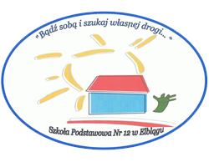
The primary school no 12 was built in 1960s. It is situated in the northern Poland in an urban area with a few factories and about 100 thousand population. Due to a high level of unemployment 700 students come from families of different economic and social position. Some of them are brought up in very poor families in financial and cultural sense.There are some who get social grants for school objects at the beginning of each year and free dinners.Some students receive various psychological support like meetings, workshops and culture support.The school has been looking for other sources of helping the students with special needs.There are several teachers trained to work with the disabled. It has participated in various projects which dealt with pedagogical, methodological, environmental and safety issues. For many years we have been cooperating with different institutions in the following areas: tolerance, promoting acqusition of foreign languages and ICT skills as well as caring about environment, sport and health. Facing the problem of drops outs, we've introduced the worshops informing about jobs and self developing.The most important school actions of European dimension are Comenius project Let E Be 2010-2012, Litter Less campaign and Eco Schools, National programs like Teaching how to code and Teaching PE and others of the local area. For 10 years the school has been participating in eTwinning projects supporting ICT and English acqusition.We always try to engage the whole school community, mainly parents and other nearby organisations, local societies, libraries, kindergartens and small business. The last few projects were devoted to programming and coding in order to develop integrating skills.The school organises Technology days for kindergartens, the disabled and parents. It proposes doing experiments, coding, using robots, tablets and various applications aiming towards teaching logical thinking, creativity and teamwork. Having it in mind, we have decided to share our common experience and gain the one about team and healthy aspects in the European community.There are teachers trained to realize the project's aims. Some use the methods of active and effective teaching. As the coordinator we are to hold Smart Hero Week during which we would like to present our educational ideas based on modern technology. We will show how useful it is to introduce programming into Maths, art and Polish and a foreign language studies. In the Erasmus team there are 30 teachers indirectly working over the tasks with 2 groups aged 5-9 and 10-14. There are History and 2 Art teachers, 5 English and 5 Polish teachers.The school coordinator held the role of the coordinator in the Comenius project. Being an English and ICT teacher she will lead the whole project with the help of another English teacher, who will take the role of the coordinator in case of any risk and an ICT one to keep the project dissemination.

Elbląg- our green town

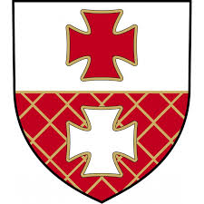

Beginnings of the city reach back to 1237. It was then that on the bank of Elbląg river the Teutonic Knights started the construction of a defensive castle. Around it a trading settlement grew. In 1246 the place received Lübeck law town privileges. Back then the main national seat of the Teutonic Order was found in Elbląg.
In 14th century Elbląg was an important port centre and belonged to the Hanseatic League. The archeological excavations in the old town prove the wealth of former citizens of Elbląg. The archeologists find thousands of products made of amber, ceramic, glass, metals, etc. These prove the vivid trade contacts of the Elbląg inhabitants with – among others - Germany, Scandinavia, England and the Netherlands.

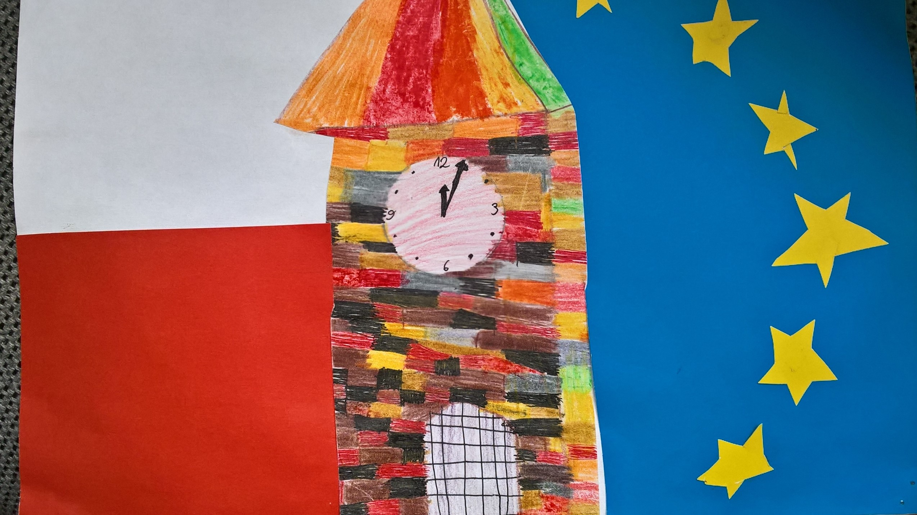

SMART Hero Week
June 2020

ACTIVITY PLAN

https://view.genial.ly/5edccfcc200cf70d60735ad3/presentation-erasmus-smart-week-in-poland-june-2020

Day 1 |  | Meeting in Primary School no 12 in Elblag  Presenting The project KA2 Erasmus+ aims and The Smart Week  The welcoming letter
Let’s visit Poland
https://www.youtube.com/watch?v=j-hnZwZJd4I&feature=emb_rel_pause

National symbols

Polish interesting places- photo presentation

the school visit
– video spot
https://www.youtube.com/watch?v=fhcXSA6CWkk&feature=youtu.be

STEM in the curriculum, the ICT and English labs
- School Spot
https://www.youtube.com/watch?v=OWqWYezGx6U&feature=youtu.be

Day 2 |  | Westerplatte - National heroes – Polish history
The cruise to the historical centre of the city
http://galeony.pl/en

sightseeing of Gdansk
https://tourguideservicegdansk.com/tours/

SMART activities in Hevelianum Centre

https://www.hevelianum.pl/en

Day 3 |  | Sightseeing of Elblag  - The spot and powerpoint presentation
The Elblag museum over the boarders- hologram fim
http://www.muzeum.elblag.pl/s/16/hologram

Robotics in University
http://ad.pwsz.elblag.pl/akademia-dziecieca-warsztaty.html

Erasmus+ coordinators Zoom meeting
1. SMART Hero workshop
- the use of Gennialy
- Flip in English acqusitions
2. coordinators summing up the work

Day 4 |  | The Erasmus+ team visit  in Malbork UNESCO  http://www.zamek.malbork.pl/galeria-zdjec
The cruise on grass

https://www.toursingdansk.pl/oferty,elblag-canal-tour.html/

Day 5 |  | The visit of the capital city  - The spot  - Students Canva presentations

