How to get Power Point 2016 For FREE

Onedrive Microsoft One Drive Continue Trial Sing up for free Sing in Next Onedrive Enter Password Click on New option Power point presentation

Easy Method of Creating Animation Scene

In a Black Presentation, click Insert and then click Online Pictures.

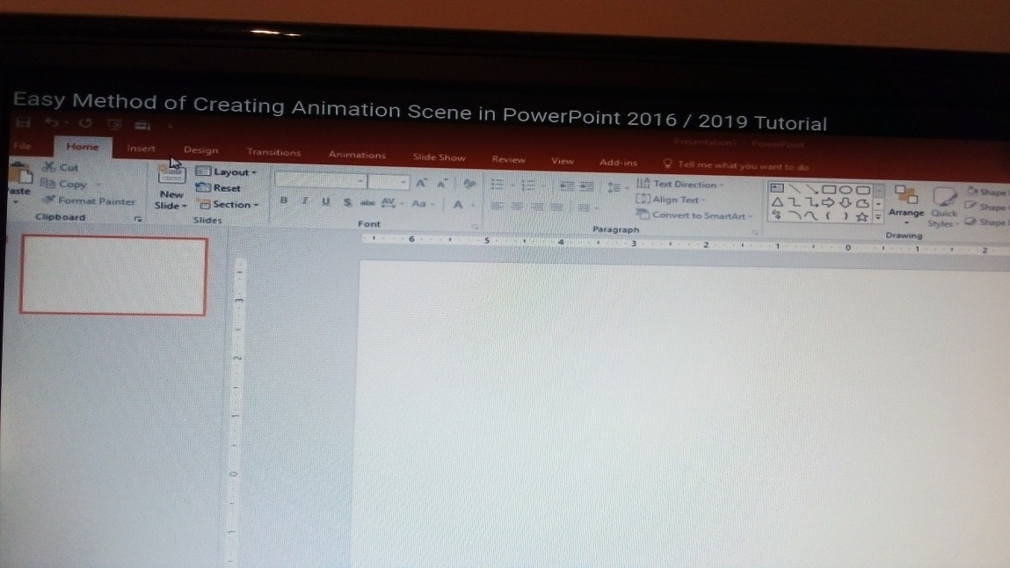
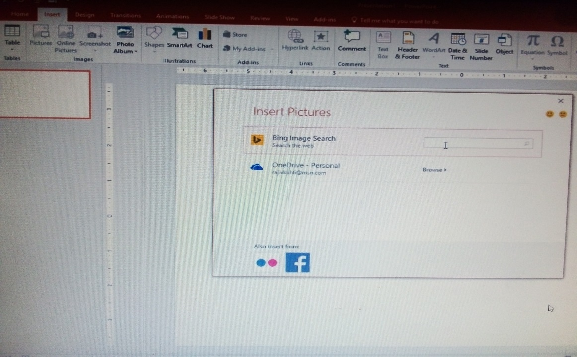

Type “Leaf PNG”. We are using PNG term to find those pictures having a transparent background.

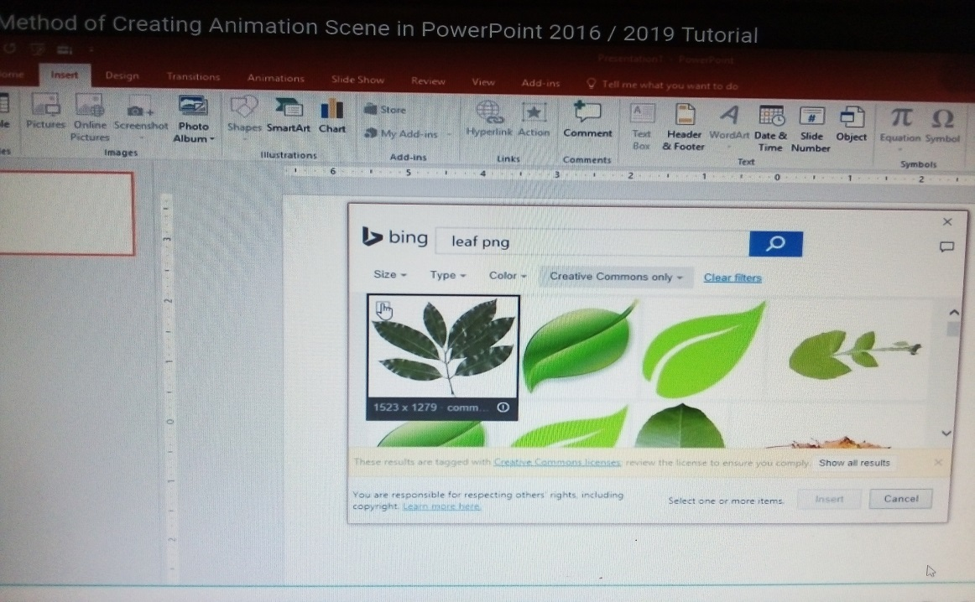

You can select more than one picture in a time by making a check mark on top left corner of each picture.
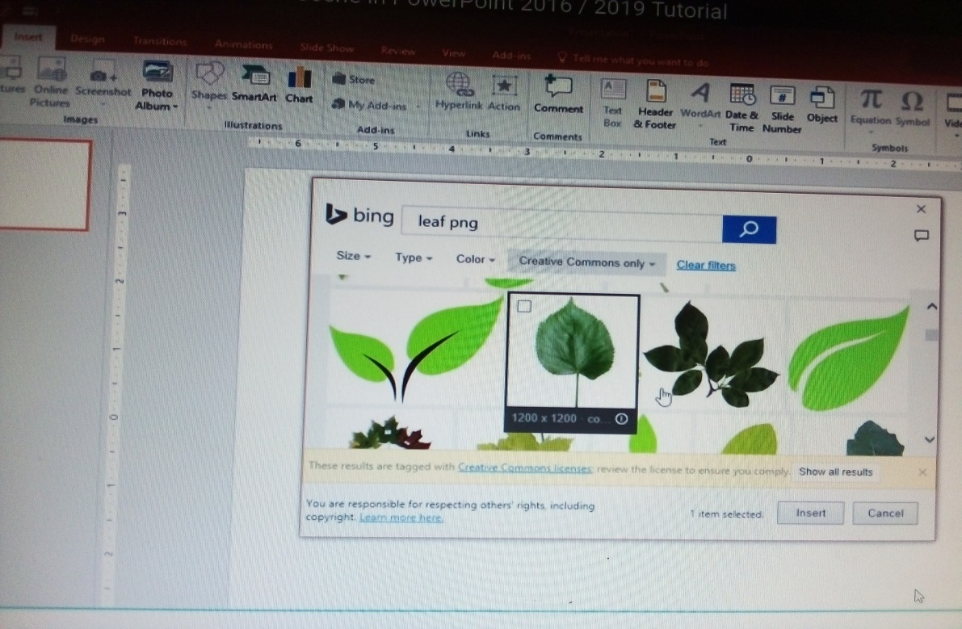

Resize all the pictures. You can hold CTRL+SHIFT+ALT keys to reduce the size proportionally from all sides.

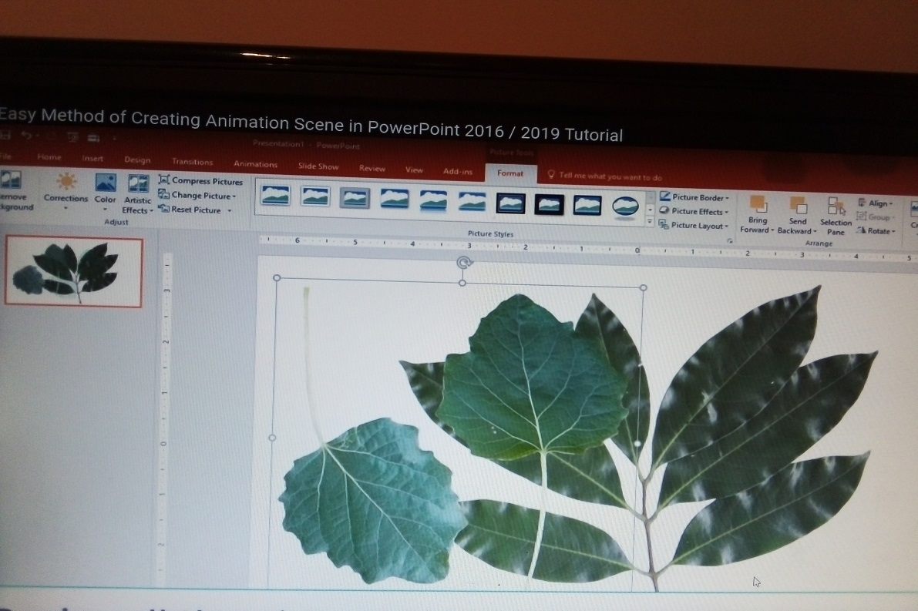

Place all the pictures outside from the slide area.

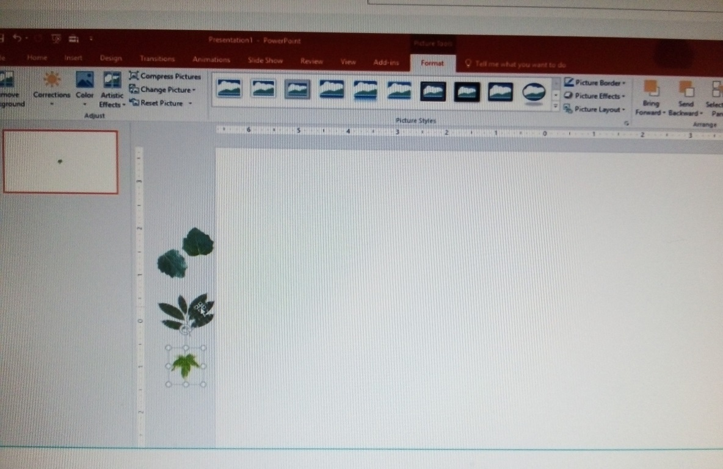

From the Animation drop down menu, select Custom Path.

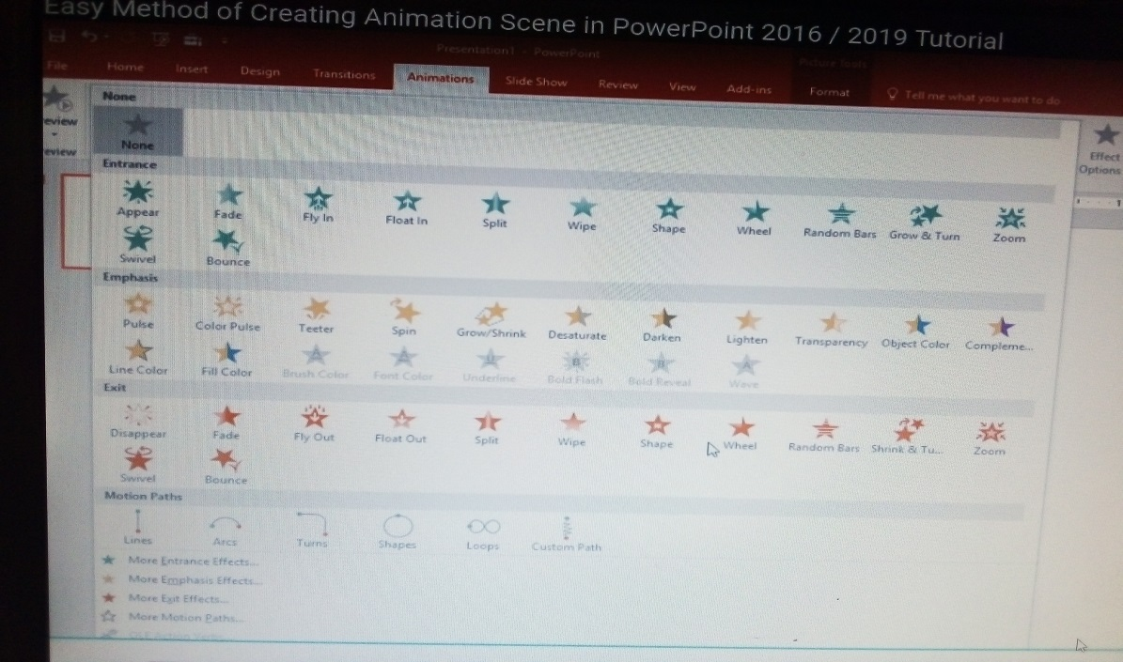
Hold down the Left Click and the path like pencil and double- click in the end to stop the path. Do this for all the leafs. You can duplicate or insert more leafs, if you want.
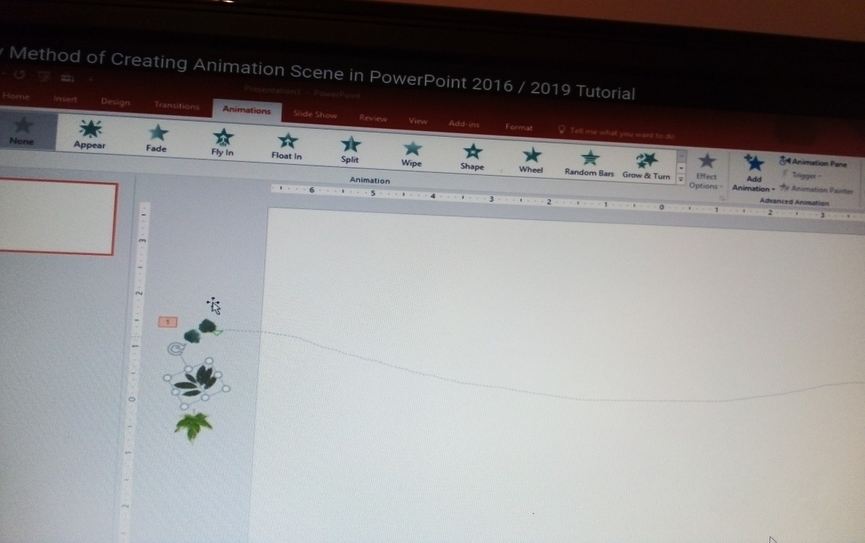

Open Animation Pane and Remove Smoothness from Effect.

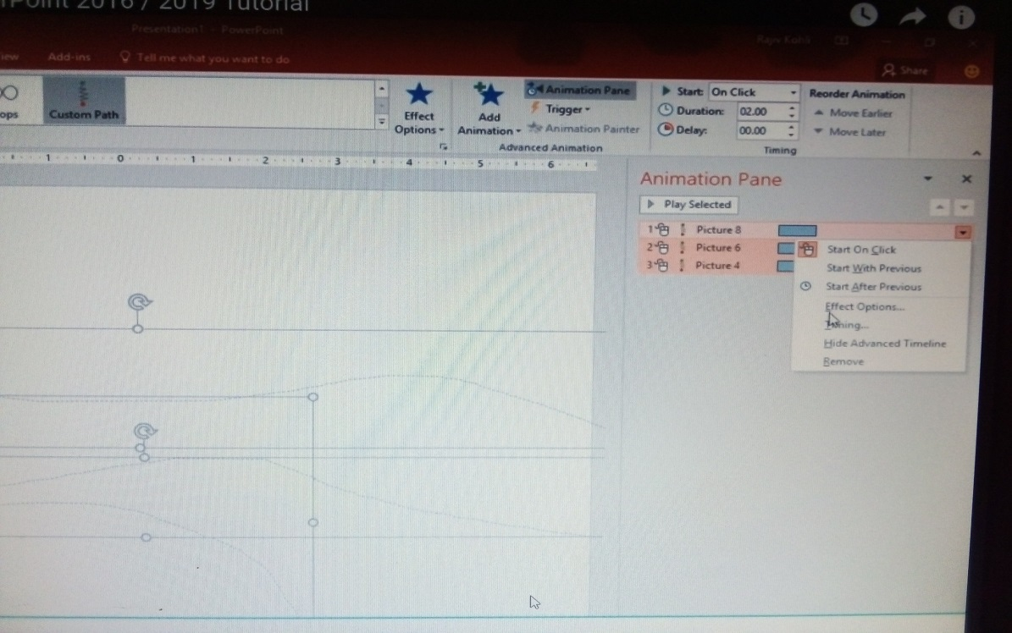
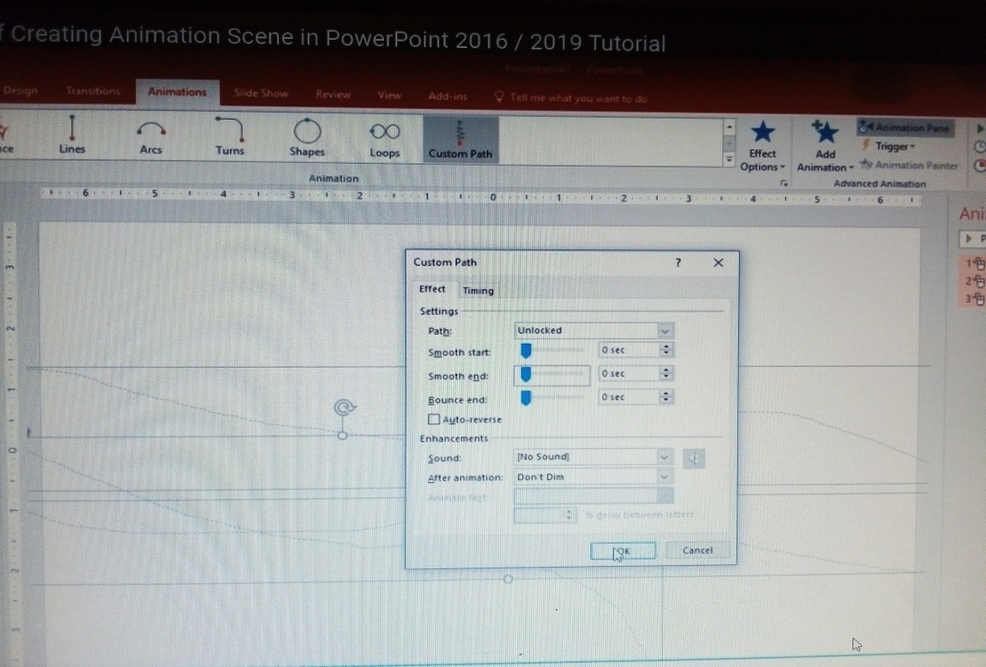

Options and set all of them to Play With Previous.

You can define different timings and delay to each leaf.
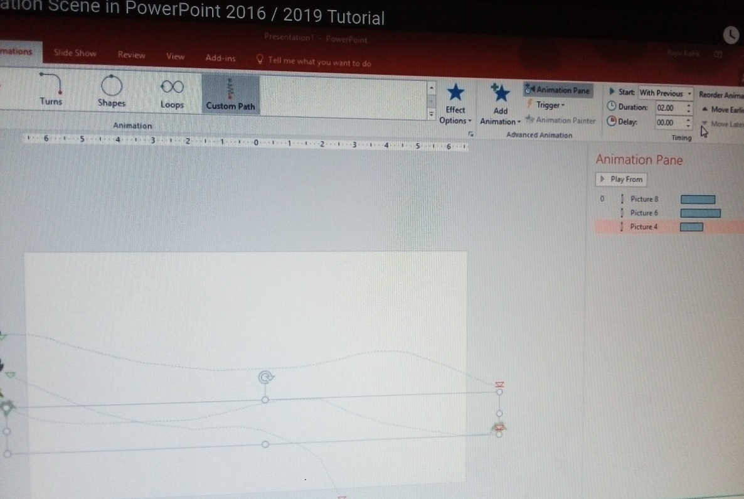

Apply Spin animation to all the leafs. You can even change the rotation and direction of rotation of each leaf separately.

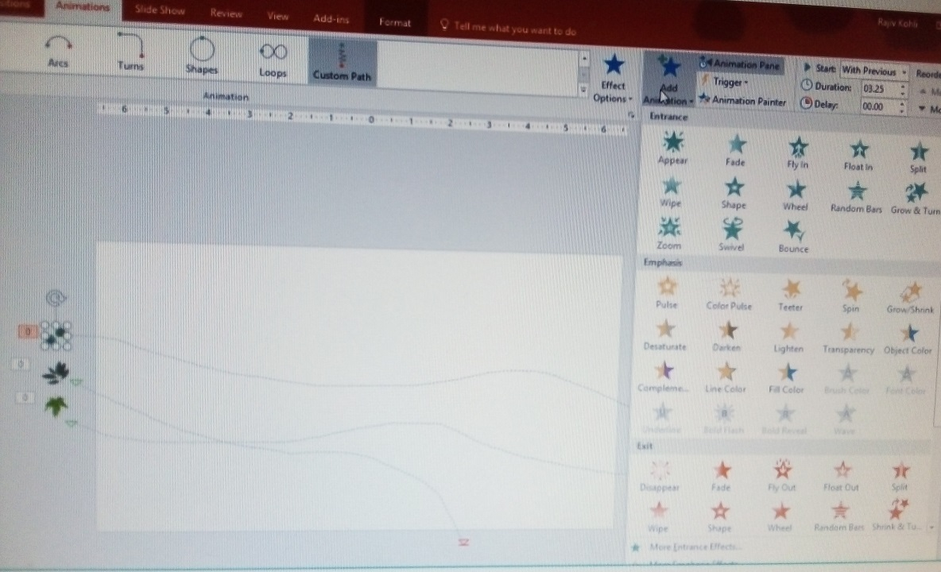

You can change the path or can apply a new custom path and can apply different speed and delay to each leaf.
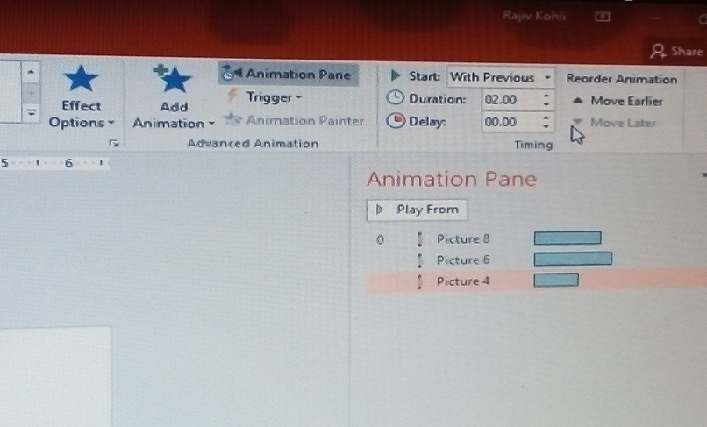

The 3rd important effect is Basic Swivel. Apply this animation to all the leafs and then you can create duplicate leafs.

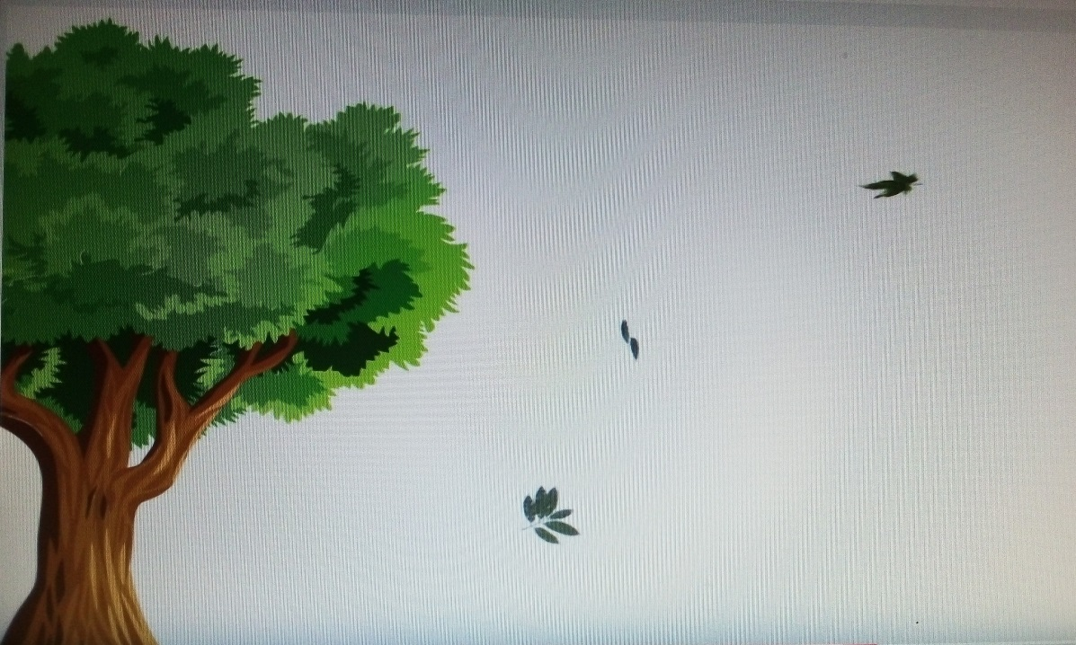

Go to Insert menu- Online Pictures and this time find tree PNG.
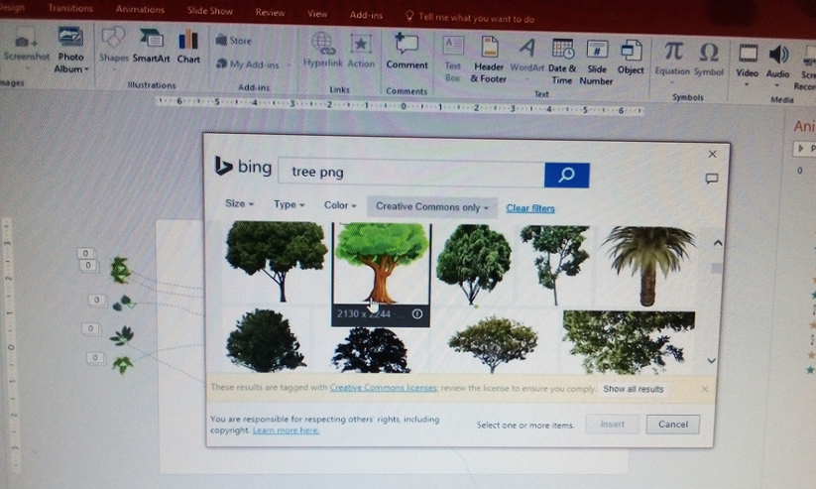
Insert the Tree picture and place it on an appropriate location
.
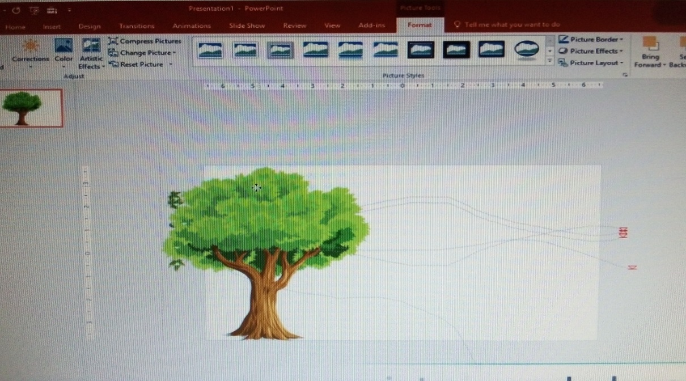

Now look for ANIMATED MOUNTAIN. You can also Google for “Animated Mountain” and look if you can find GIF files.

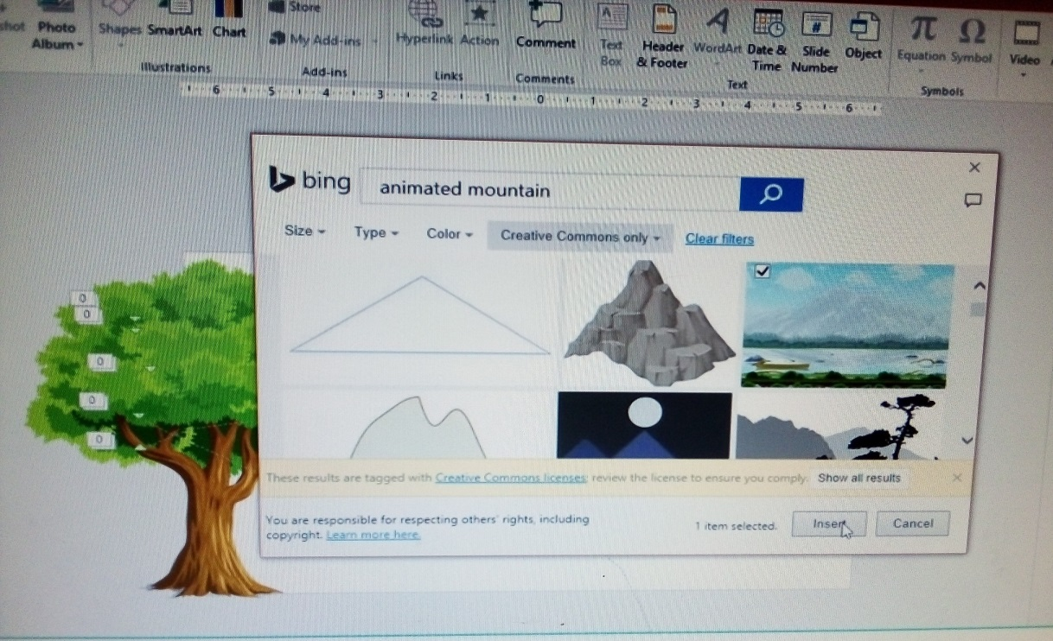

Resize it and send it behind all the other objects.
