Erasmus+ ”Learning is interesting and fun”
Nice, France 10.11.2019 – 16.11.2019

Spanish teachers:Maria José Berengue, Meritxell Teixidor, Albert Ara and Lourdes Manuel

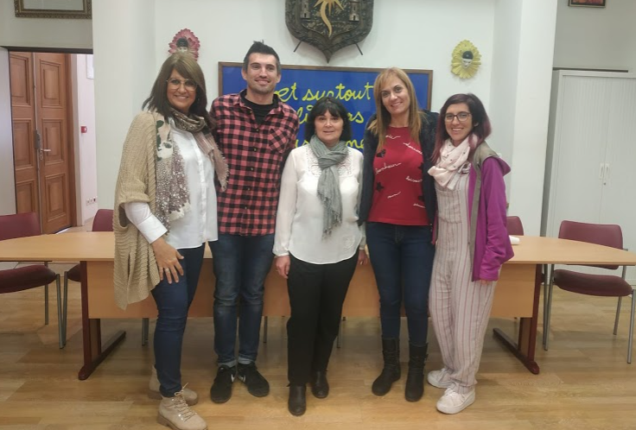

There we meet the other teachers from Estonia, Greece, Turkey in Tourrette-Levens
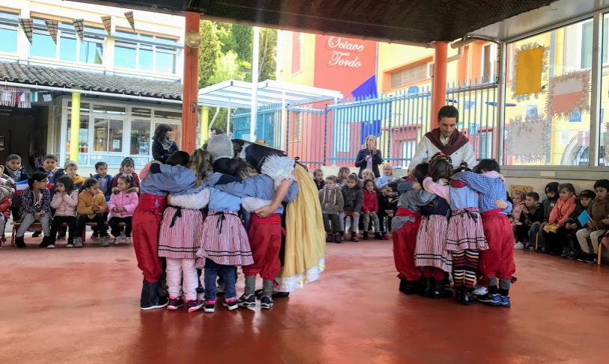

We started the School tour, where we can see how the school is and how they work.
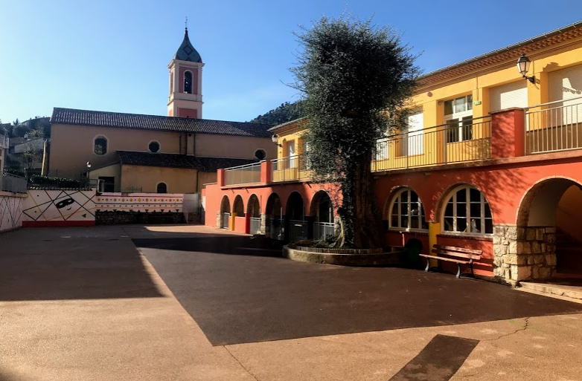

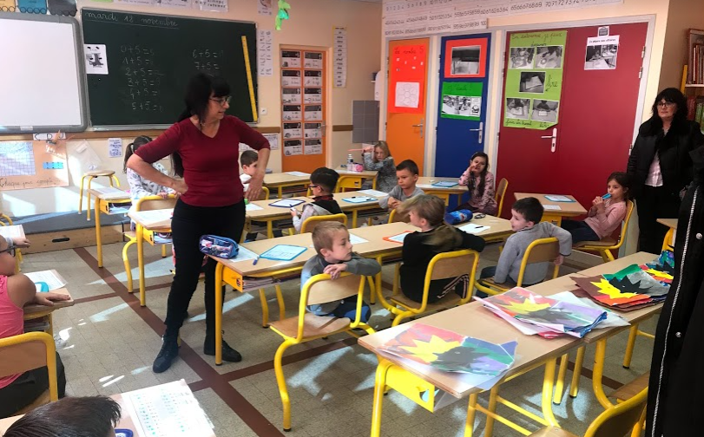

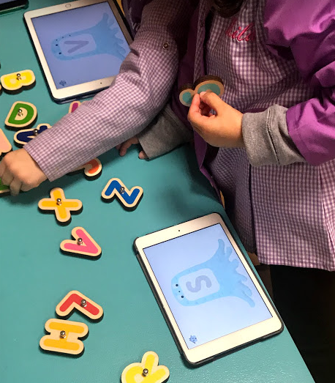

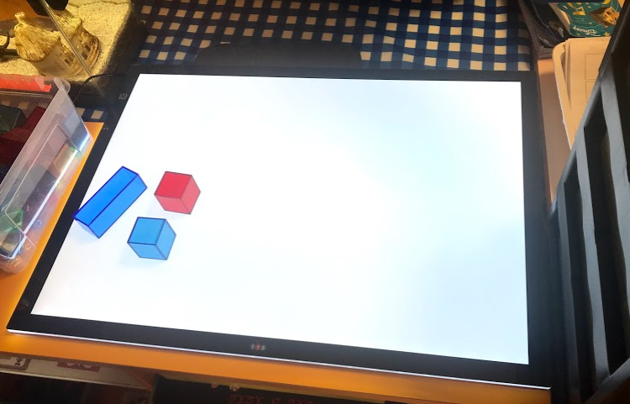

Later, we shared all our Smart Weeks 3 that we have applied in our schools and the workshops, we share teaching and learning tools to be used in our schools with our students.

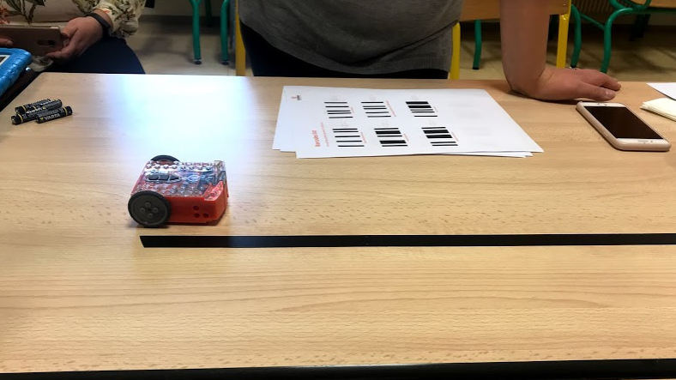

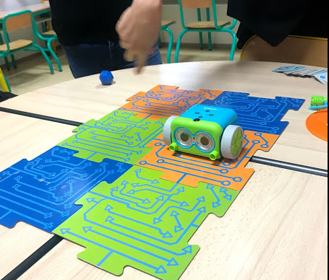

We receive the certificates and leave to our countries to apply all the tools that we have learnt

