Topic: Sounds
What was used: Beebot robot
Fields: cognitive,language
Age: 6 years

Goals:
- children knows which sound of the words begin
- children knows which sound is which letter
- children knows pairing

Activity description:
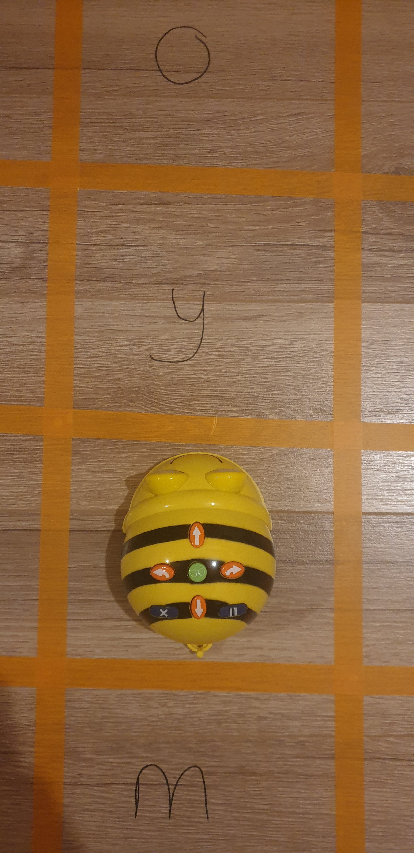
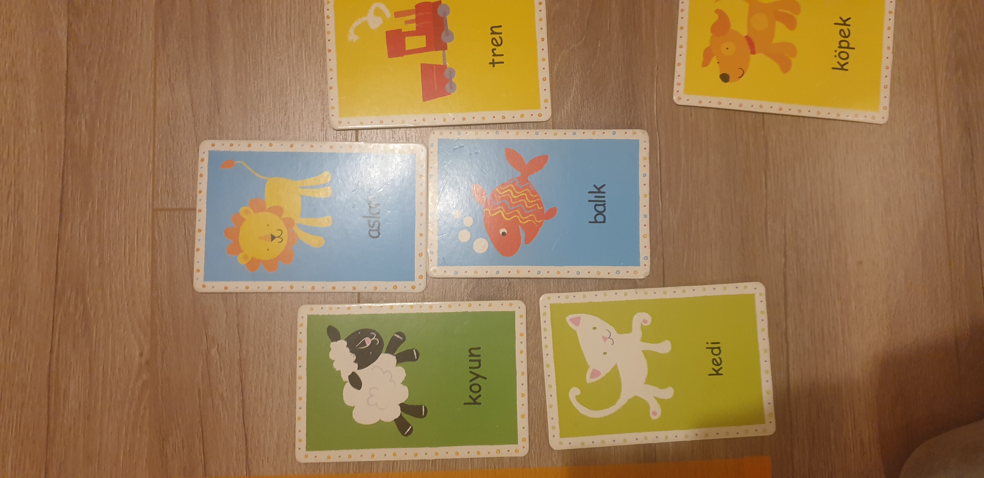
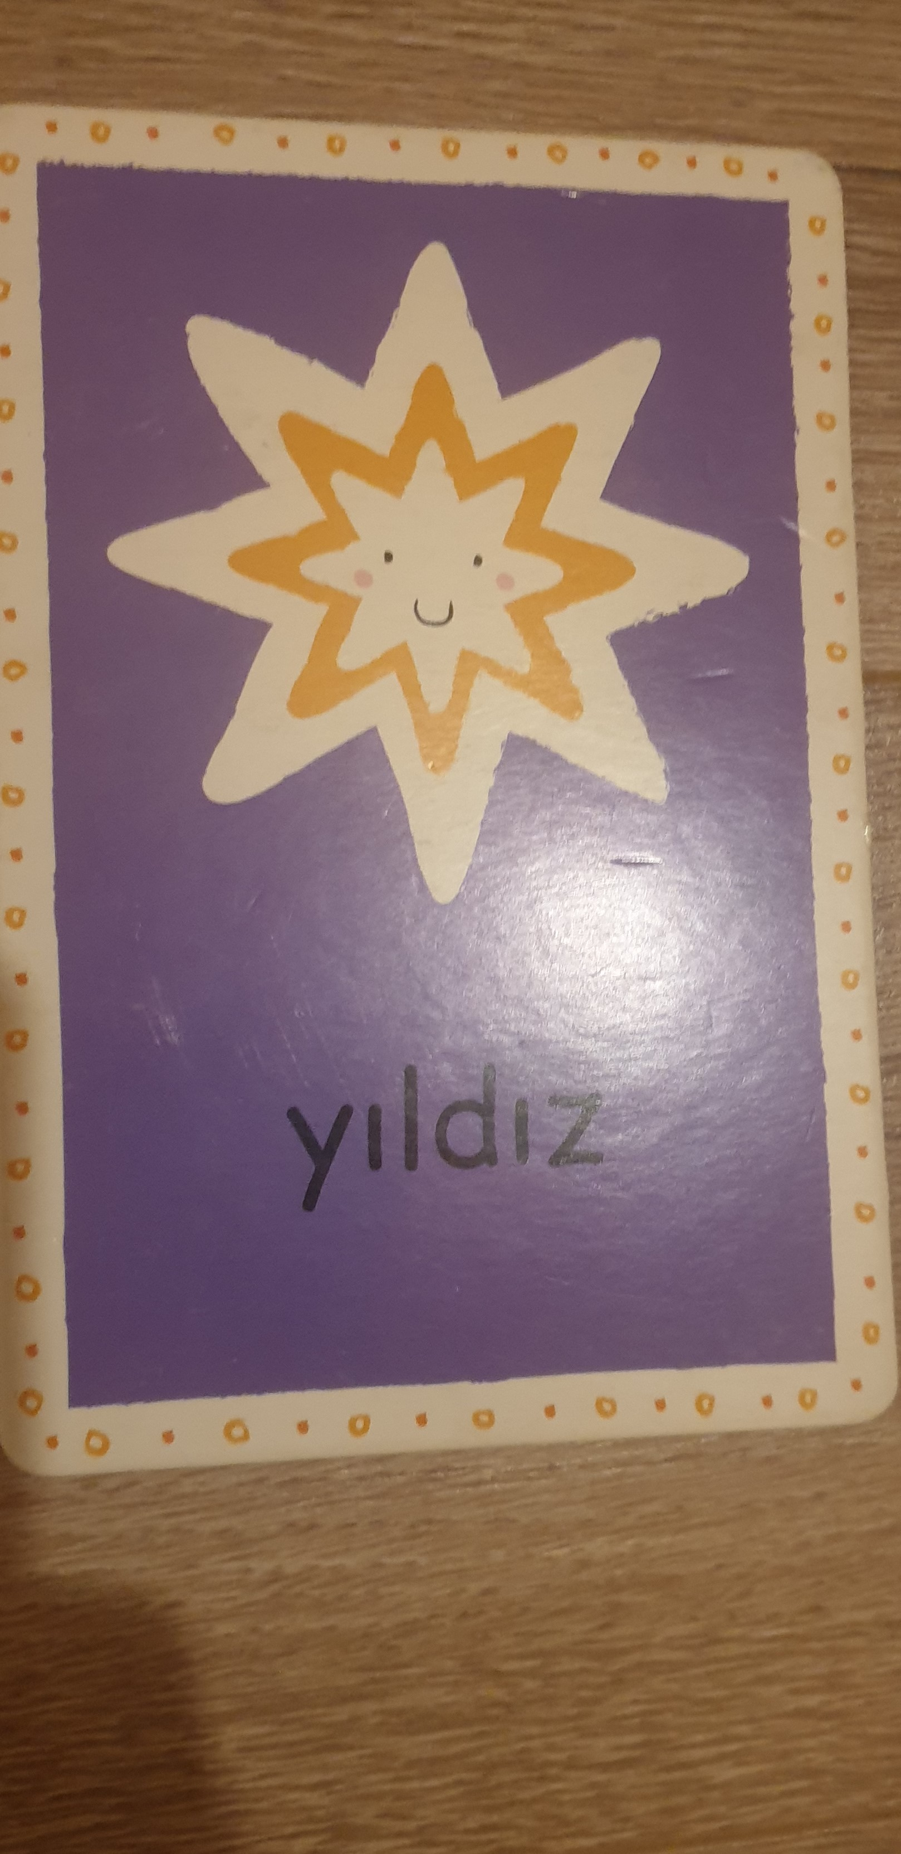
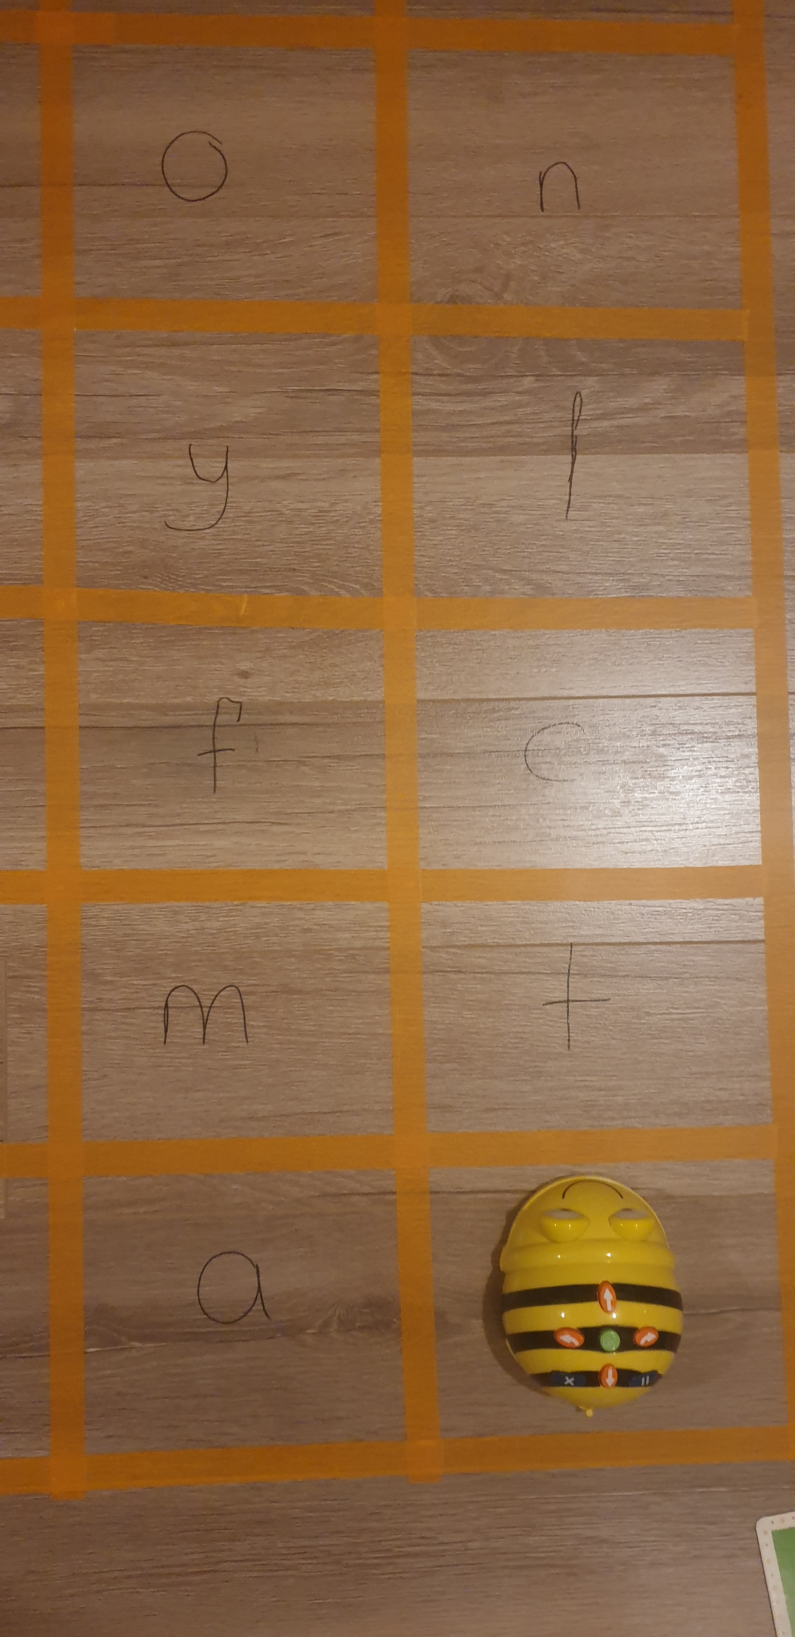
The teacher shows the floor she has prepared for the children in the week of letter and sound exercises with the children. The child in turn draws a card and first makes the sound with which letter the object he draws begins, then finds this letter on the carpet and sends the beebot to this letter.

