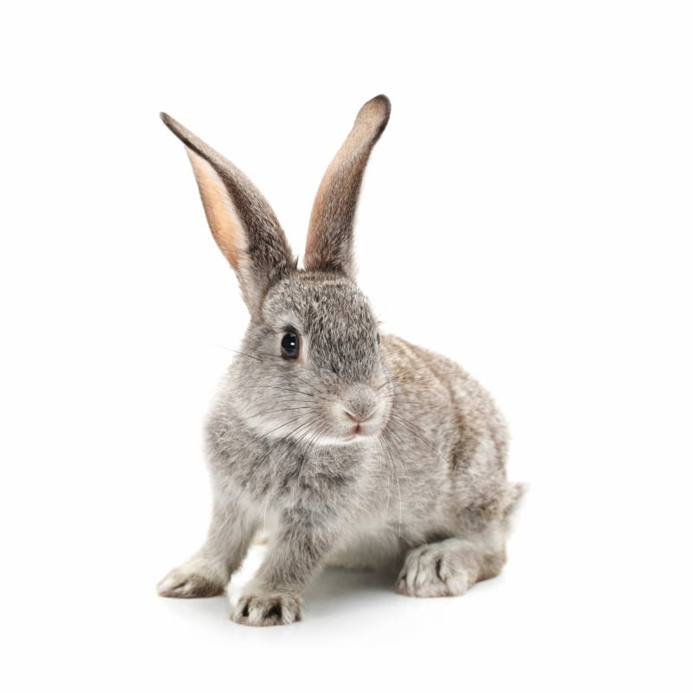
My nam is Maja. I go to the sixth grade in a primary school. I'm twelve years old.
I’m 160 centimeters. I have shoulder - length blond hair.
My eyes are blue.
I dress very loosely, usually oversize. So it's a mix of indie and streetweer styles.
I have three brothers but two of them are my aunt's sons. They are like my brothers because we all live in the same house.
The oldest is nineteen years old and his name is Mateusz, then the younger is fourteen and his name is Krzysiek, the youngest is four and his name is Franek. My mother's name is Monika and my father is Tomek.
My avatar is a rabbit because at home I have a rabbit called Lusia, but I also have 2 dogs Gucio and Sonia and 2 cats Kitek and Fat.
I love animals. I am interested in photography and in the future I plan to have my own photo studio.

