Erasmus+ Transnational Project Meeting  October 10 and 11, 2017 | 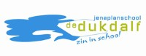
Location : Openbare Jenaplanschool De Dukdalf, Regenboogpad 7, 2317 XK Leiden, The Netherlands
Attendees : Portugal: Ana Pina, Cecília Ferreira;
Italy: Maria Grazia Pipitone, Chiara Audia;
United Kingdom: Louise Bunting, Amanda White;
Slovakia: Alzbeta Krupova, Viera Turianska, Lucia Dovalova;
Turkey: Samet Yumak, Ercan Altas, Mehmet Uygur;
Latvia: Gunita Kelpa, Ieva Zarina, Liga Bukovska;
The Netherlands: Henk Frenken, Annemarie Clignett
Minutes by : Annemarie Clignett
Minutes of Meeting
Tuesday, October 10, 2017 (09.15 – 16.00 hrs)
- Introduction by Henk Frenken, director De Dukdalf
Henk introduces all the teams and Annemarie, who will prepare the minutes of meeting.
Then Henk tells us something about the history of Leiden and the Spanish occupation.

Announcements:
- All photo's/minutes/reports will be put on eTwinning;
- Annemarie will make a Whatsapp group;
- The wifi code is given;
- Pictures from this morning (arrival at de Dukdalf) are included in these minutes.
Programme of today:
- Today we will listen to and watch the presentations of all partner schools before and after the coffee break;
- We will have lunch together with the teaching staff (1 vegetarian);
- After lunch we will look at the different project logo's and we will choose one to use in the future;
- After that we will discuss the questionaire about the school profile (Positioning the School in its Context);
- Because today we will have a photographer at school, we will also take pictures of all the partner schools together. Everyone will get a picture as soon as possible;
- The future time table will be established, with travel options for the upcoming meetings;
- And diner will be served in Leiden.

Tomorrow, October 11:
- Henk really wants everyone to see the movie "Alfabet" – about curricula around the world and socio-emotional learning;
- The partner schools will be attending classrooms with songs/stories about their home country in English for the students;
- After lunch break tasks will be divided;
- Further co-operation will be prepared by discussing the theme "Explore yourself" – gathering important facts and aspects from partners' culture which influenced the most on cultural identification in each country. Exchanging ideas between partners to get knowledge about partners' cultures (historical, cultural, religious aspects, important symbols);
- The programme for Thursday, October 12 will be presented;
- Diner in Leiden.
- Presentation of the Partner Schools
For us to get to know what all the partner schools are about, we watched with much interest all the presentations. Unfortunately we did not have the possibility to make photographs of all the schools.
Before lunch the following schools presented themselves:
- Italy

- Slovakia

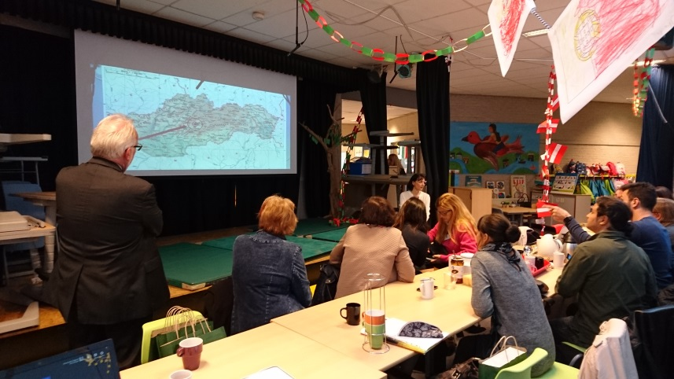

- Turkey

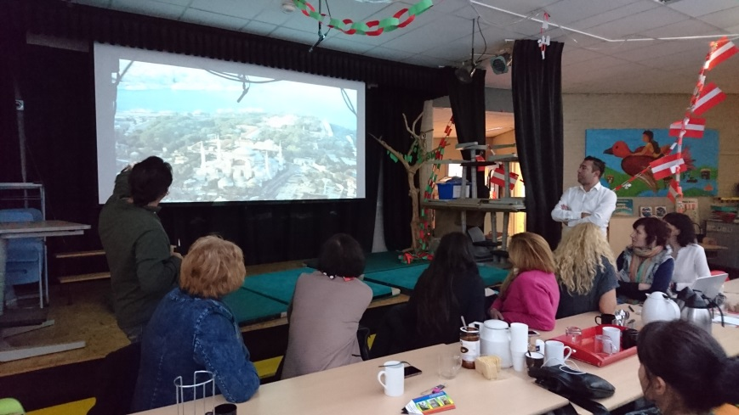

- United Kingdom
After lunch, the following schools presented themselves:

- Latvia
- Portugal
All presentations are found on eTwinning.
- Presentation of the Project Logo
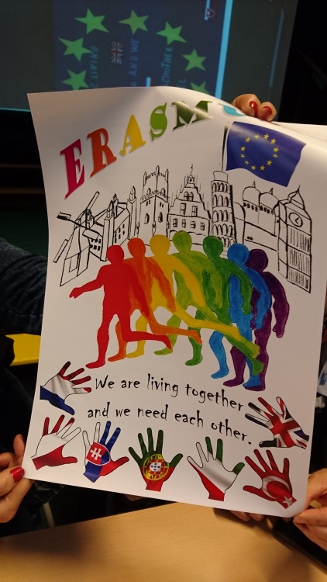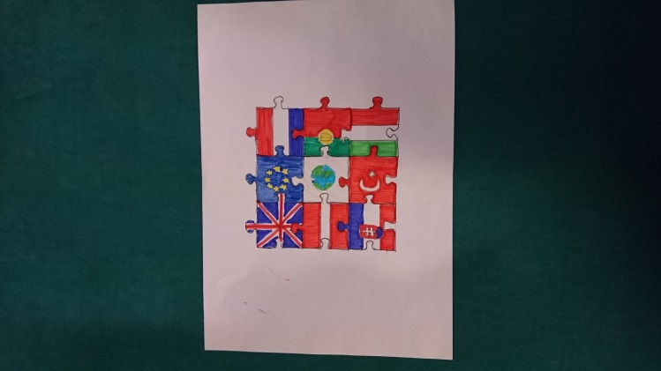
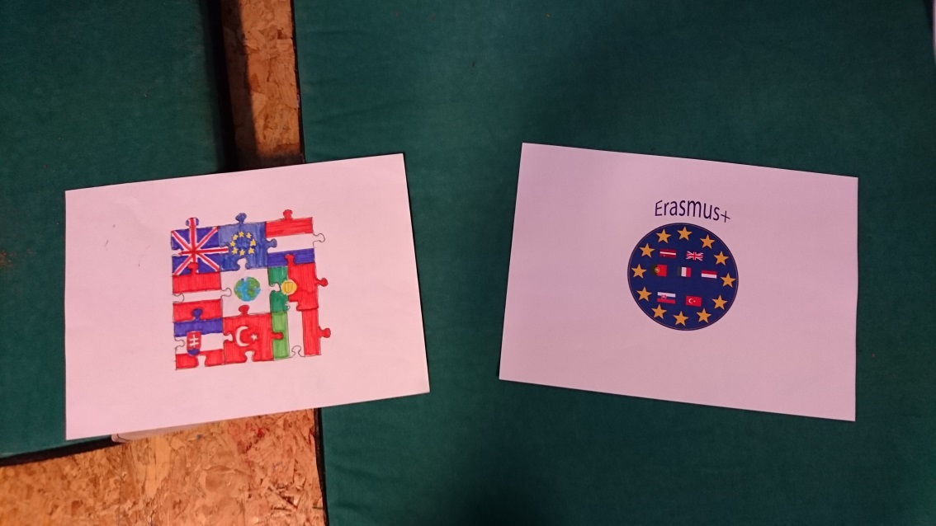
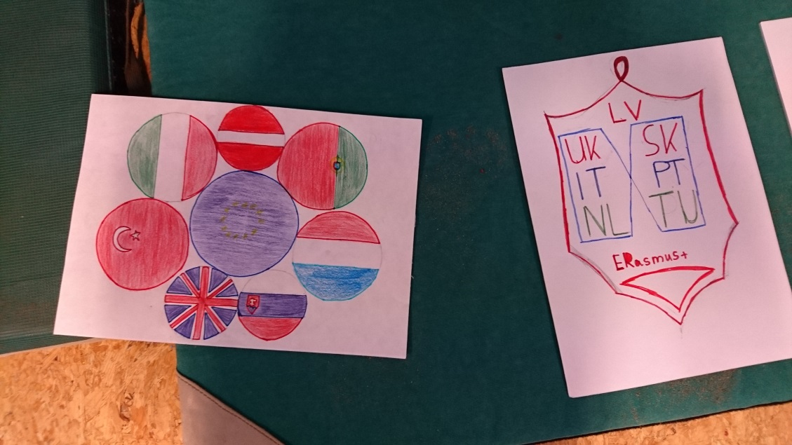
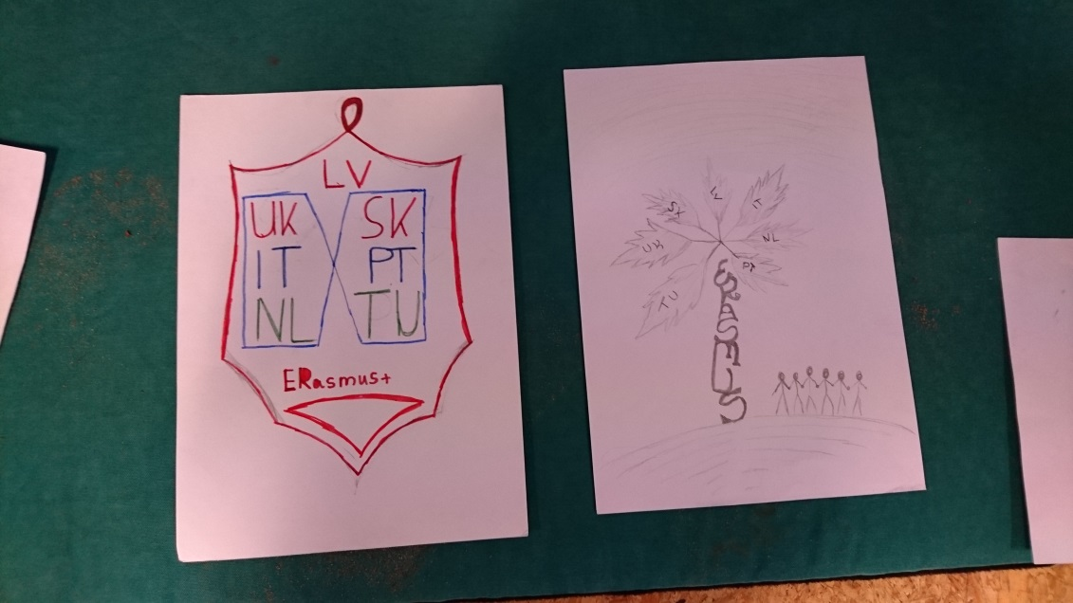
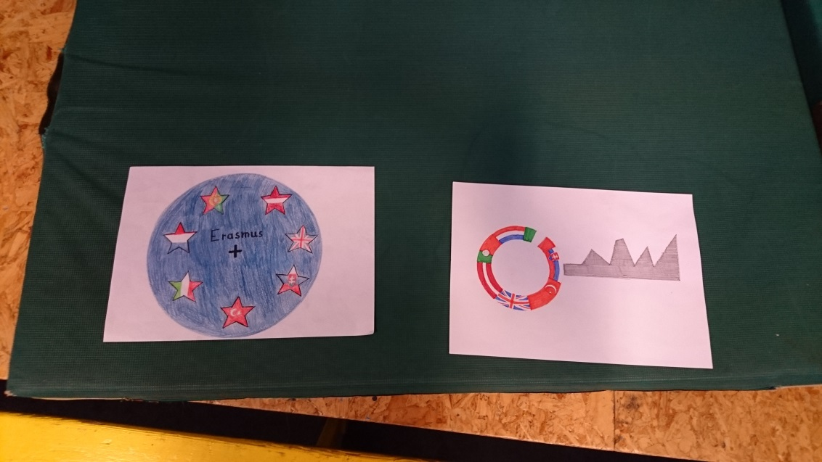
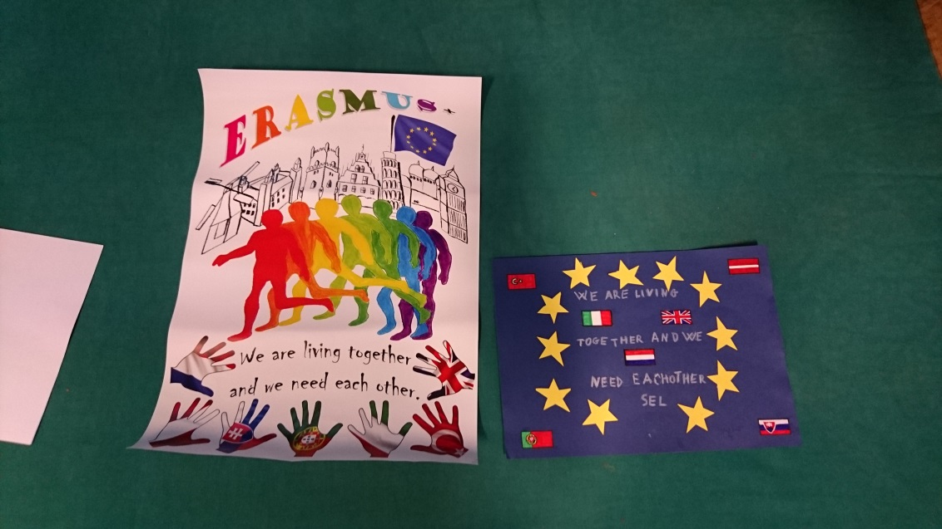

The winning logo:

- Questionaire about the School Profile
A discussion took place about the questionaire which every school had filled in.
Some of the remarks:
Henk asked everyone about their opinion while filling in the questionaire. It took some time for everyone to form their answer.
"It was alright, we had to think about the organisation of the school".
Henk: it is very important how your own mindset is. Important for socio-emotional learning. It influences your role as a teacher. If you have a fixed mindset (Carol Dweck – pedagogical – fixed/growth mindset. Fixed: routine, do not want to learn new things. Growth: study, grow in your way of education – dynamic proces).
You need teachers who have a mindset to allow socio-emotional learning. It is about the wellbeing of children.
We have a lot of participants: is everybody willing to influence children into growth mindset? We/the children need 21st century skills – also ICT, cooperation, respect, responsibility to accomplish that. How do we handle that?
Turkey: we agree. Now we have computer lessons, 5 years ago we didn't. Change computer lessons into coding. Integrate ICT into all other lessons. It would be easy for the children, they are using it now.
Henk: is ICT a plus to socio-emotional learning? How does using phones influence socio-emotional learning? Do you need teachers in 5 years? You can find everything on the computer. That are questions which need to be answered today, about which we have to think about today.
How do we fill the project socio-emotional learning? We have to discuss how we think about it.
Ana/Portugal: you can only make friends in real life, not online. It is important to get to know each other.
Turkey: so we can say we are losing socio-emotional learning skills because of the phones etc.
Ana: you can do both.
Italy: social contact is face to face, not online messages. For children it is important to have real contact, they learn to think.
Henk: you need other people for socio-emotional learning. We are afraid to make mistakes, but without mistakes you don't learn. In education we measure children on the mistakes they make. We need to look at children at how many things they do okay and focus on that.
Everybody has their own talents. Ranking list: on top and the poorest one. When you take out the lower one, the one above will be the poorest one. The problem is not solved. That's the problem with comparing.
Important is also how close you are in the relationship between children/parents/teachers.
Schools vision: Jenaplan (Peter Peterson, professor in Jena), same time as Maria Montessori. Vision based on social behavior. Idea: you are part of a family, learn from people with different ages. So the classes were mixed with children with different ages.
Everybody has the right to be the person you are.
At de Dukdalf, for example, we have:
- 3 classes 4 year old (group 1, around 25 children);
- 4 classes 5-6 years (group 2-3). The smaller children have the opportunity to play in the corners and they learn from the older children. The older children can play too;
- 5 classes (group 4-5);
- 3 classes (group 6-7);
- 1 class (group 8).
All classes have two different ages. This way, the children learn from each other. We have to prepare them for a future which is unknown. To accomplish that, we have to use multiple intelligences.
Now: enquiry learning is becoming important within teams/projects: solving one question using multiple disciplines. For example: which animal has the biggest poo: how much does the animal eat etc. (child from 5-6 years asked the question). Involve children in their own education management.
Next meeting we will elaborate on this subject by exploring how the different cultures can contribute to socio-emotional learning in school and help the children to develop a growth mindset.

- Establish the Time Table
Time table for visits:
Slovakia:
- January 15-19 (travel on 14th)
- Via Bratislava (3 hours to Badín by bus), Budapest or Vienna (1 hour to Badín). Budapest is closest, pick up can be arranged (about two hours travel). Budapest is better to economize.
- 4 students, 2/3 teachers.
Latvia:
- June 17-22 2018;
- fly to Riga, 4 hours by bus;
Italy:
October 8-12 2018;
United Kingdom:
- March 2019, to be planned during visit in Italy;
- 2 students, 2 teachers;
Portugal:
- June 2019, to be planned during visit in the United Kingdom;
- Final meeting.
- Closing
Annemarie will prepare an evaluation form via Google forms – some simple questions – Ana will provide a template.
Henk closed the meeting at 16.00 hours. All present attended a diner held at "Restaurant Panda" in Leiden.

Wednesday, October 11, 2017 (09.15-16.00 hrs)
- Attending classrooms with songs/stories about home country in English
Everybody was divided between the different classrooms and provided songs/stories/craftwork to do together with the children. This was a big success!
- Dividing Tasks
The programme for the next trip to Slovakia in January 2018 was prepared.
- Explore Yourself
Important facts and aspects from the partners' culture were discussed, which influences the most on the cultural identity. Several ideas were exchanged (historical, cultural, religious aspects, important symbols) and resulted in the following subjects for activities:
- Cookbook with typical traditional dishes per country. This Cookbook will be extended with every visit to the different countries. The recipies will be accompanied by pictures of the dish;
- School activities during Christmas/New Year and activities during this time in the different countries.
Sending Christmas cards to the partner schools by the children.
- Traditional professions;
- Traditional costumes and dances;
- Learning a joint dance;
- Winter Olympic Games.
- Closing
Henk closed the meeting at 16.00 hours and all present attended diner at "Verboden Toegang", a restaurant in Leiden.

De Dukdalf welcomes all partner schools with all the children outside the school.
We sang some songs to welcome everyone: "40 years Dukdalf", "Lalala Leiden", "Pieter van der Werff"
