Teacher-student relationships are key to greater wellbeing

Effective teacher-student relationships are intrinsic to student wellbeing including their social and academic development. Yet these relationships are also important for maintaining teacher wellbeing with research suggesting that poor student relationships are a determining factor in the loss of self-efficacy and wellbeing.

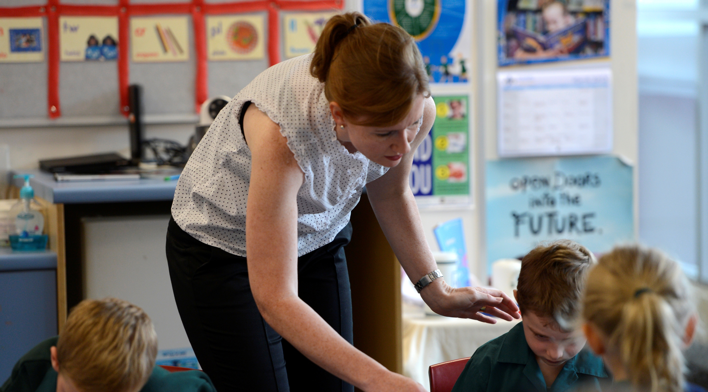

Indeed, according to a 2005 study, teaching is ranked as one of the most stressful out of a database of 26 occupations, with the emotional involvement of teachers with their students seen to be a substantial part of this stress.

This may be because teacher-student relationships are inherently fraught.

How do you keep the balance of camaraderie and authority?

How do you break down barriers erected by students who have been abused, abandoned or otherwise defeated by their relationships with adults in the past?

How do we bond with students who represent our inherent biases? Who don’t meet our expectations or attempt to engage at any level? How do we create trust where trust has been frequently breached?

While focusing on quality positive teacher-student relationships can often be too hard to even think about, the impact they have on teaching and learning is undeniable.

Good teacher-student relationships are the foundation of effective classroom management, of student engagement with content, of achieving academic goals and positive social and emotional development.

In terms of teachers, these positive relationships build self-efficacy, increase engagement with the teaching practice and reduce stress.

Yet learning to build these relationships is not on any curriculum for training teachers, nor is there any real focus in ongoing professional development.

Instead the focus is on curriculum knowledge, something which is compromised if the teacher-student relationship is such that there is little engagement, disruption through problematic behaviour and diminished teacher wellbeing and effectiveness.

Interviews conducted with teachers in 2000 illustrated quite clearly that for most teachers their relationships with their students are one of the main reasons for staying in the profession, yet acknowledgement of the consequences of poor relationships were cited as major factors in teacher stress and negativity.

These interviews emphasise the value that teachers place on their personal relationships with students in their classroom, and demonstrate how relationships that are difficult, based on conflict or alienation, not only threaten a teachers’ professional self-efficacy but their personal wellbeing as well.

Learning how to build these relationships needs to become a fundamental part of teacher training, especially the skills required to build relationships with those students who are going to be the most difficult to engage but are also the ones who are most in need.

This is becoming even more significant with very recent research suggesting that the contagion of emotion in classrooms elevates both teacher and student stress in a destructive loop.

This 2015 study, found a link between teacher occupational stress and student physiological stress regulation and suggested that stressed and burned out teachers experience more challenges in classroom management, have fewer emotional resources to draw on to form nurturing and supportive relationships with students, and tend to be less responsive to students' needs.

This predicts student problem behaviour, greater teacher stress and an increase in student disengagement and tension, creating more teacher stress and so on.

So what are the fundamentals of building positive teacher-student relationships to enhance teacher wellbeing and student learning?

Clearly, relationships with ‘good’ kids come naturally, but teachers can become nervous and anxious with students who exhibit behaviours or have ‘reputations’ that are confronting, complex, or confusing.

Giving these students room to change, to do things differently, comes from showing a level of care, concern, interest and acknowledgement that their lives are quite tough, that they do have some behavioural issues to work on and that your classroom is a space they can feel safe and included.

Social and emotional learning for teachers and practice in self-awareness can help us to recognise that with some students we may automatically shut ourselves down, brace for abuse, be dismissive or impatient, or let our inherent biases and prejudices interfere with our ability to develop certain relationships.

All of which is not a judgement but a nod to the nature of human kind of which teachers are a part.

While skills training will be helpful in guiding us in ways to break through the barriers some students will have erected, we need to also acknowledge that, unconsciously, we may be creating barriers of our own.

Part of this is becoming aware of our verbal and nonverbal behaviours and the messages they may be conveying to our students – for example having a ready smile for one student at the door and a glazed expression for another does not go unmissed even if we are not fully aware of the shifts in our facial expressions.

Similarly, using open and relaxed body language when talking with some students and closed and defensive postures with others, is also very telling for those at the receiving end.

As is having a mismatch between what you’re saying and what you’re doing in terms of tone of voice, body language and expression.

While teachers have an enormous amount of responsibility and expectation put upon us, for our own wellbeing it is necessary to make the efforts required to build and form bonds across the classroom to ensure we, and our students, can succeed.

A range of issues that feed teacher stress can be reduced and even solved if these bonds can be secured and developed, not just for us and our students across one academic year but subsequent years as well.