How to make the recording(s)
We hope you have got/and will get much pleasure out of rehearsing and performing the song. However, the recording sessions call for a different approach and one that needs a good deal of forethought and planning in order to get the best results. The work will require much rigour – calling upon the greatest amount of precision possible from your singers. While it will be lots of hard work, generally we find students enjoy the recording part – as they feel a bit like ‘pop stars' and a bit like they are appearing on the X Factor! You will also thank us afterwards because the resulting quality of your choir’s singing will be awesome as a result of the rigour to which they have been subjected!
We will only be able to include choir recordings on the final master recording that have reached a reasonable standard and, as stated before, recordings being in sync with the supplied choir MP3s is the most crucial factor. We are sure that all of you will manage this!
Getting used to singing while wearing earphones
This requires practice. Many people/students find this hard at first especially as they cannot hear their own voice in the same way as usual and this can raise vocal tuning issues. This improves with practice. It may be useful for some students to experiment with pulling one earphone off on one side so that they can hear their own voice and the voice of others while they sing. If you look at the VATW site photos page you will notice some students doing just this!

Earphone leakage
This is when the sound from earphones is picked up by the microphone you are using i.e. in this case the guide demo track your students are listening to while they sing, is picked up on the recording. Try to eliminate/reduce this as much as you can. It is obviously made worse when the students are close up to the microphone. The more you can reduce this the better the quality of the recording for mixing on to the final track.

Fool proof recording
This feels a little like stating the obvious, but it is worth reminding ...... that when recording choir parts, make sure your students are listening to the demo track as a guide. To inspire yourselves before you record you could enjoy watching the YouTube video of the studio session for recording ‘We Are The World’. This is a great resource and makes a superb music quiz for older students …can they recognise these icons of the music industry …..you are helped by the credits rolling at the end of the clip! http://youtu.be/M9BNoNFKCBI

How to get as close to a ‘pure voice’ sound as possible
We need the voices of your choir to put on the final master recording. This means that your recording(s) should only be voices! In other words, we do not want a recording of your choir that includes the backing track in the background. This would lead to quite an unpleasant sound when we come to put all the recordings together – making the final mix. We want you to set up your recording so that the students listen to the backing track on earphones while singing. This of course pretty much mirrors the way it is done in professional recording studios. ‘WOW that sounds difficult’ we hear you say! NO not at all....here is what you do:
1. Ensure you have reasonable quality recording equipment. A basic microphone and recorder should do the job. Nowadays, these pieces of equipment are easily available at reasonable prices if you do not already have them. You may find somebody in your school parent community who can help out.
2. You need to have sets of earphones and a junction box/junction boxes....the more the merrier! See the picture of a typical junction box below ... this feeds from the sound source where you are playing the choir part MP3s while the students sing.

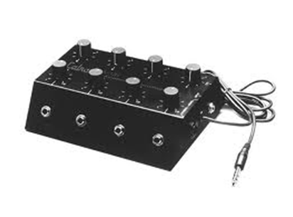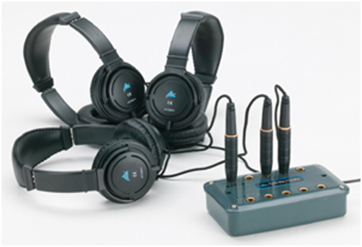
This approach means that you can record groups of your choir singing ...the number of groups you record will depend upon the number of earphones you have available ... the more earphones you have ....the fewer the groups. Working in this way means that when you record, your singers can hear the music backing, but the recording only captures their voices. Within reason we are happy to accept any number of recorded groups from you. All of your recording submissions should be in wav file or MP3 format.
Recording groups.
The groups that you record will require some forethought. The obvious format is to require different sections of your choir. However, you will inevitably have some variations in the quality/confidence of your singers. We have sometimes found ourselves breaking sections down i.e. a stronger section of the best singers recorded, then other groups where some of the best singers support the singing of less confident individuals.
How to get the best sound - the recording environment
It is well worth choosing the room in which you record very carefully. Smaller rooms with soft furnishings will often give the best results.
Microphone placement - The distance of your singers from the microphone is important and it is worth experimenting with this a little. It varies a bit from microphone to microphone. Successful recordings we have done in the past have been with students arranged in a semicircle around the microphone so that they are all a similar distance away. About a metre from the microphone is often about right for choir work. It will be good if you are able to monitor the sound levels and quality using earphones yourself, and adjust choir positions/proximity to the microphone accordingly. In particular watch out for any singer with a much louder voice than others and adjust their standing position if necessary. You may find this problem is exacerbated because students may sing differently with earphones on (known as the IPod syndrome!). Be careful that you do not ‘over record’ i.e. have a recording level that causes distortion of any sort – this would make the recording unusable for us.
Key teaching tip: Your singers do not have to sing loudly
The joy of audio recordings with microphones is that you do not need to sing loudly – pitch and tone are far more important. The volume of your singers can of course be boosted by the recording equipment as necessary. As mentioned above ‘over recording’ and distortion are the main ‘enemies’. In the process of finally mixing vocal submissions we can usually work with recordings that were rather low volume – boosting the volume with our studio equipment. Sadly there is very little that can be done with distorted/over recorded submissions.
Extraneous noise.
You will need to take care that there are no extra sounds on the recording. There are many hazards in any school environment for someone trying to make a recording! Typical problems can be school bells, kitchen or air conditioning equipment and …..of course …PEOPLE! We have had some interesting recording sent in at times…one actually had chickens clucking in the background!

