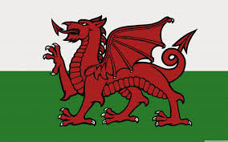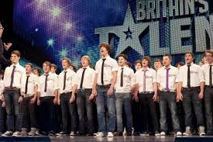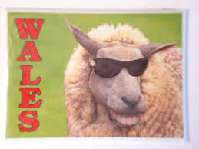

The world thinks we can sing and that we do sing a lot!

**Also the world thinks we love sheep because we are Welsh although there are more sheep in New Zealand than Wales!**