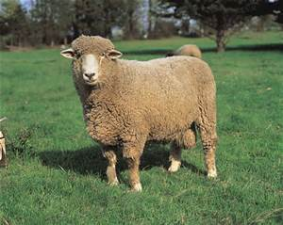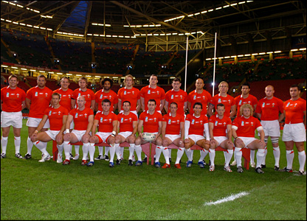

We are known as people who love sheep

We Sing the Welsh anthem when the rugby is on