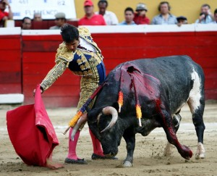

Their favourite animal is bull

We think that they are torero bullfighters

They love bulls