eRASMUS
Small Towns In Europe: identity, challenges and opportunities
Active citizenship- Bilbao
STUDENTS’ PREWORK

Active Citizenship is the participation in civil society, community and/or political life, characterised by mutual respect and non-violence and in accordance with human rights and democracy.
The dimensions of Active Citizenship are: participation in Political Life, Civil Society, Community Life and the Values needed for active citizenship (recognition of the importance of human rights, democracy and intercultural understanding).

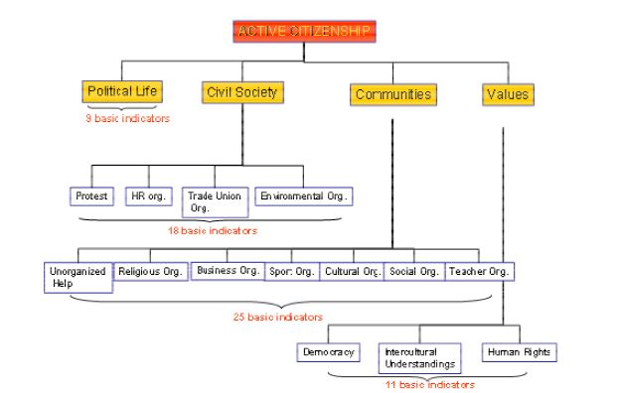

Before the Meeting in Bilbao we will ask you to do the next tasks connected with your community and local government, ALL THE INFORMATION COLLECTED WILL BE USED AS MATERIAL DURING THE MEETING IN BILBAO.

LOCAL GOVERNMENT INFORMATION SEARCH (I)

PART 1: DEMOGRAPHIC PROFILE

Name of your community (city/town, county, country) _____________________________________________________________________________

- What is the average age of the population?________________________________________

- What percentage graduated from high school or higher?____________________________

- What is the percentage of families below the poverty level? _________________________

- What is the percentage of families in your country below the poverty level?________________

- What other observation can you make about your community based on the census data profile?

- What problems might your community face as a result of the data described above?

PART 2: POPULATION CHANGE

- Did the population of your community grow or decline between 2000 and 2016?__________

- What was the percentage change (growth or decline) from 2000 to 2016? ________________

- Can you think of possible reason(s) for this growth or decline?
__________________________________________________________________________________________________________________________________________________________
____________________________________________________________________________

- Is the change in population good or bad for your community? Or both? Why? _______________________________________________________________________________________________________________________________________________________________________________________________________________________________________

LOCAL GOVERNMENT INFORMATION SEARCH (II)

CITY´S NAME COUNTRY

RESEARCH | Information on your Local Government
- What is the form of your local government (for example, mayor-council, council-manager)?
- When and where does your local government meet?
- Are any meetings open to the public? If so, which ones?
- How long is the term of office for the elected officials in your local government?
- Are the members of your local government appointed, elected by district, “at-large,” or some combination?
- How many members are in your local government?
- How many of them are women?
- Which is the ages average among the members?
- What is the youngest member´s age?
- How many political parties are represented?

Is there anything else that you want to remark? ...................................................................................

OBSERVING LOCAL GOVERNMENT

Members in attendance: _________________________________________________________
_______________________________________________________________________
Location and Date ____________________________________________________

- Is this a regular meeting or a special hearing?  - Is there an agenda available? If so, staple a copy with observation. If not, why not?  - Who is in charge of the meeting?  - Does this person decide who speaks?  - How many citizens were in attendance? What was the role of citizens in the meeting?  - How did the meeting begin?  - Who introduced the resolutions and bills? (clerk, legislator…)  - How is a vote conducted?  - Did the meeting involve testimony from any outside agency or expert? | Does this person decide who speaks?
How was the meeting concluded?

- Summary of the Meeting

- Sketch of the room layout (draw in other page)

Now that you have completed the “Observing Local Government in Action” handout, use the information that you collected to answer the following questions.

1. Would you describe the meeting as formal or informal? Do you agree with this style?

2. Is there significance to the layout of the room? Does the layout indicate positions of importance? For example, do more senior members of the government have more desirable seating locations, or do members sit alphabetically?

3. Describe how one issue/topic was discussed. What did you agree should be included in the discussion? What do you think was missing? Was every voice heard? What voices were missing?

4. Do you think that the style of government you observed gives fair access to citizens? How would you change it if you could?

5. Does the public have access to the meeting you observed? If not, how can this be improved?

6. Many governments and individual organizations require that citizens have access to all open government records. Does the public have a way of finding out what will be discussed at the meeting? How can this be improved?

