Finland, the land of the thousands of lakes:
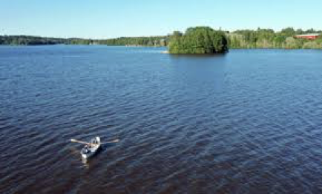

Sedu Ilmajoentie is answering to:
EPL LOZERE, Saint Chely d''Apcher, France
Legta Louis Pasteur, La Canourgue, France
Spojená škola SNP 30, Ivanka pri Dunaji, Slovakia

Answers to our school presentation:
Tour 1:
What two exams are available in our school?
Animal Health Care and Rural Technologist
Animal Attendant and Rural Entrepreneur
Animal Attendant and Rural Economics

How many line of business do we have?
four
two
three

What kind of place is the “Vauhdittamo”?
classroom in where you can give fast answers
classroom in where you can relax
classroom in where you will get extra support to your homework and exercise

Do we have own students’ apartment?
yes, we have own students’ apartment in our school area
yes, we have own student’s apartment outside of school area
no, we have rented our students’ apartment

Tour 2:
For how many years we have rent our cow shed to individual dairy farm?
five years contract
ten years contract
fifteen years contract

What kind of operation we have made with the piggery of our school farm?
we have own piggery in our school farm
we have rented the piggery for animal husbandry purposes
we do co-operation with individual pig farm

What kind of system we have with the small animals’ education?
we have own buildings for small animals’ education
we do co-operation with individual veterinary homes, pet shops and companies
we have rented own veterinary home

Tour 3:
What are the name of the tractors’ we use?
Valtra and John Deere
Valtra and New Holland
Valtra, Fendt and Case

How many excavators do we have?
five
three
two

What functions do we have in our tractor simulator in our education?
tractor and car
combine harvester and forklift truck
tractor, combine harvester, excavator and truck

Tour 4:
Because of our climate conditions we can get per growing season?
two grass and one grain harvest
three grass and two grain harvest
three grass and one grain harvest

What group of plants do we normally grown in our school farm?
oat, barley, wheat, tomato and grass
oat, maize, rye, salad and grass
oat, barley, wheat, rye and grass
Tour 5:

How many hectars forest areas do we have in use?
140
180
160

Do we have construction education in our school?
yes, we do
yes, we do, but only during autumn period
no, we don’t

