
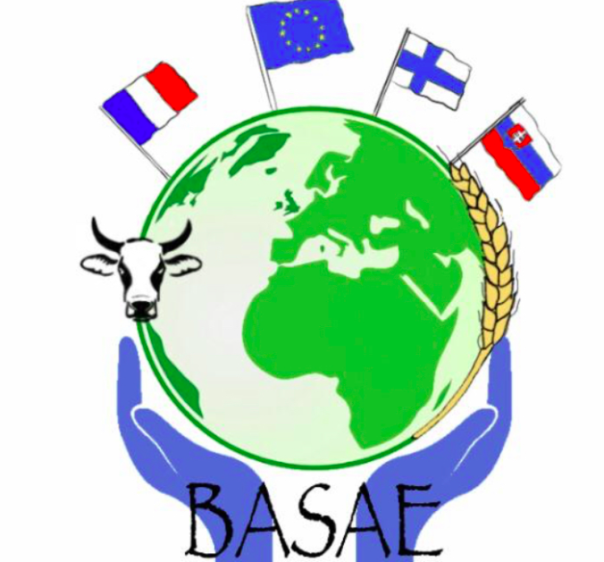
BASAE PROGRAM IN FRANCE
13 -17 juin 2022

Dimanche  aéroport  12 juin | Mon  13 june | Tuesd  14th | Wed.  15th | Thursd.  16 th | Friday  17th
Accompagnateurs
2 drivers  Mrs Petit  M. Martin  Mrs.Vega | Mrs Vega  Mrs Payne  Anaïs | Mrs Vega  Mrs Chaleil + Mme Marouzzi | Mme Vega  Mme Payne  Mme Chaleil  M. Hanssens | Mme Vega  Mme Chaleil  + M. Cazoux  M. Hanssens | Mme Vega  Mme Petit ?
Activities during the morning | 7h00- 8h00  Breakfast-canteen  Welcome reception +  Ice-breaking activities  Preparation time to present the game to other middle school and high school students in Lozère | 7h00- 8h00  Breakfast-canteen  10h00:  Workshops organised by “La Masion de l'Europe de Nîmes”  “The Green Pact” | 7h00- 7h40  Breakfast-canteen  Game presentation to middle school students + play time - in the village of Mende / Visit of the village of Mende | 7h00- 7h40  Breakfast-canteen  Village tours Quézac +  Sainte Enimie | Depart to Clermont-Ferrand
Lunch time | Lac de Moulinet  Restaurant | 12h-13h  School canteen | 12h30  canteen at La Canourgue | 12:00  Picnic
Activités- après-midi | Hiking + swimming  Moulinet lake | 14h30  Game presentation to middle school students + play time - collège “Haut de Gévaudan in St Chély d'Apcher” | -  15h -17h  Official ceremony + Europass mobility ( multipurpose room)  Students will present a power point to explain the project, a video with all the pics and vidéos they have taken + game presentation  Snack time | 13h00 -17h :  Aquatic activities (kayak- 13 km)
Dinner | Canteen | 18h30 – 19h15  Canteen | 19h15 :  Canteen | 18h30 – 19h15  Restaurant at St Chély
Evening activities | Decoration time  Photo exposition at the multipurpose room (salle polyvalente) | Free time  or activity proposed by other teachers : bowling, cinema etc... | Free time  or activity proposed by other teachers : bowling, cinema etc...

