RECEPTION AND IDENTIFICATION CENTER (R.I.C.) AT FYLAKIO, EVROS
The Reception and Identification Center started its operation in March 2013 at Fylakio, Evros in order to substantially contribute for the implementation of the actions of the Reception and Identification Service related to the fair and effective treatment of mixed migration flows to our country. It is a structure of European specifications that according to no.11.1/1076 law has as its objective "the reception of the foreign nationals that have been arrested on account of illegally entrance or residency in Greece, in conditions that ensure their human dignity and their rights, according to the mandatory international obligations of the Country. During this reception there are taking place some important procedures. such as the identity verification,their recording, the medical examination as well as their psychosocial support, the counseling of their rights and their obligations and the care for persons that belong to the vulnerable groups such as the unaccompanied children".
Maximum residency days at the R.I.C. are 25 days. Assessment of the results with statistical data, for the months of its operation , R.I.C. from March 2013 to April 2015, has recorded 4.457 foreign nationals, from which 3.821 men and 566 women. The majority of the temporary residents are between 18 to 25 years old, families as well as the unaccompanied children, constitute the most frequently occuring vulnerable groups that are hosted by the R.I.C.

PROVISIONS OF THE RECEPTION AND IDENTIFICATION CENTER
- Provides interpretation for the communication assistance of the temporary residents with the employers. Interpretation is taking place under conditions of absolute confidentiality and accuracy.
- Administers clothes and footwear to the incomers with such needs
- Provides personal hygiene effects as well as beddings that are renewed according to the residents’ needs.
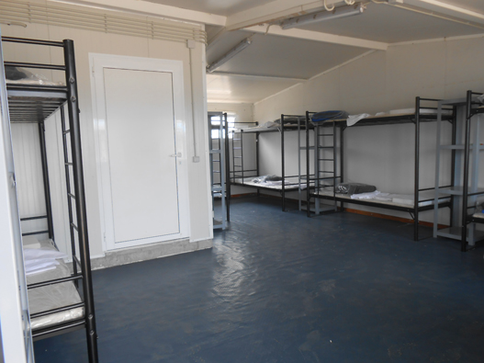
- The residents make use of the open, yard ground as well as the special designated entertainment and worship areas all day long (7.00a.m.-22.00p.m.)
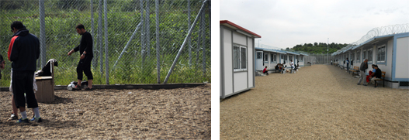
- Provides, at specified hours, lunch three times a day. Temporary residents, in case they wish, they can live the sector for their prayer to special designed worship area.
- Residents can use washing and drying equipment for the cleaning of their personal belongings
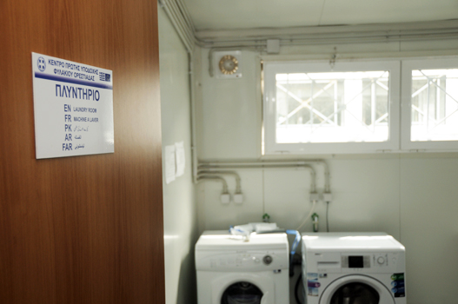
- Residents that have children can make use of the equipment of the dining and entertainment room for the preparation of the infantile meals and beverages.
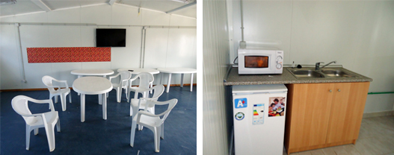
- Provides free shower and W.C. usage on a 24 hours base

R.I.C. structure includes:

- Waiting room for the center newcomers
- Surgery - examination room for the necessary medical exams
and the provision of primary health care

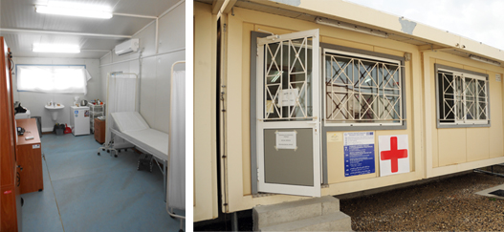

- Offices designed according to the organizational structure
- Special designed living areas
- Special designed entertainment areas

R.I.C. organizational structure includes:
- Administration support bracket, responsible for the administrative coordination of the Center
- Recording and verification bracket, responsible for the identity as well as other elements’ recording and verification of the third country nationals
- Medical examination and psychosocial support bracket, responsible for the provision of the above mentioned services
- Information bracket, responsible for the consultancy of the third country nationals regarding their rights and their obligations
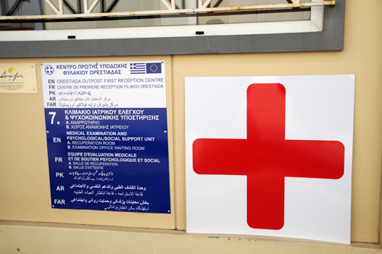
Reception and Identification Center – Psychosocial Support
Every resident to the First Reception Center, has the opportunity to speak in strict confidence to a mental health professional whenever he or she wishes so. To a mental health professional would also be directed the temporary residents that are considered that they seek psychological support. The interested parties are accompanied by a special trained cultural mediator/interpreter, if they wish so, during the sessions.

Reception and Identification Center – Communication with third parties
R.I.C. staff tries to facilitate the communication of the residents with NGOs representatives, the U.N. Refugee Agency, as well as with immigrants’ associations and communities and with their relatives. The communication is free and unimpeded. The center’s staff provides contact details and every other information requested. The temporary residents have the right to receive visits from lawyers and relatives to specified visiting hours. They also have the right to ask for writing material, envelope and paper in order to send a letter via post.Finally, there is telephone access in order to contact or receive calls by persons and Organizations.
Reception and Identification Center –Temporary residents’ Complaints
The temporary hosted residents have the ability to record their complaint to a specific form with the assistance of the mediator/interpreter. The complaints are collected by R.I.C. staff and there are afterwards forwarded to the Central Service. They are handled from the Central Service staff during the data processing in the context of R.I.C. proper function evaluation and quality assurance.

R.I.C. -Presence of International Organizations representatives
At the R.I.C., representative of the U.N.Refugee Agency of the United Nations is at the disposition of the temporary residents as well as representative of the International Organization for Migration (IOM). The role of the representatives of the UN Refugee Agency of the United Nations is the consultancy of the third country nationals regarding topics of International, European and Greek law, within the framework of the organizational information bracket. The role of the IOM representative is related to the consultancy of the interested parties for the option of voluntary return that is taking place with security and without any financial constraint from their part.
R.I.C. Voluntary return programme of Hellenic Police (EΛ.ΑΣ)
The R.I.C. temporary residents have the opportunity to choose the option of voluntary return through the Attica Aliens Division. Attica Aliens Division communicates with the relevant consular authorities for the issue of all the necessary travel documents, it also takes care in order to ensure the safe transfer of the immigrants and provides financial support , three hundred euros (300€), for those that are not under arrest and they wish to return. It also administerallowanceof two hundredeuros (200€) for those that are under arrest and they wish to return.
R.I.C:
In case there is no legal reason for the temporary residents to be in the country or in any other EU country,they are not asylum seekers and they do not follow the above mentioned programmes of supportive return, they will be referred to the Hellenic Police that will take action for further administrative procedures in order to return to their country through expulsion procedure

THE MUSE CALLIOPE IN GREEK MYTHOLOGY

THE MUSE CALLIOPE
Calliope is a famous name from Greek mythology, for Calliope was one of the Younger Muses, the beautiful goddesses who would inspire writers, artists and artisans.
Calliope the Muse of Epic Poetry, and hers was a name invoked by many writers and poets in antiquity; for they would give praise to the Muse for their ability to bring forth words of great eloquence.

CALLIOPE DAUGHTER OF ZEUS
As one of the Younger Muses, Calliope is the daughter of Zeus and the Titan goddessMnemosyne; making her sister to Clio, Erato, Euterpe, Melpomene, Terpsichore, Thalia, Polyhmnia and Ourania.
Calliope was named as the eldest of the Younger Muses, conceived on the first night that Zeus lay with Mnemosyne.

CALLIOPE GODDESS OF MUSIC
Calliope was a Greek goddess of music, song and dance, and was specifically named as the Muse of Epic Poetry. In this role, Calliope was normally depicted with a writing tablet in her hand.
Calliope was also said to be the muse who bestowed the gift of eloquence about mortal kings, coming to them when they were a baby, and anointing their lips in honey. As a result of Calliope’s actions, when adults, the anointed ones would spout gracious words, and utter true judgements.
Calliope was also considered to be the leader of the Muses, the wisest of the sisters, and also the most assertive.

CALLIOPE MOTHER OF ORPHEUS
Stories from Greek mythology would tell of the marriage of Calliope to the Thracian king Oeagrus, with the wedding taking place at Pimpleia. The marriage of Calliope and Oeagrus was said to have brought forth two notable individuals Orpheus and Linus. Orpheus was the great musical hero of Greek mythology, and Linus was the inventor of rhythm and melody; alternatively the father of Orpheus and Linus is named as the Olympian god Apollo.
Initially Calliope and Orpheus were said to reside at Pimpleia, but later Calliope and her son were to be found with the other Younger Muses upon Mount Parnassus. For here Apollo visited to continue the musical training of Orpheus, which had been commenced by Calliope.
The Muses Urania and Calliope - Simon Vouet (1590–1649) - PD-art-100

CALLIOPE IN GREEK MYTHOLOGY
Calliope was rarely spoken of as an individual but she is named as present, and spoken to by Thetis, when the Muses sang their dirges during the funeral rites of Achilles. Calliope was also certainly present when the Younger Muses were victorious in their contests with the Sirens and Pierides. Indeed, Calliope was said to be the Muse who caused the Pierides to be transformed into magpies after they had had the impudence to challenge Calliope and her sisters.
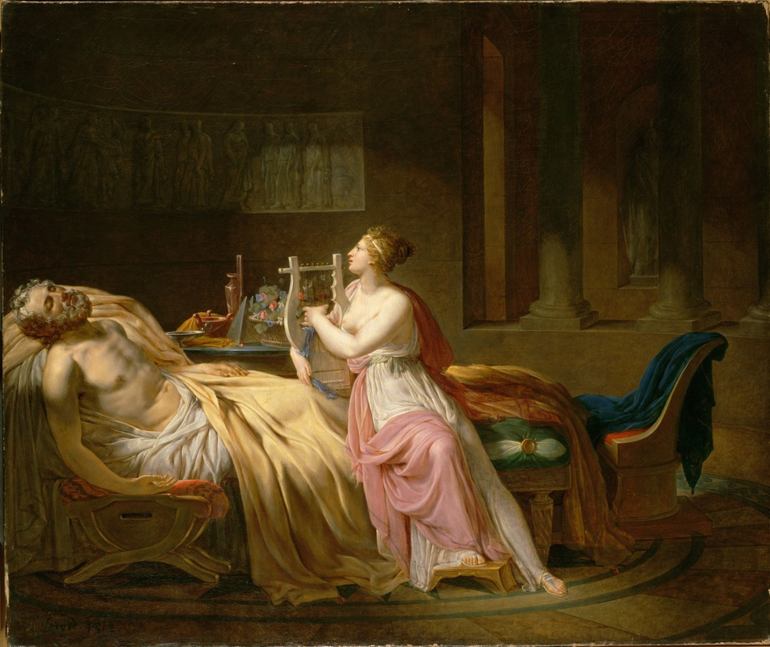
Calliope Mourning Homer - Jacques Louis David (1748-1825) - PD-art-100

