Asylum in Greece
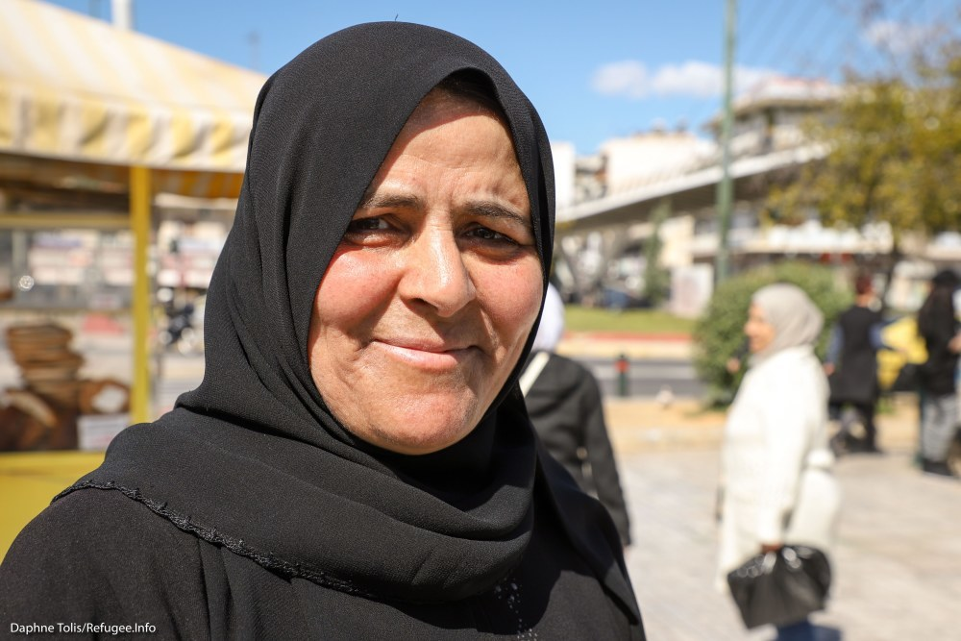

Who can apply
Anyone who needs international protection from persecution or danger can apply for asylum in Greece.

Who gets priority
Vulnerable people get priority for appointments with the Greek Asylum Service.
Through the Syria Fast Track Program, The Greek Asylum Service may prioritize asylum claims submitted by people with a Syrian passport, or a Travel Document for Palestinian Refugees issued in Syria.

How to apply

On mainland Greece
- Start with Pre-Registration. To pre-register, call the Asylum Service on Skype to get an appointment for Full Registration.
- Attend your Full Registration appointment. During this appointment, you will briefly explain why you are asking for asylum.
- Attend your asylum interview.

On the Greek islands
- You can express your wish to apply for asylum during the Reception and Identification Procedure.
- Next, the Asylum Service will fully register your asylum claim. You may or may not have an "admissibility interview" to determine if you can apply for asylum in Greece or if you should be returned to Turkey. Learn more about the procedure on the islands here.
- If you don't have an admissibility interview, or if you have one and authorities find your asylum claim should be examined in Greece, you will have an asylum interview. The asylum interview is called an "eligibility interview" on the islands.

After you apply
Once you have your asylum interview, you may wait months to get a decision. If you are applying through the Syria Fast Track procedure, you will get a decision the same day.
The Greek Asylum Service should contact you when it has reached a decision on your asylum application. Make sure it has your up-to-date contact information.

Successful applications
If your application is successful, you will either receive one of two kinds of protection:
- Refugee status (full asylum)
- Subsidiary protection (partial asylum)
These two statuses give you slightly different rights.

Refugee status
Refugee status is for people who face persecution in their country of origin because of their:
- Race
- Religion
- Nationality
- Membership in a certain social group
- Political opinion
People who get refugee status get:
- A Residence Permit that is valid for three years
- The right to apply for a Travel Document
- The right to bring family from their country of origin to Greece
People with refugee status cannot:
- Travel to their country of origin without the risk of losing their refugee status

Subsidiary protection
Subsidiary protection is for people who do not qualify for refugee status but face serious harm if they return to their country of origin.
“Serious harm” is:
- Death penalty or execution
- Torture
- Inhuman or degrading treatment
- Serious physical threat to your life or body, including because of ongoing violence in your country
People with subsidiary protection get:
- A Residence Permit that is valid for three years
- The right to apply for a Travel Document, if they can’t get a passport from their own country
- The right to travel to their home country, only if they hold a valid passport from their home country and not a Travel Document
People who get subsidiary protection cannot:
- Bring family from their country of origin to Greece
Whether you get refugee status or subsidiary protection, you usually cannot go to another European Union country and ask for asylum there. If you do, you may be returned to Greece.

Rejected applications
If your application is rejected, you have the right to appeal to the Greek Appeals Authority. You must submit your appeal before the deadline on your rejection decision. You can appeal immediately after you get rejected.
Ask a lawyer for help with your appeal.
Legal Aid Organizations
If you do not appeal and you do not have a document allowing you to stay in the country, the Greek authorities may start the process of returning you to your country of origin.

Documents
Once you get your decision, you will likely wait 3 months or more until you get your Residence Permit. You can apply for your Travel Document as soon as you get a positive decision on your asylum case.

Benefits
You can continue to access the cash assistance program for a limited time after you get asylum.

Police Note
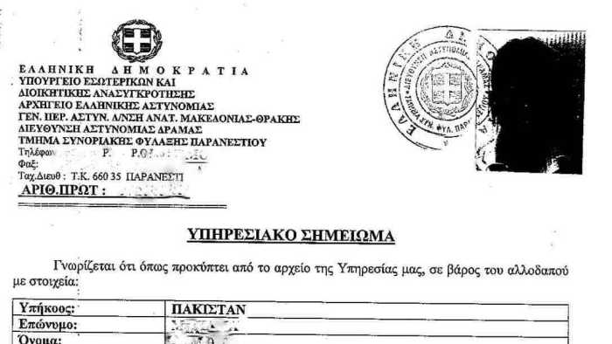
This document proves that the police have identified and registered you. You receive it when you first enter Greece. Yours may look different from this one.
Police upload all the personal data on your Police Note to the Alkyoni police computer system. This system is connected to the Eurodac system, where your fingerprints are stored.
Make sure all your personal information is correct on the card. Ask for corrections if you find mistakes. You have the right to ask for a translator to help you check or correct your information.

Rights
With a Police Note, you have the right to:
- Apply for asylum within two weeks
- Not be detained, if a detention order hasn’t been issued or hasn’t been clearly communicated to you
- Get housing
- Get health care
- Get free legal aid (usually provided by NGOs)
- Apply for cash assistance
Your Police Note does not give you the right to:
- Work in Greece
- Travel outside Greece
- Bring family members to Greece

Cash assistance in Greece:Cash assistance
Unlike in some other European countries, in Greece, the government does not give refugees a cash allowance. However, nongovernment agencies are now giving cash to people in every formal camp and accommodation site in Greece, as well as to people in urban private apartments.
If you are eligible for cash, you will get a card that looks like this:
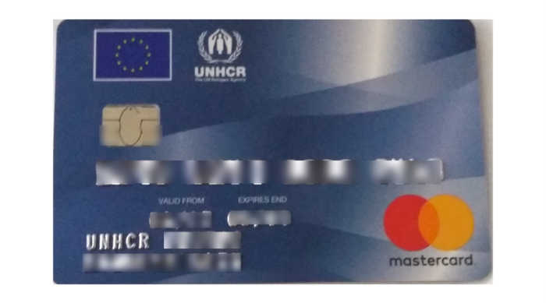
As a participant in the cash program, the amount of cash you get depends on the size of your family and whether you are living in a site that provides meals.
If you are in an official site ask the site management to find out how to get cash. If you are in UNHCR- or NGO-run accommodation, ask the organization in charge how to get cash.
If you are living in a private apartment, you may also be eligible for cash. If you think you are eligible for cash and living in a private apartment, but you’re not yet receiving cash, call the Greece Cash Alliance hotline. Learn more:
GREECE CASH ALLIANCE HOTLINE

Who isn’t eligible for cash?
- If you are living in a squat, you are not eligible for cash.
- If you are under 18 and traveling alone, you are not eligible for cash.
- If you have a regular, stable income from working, you cannot get cash assistance.
- If you arrived in Greece before January 1, 2015, you cannot participate in the cash program.
- If you have a restriction of movement notice for the Greek islands but are currently on the mainland, you are not eligible for cash.

After I am granted asylum in Greece, can I get cash?
If Greece recognizes you as a refugee or grants you subsidiary protection, you are still eligible for cash, but only for a limited time.
Cash agencies and authorities have not yet made a decision on how long you can get cash. We will tell you as soon as they do.

Do I need ID to get cash?
To be eligible to get cash, you need a valid ID from the Greek authorities. Valid ID includes:
POLICE NOTE (with DIKA number)
PRE-REGISTRATION CARD
FULL REGISTRATION CARD
RESIDENCE PERMIT
Note: If your ID/documentation has expired, it will not be accepted, and you will not get cash. If your ID is about to expire, take steps to renew it. Learn more about lost or expired documents here:
LOST, DAMAGED OR EXPIRED DOCUMENTS

How much cash do I get, and how often?
Your agency will add cash to your card each month.
The amount of cash assistance you get each month depends on how big your family is. It also depends on whether you are living in a place where catering is provided.
If you are living in accommodation where food is provided, you will get between €90 and €330 a month, depending on the size of your family.
If you are living in accommodation where food is not provided, you will get between €150 and €550 a month, depending on the size of your family.

I’m moving locations. How do I keep getting cash?
If you move locations, tell the agency currently giving you cash that you’re leaving, and tell your new cash provider where you are moving. If you don’t know which agency will provide you cash in your new location, we’ll help you find out.

I have been asked to move from a camp to private accommodation. Will my cash be stopped?
If you are moving from an official site to private accommodation, you will continue to get cash. However, it might come from a different agency than the one at your camp.
You will not receive any less cash than you were getting at the camp. In fact, if you are moving from a camp that provides food to private accommodation where no food is provided, you will receive more cash than you did at the camp.
Before you leave your old site, make sure you tell the cash agency or site management there that you are leaving.

Where can I use my card?
You can use your card in ATMs and point-of-sale machines, which are available in many shops. In Athens, many refugees use their cards in shops around Omonia Square.

Will I be charged for using my card?
Maybe. If you use the ATM to withdraw cash or check your balance, you will be charged a fee.
Please ask the agency giving you cash for more details.
If you use the point-of-sale machine to buy goods, you will not be charged a fee.

Is there a time limit on when I can spend my cash?
There is not normally a time limit on your cash, and any cash that is not spent in a month is carried over to the next month.

I was on the islands and then moved to the mainland without permission. Can I get cash?
No. If you moved to the mainland without permission, the only documentation you will have is a restriction of movement notice. You cannot get cash on the mainland with a restriction of movement paper from the Greek islands.

Can I use my cash card outside Greece?
Cash cards are valid only inside Greece and don’t work outside Greece. If you are leaving Greece through Relocation or Family Reunification, make sure you withdraw your money from the card before you go.

How long will cash assistance be available?
We don’t know yet how long cash assistance will be available. We do know that it will be available throughout 2018.

ducation in Greece:Education

For adults

Services
Educational activities
Vocational training
Language classes

Higher education
Getting a bachelor’s degree
Getting a master’s degree or PhD

For parents and children

Services
Education services for parents

Going to school
Kindergarten for 5-year-old refugees
School program for refugees 6-15
School program for refugees 15-18
Where to get your kids vaccinated for school
Parents' guide to Greek schools
How to get a bachelor’s degree at a Greek university
Getting a master's degree or PhD in Greece
How to apply for a European Qualifications Passport for Refugees
The Greek Ministry of Education has also prepared information on how you can access education here.

Apps and other online resources

Free language learning apps
Duolingo can teach you many languages’ basic grammar and vocabulary. It has English, Arabic and Farsi interfaces, among others.
Memrise is another language-learning website and app that can help you with vocabulary especially. It uses community-generated content. It is also available in English, Arabic and Farsi interfaces.
Antura and the Letters uses games and quizzes to keep kids ages 5 to 10 engaged while learning the modern standard Arabic alphabet.

Apps that help you study academic subjects
- Coursera is an online learning platform with courses ranging from maths, physics, and computer science to social science and language learning. Most courses are free, but to get a certificate of completion you may need to pay. Coursera offers financial assistance for refugees.
- Kiron aims to help refugees and asylum-seekers begin or continue studying at the university level for free. You need to speak intermediate-level English and have regular access to the internet. Learn more about applying here.
Other online learning platforms include:
- EdX
- Future learn
- Alison
- Academic Earth
- Lynda, which focuses on education videos
- Khan Academy, which some say is especially useful for math and coding
You can also search for courses on MOOC.

Transportation in Greece:If you get fined on the Metro
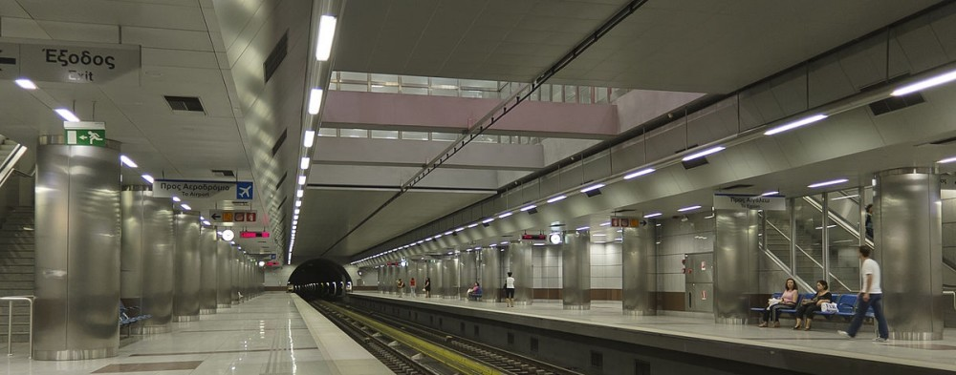
Credit: IRC
If you get fined for using public transportation without a ticket, you will have to pay 60 times the price of the ticket.
Can I pay less?
You can get a 50% discount on your fine if you pay it within 10 days.
A tip to pay even less:
In Athens, during the first 2 weeks of every month, you can buy a monthly pass.
If you get fined during the first 2 weeks of the month, buy a monthly pass the same day you get the fine.
You will need a passport-type photo and €30 to get a monthly pass. The pass also allows you to use all public transportation for the rest of the month.
The same or the next day, between 7:30 a.m. and 2:30 p.m., visit a Public Transportation Fine Payment Office and ask them to erase your fine.
Bring your:
- Pre-Registration card, Full Registration Card or Residence Permit (or any document that proves your identity)
- New monthly transportation pass
- Fine notice
How do I pay my fine?
The easiest way is to go to a post office and pay by check.
Post employees should be able to help you to fill out the check. You must write on the check:
- The fine number
- Your name
- The name of the transportation company that issued the fine
There is a €4 charge for the check.
Find a post office near where you live here.
If you don’t want to pay the extra €4 for a check, you can visit a Public Transportation Fine Payment Office.
Where can I find a Public Transportation Fine Payment Office?
If you got fined on a bus (or trolleybus) in Athens visit: Admitou 17 or Parnassou 6.
If you got fined on metro or tram in Athens visit: Metsovou 15.
If you are outside Athens, ask someone who speaks Greek to help you find a Public Transportation Fine Payment Office.
What if I don’t pay the fine?
After 2 months (60 days) from the time you get fined, the amount gets multiplied by 5.
Then the transportation company will send this unpaid fine to Greek tax authorities, who will register it as a debt under your name.
This means that, if you have a Greek tax number (AFM) (or if you get an AFM soon), the tax authorities will keep asking you for the payment.
As your AFM number is linked with your Pre-Registration or Full Registration or Residence Permit number, there is no way to avoid getting charged for this large amount of money.
If you get an AFM at any time after you are fined, any existing fines will be linked to your new number, and the tax authorities will start asking you for the payment.
Can’t I just ignore my fines?
Not if you have an AFM — and if you want to work in Greece, you must get an AFM.
Once you have an AFM, the tax authorities will start asking you to pay your fine — with added interest — starting two months after you get the fine.
If you have a bank account under your name or get one in the future, things can get even worse once you owe more than €500.
Current Greek law allows tax authorities to confiscate funds from your bank account when your debt is more than €500.
How can I protect my bank account?
Go to your bank and ask to declare your account “non-confiscated.”
Declaring your account “non-confiscated” ensures that tax authorities can’t confiscate any of your money if doing so would leave you with less than €1,200 in your account.
For example: If you have €1,562 in your non-confiscated account, authorities can only take €362. If you have €943 in your account, authorities cannot take any of your money.
Can they confiscate fines from my cash assistance?
No. Refugee.Info has confirmed that tax authorities cannot confiscate debt payments from your cash assistance.

Volos: a city next to the sea, port of the Argonauts
Volos is a modern city with a special charm and its own particular colour, marked largely by its place between the sea of the Pagasetic Gulf and the imposing Pelion Mountain.
The sea creates a fabulously long coastline with numerous recreational centres and some of the city’s countless famous little taverns, or tsipouradika, serving the traditional “tsipouro” aperitif and special seafood appetisers, or “meze”.
The pedestrianised waterfront Argonaut Road, with the passenger port at its west end and the impressive view of the sea and tree-covered hill of Pefkakia, is the most popular meeting spot and ideal for a stroll for both residents and visitors to the city.
The main commercial pedestrian road, intriguing buildings, public mansions, industrial installations dating to the early 20th century and historical churches make touring Volos a truly enjoyable experience.
The noteworthy cultural activity, the diverse mosaic of its inhabitants and the vibrant university community round out the city’s image.
The Argo is the symbol of the city. The mythical ship became known around the world through the myth of the expedition of Jason and the Argonauts to Colchis.
A few kilometres west of the city are the archaeological sites of Sesklo (the settlement dates back to 6000 BC and is the oldest in Europe) and Dimini (the best-known prehistoric settlement in Greece and most important of the late Neolithic period).

The journey begins in Volos

