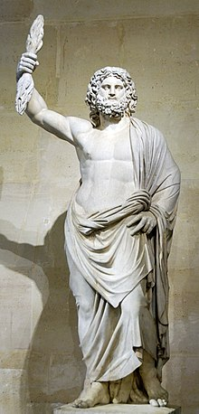
Zeus de Smyrne, discovered in Smyrna in 1680

Hospitality in Ancient Greek Culture

Greece is composed of numerous regions and outlying islands. In ancient times its scattered city-states each had their own dialects and customs. As seafaring peoples constantly engaged in trade among themselves and with outsiders, Greeks were inevitably in regular contact with strangers, and were themselves in situations where they were strangers. To maintain order and civility between Greeks from various regions, Greek hospitality was not just a kindness. It was an unspoken cultural law that preserved order for a people who were simultaneously countrymen and strangers.

Deep Roots in Ancient Greece

The concept of Greek hospitality was so deeply embedded in ancient culture that it took the form of a code of conduct. “Xenia" is used to describe the virtue of showing generosity or courtesy to strangers of any condition and creating a genial relationship between host and guest. Scholars also detect a religious underpinning to this code of social conduct. In ancient Greece, it was believed that any stranger might be a god in disguise checking up on mortals. But xenia also required guests to observe certain precepts. According to legend, even an event as momentous as the Trojan War began because of a guest's violation of xenia. The Trojan prince Paris was a guest of King Menelaus of Sparta when he abducted Menelaus' wife, Helen.

Defining The Principles of Xenia

In Greece, there were specific principles of xenia that applied to both guest and host. For example, the host was forbidden to ask any initial questions of a guest even if they were complete strangers. Moreover, the host was expected to offer his guest refreshments, a bath and clean clothes. The guest was expected to be polite and to abstain from making inconvenient requests. The host particularly was expected to give a gift to the guest in order to acknowledge the honor of hosting duties.

Xenia and the Cyclops

The most important sources for xenia are preserved in literature and particularly in Homeric epics. Both the Odyssey and the Iliad are filled with episodes in which xenia is either honored or ignored and the subsequent consequences are notable. For instance, when Odysseus sails to the island of the cyclops, the monster’s treatment of Odysseus and his sailors is a violation of the custom of xenia. The cyclops is punished for the transgression. Odysseus blinds his "host" and escapes. Though the cyclops episode depicts an abuse of xenia, the absence of host-guest laws also indicates just how savage the island of Greece was.

Finding the Perfect Host in the Odyssey

Hospitality in the Odyssey complicated the codes of xenia by exploring situations where the laws of hospitality might be tested. For instance, Odysseus’ wife Penelope is forced by custom to entertain an entire household of suitors. From the start of the story, these men slowly drain the household of resources all because they assume their host Odysseus is dead. In short, the guests not only make unreasonable, burdensome requests that were impolite for guests but they do so with the assumption the host himself is no longer alive. The conclusion of the poem involves Odysseus’s slaughter of the suitors. This violent ending can be seen as retribution for an egregious abuse of xenia or conversely, a violation of its very precepts.
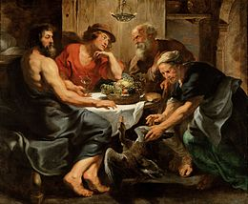
Jupiter and Mercurius in the House of Philemon and Baucis (1630–33)
the workshop of Rubens: Zeus and Hermes, testing a village's practice
of hospitality, were received only by Baucis and Philemon,
who were rewarded while their neighbors were punished.

Xenia consists of two basic rules:
- The respect from host to guest. The host must be hospitable to the guest and provide him/her with food, drink, bath and gifts when they leave. It is not polite to ask questions until the guest has finished the meal provided to them.
- The respect from guest to host. The guest must be courteous to the host and not be a burden. The guest should also provide a gift if they have one.^{[2]}
Xenia was considered to be particularly important in ancient times when people thought gods mingled among them. If one had poorly played host to a stranger, there was the risk of incurring the wrath of a god disguised as the stranger. It is thought that the Greek practice of theoxenia may have been the antecedent of the Roman rite of Lectisternium, or the draping of couches.
While this particular origin of the practices of guest-friendship are centralized around the divine, however, it would become common practice among the Greeks to incorporate xenia into their customs and manners for very much all of ancient Greek history. Indeed, while originating from mythical traditions, xenia would very much become a standard practice throughout much (if not, all) of Greece as customarily proper in the affair of men interacting with men as well as men interacting with the Gods.

WELCOME TO PIRAEUS

A port-city with a fascinating and ancient history, vibrant, with sights worth seeing. A city that grew and gained power, becoming an important commercial, cultural and industrial center throughout the centuries. In its welcoming embrace you will find on a daily basis thousands of people travelling to the Aegean Sea and Crete, and others visiting Piraeus for food, coffee, entertainment, shopping, walks with a sea view, visits to the museums or around the neoclassical buildings that stand as irrefutable evidence of its glamorous past. Wander around Piraeus with us and discover its unforgettable charming corners that will make you visit it again and again!

History
The historical development of Piraeus is inextricably connected with that of Athens as well as the history of two cities. Thanks to its three harbors, Piraeus was the port of Athens since antiquity. It flourished during the Classical and Hellenistic times, while since Roman times it began to decline and during the Byzantine period, the Frankish and the Turkish Occupation it was almost an insignificant port. However, after the establishment of the new Greek state and the transfer of the capital to Athens, its development was impressive. Following its development, Piraeus attracted many immigrants. They are not random the names that have some of the districts, such as Hydreika or Maniatika. The arrival of refugees to Greece from Asia Minor after the Asia Minor Catastrophe of 1922, many of whom settled in the area of Piraeus, gave a big boost in its economic development.
THE NAME
It is widely known that the name “Peiraiefs” comes from the word “peran”, in the sense of distant or opposite land. According to others the name comes from the word “diaperan” or “peran reo” and the verb “peraio”, which means ferry someone to the other side, because in ancient times there was a marshy area in between the two lands, the so called "alipedon", in the area where Faliro is located today. But as the geological researches have shown, Piraeus was actually an island. It was united with the coast of Attica during the Quaternary Period, due to the siltation of the river Kifisos where today Moschato and Faliron Delta are situated
FIRST INHABITANTS
The first inhabitants of the region are considered Minians, people that came from Boeotia. Minians left their homeland, the region of Orchomenos, because of invasions by Thracian tribes. According to those mentioned by Euripides in his work Hippolytus, Minians finally reached the hill of Castella which they fortified and named Munichia in honour of their hero and king Mounichos. In historical times, Piraeus was first mentioned in 510 BC in texts referring on the reforms of Cleisthenes. The administrative division of the Athens city state in 10 tribes and 176 municipalities included Piraeus as the seat of the Ippothontida municipality.
THE ANCIENT WALLS
Themistocles was the first to realize the strategic position of Piraeus with the three natural harbors and in 493 BC, when he was elected archon of Athens, he started the first major port and fortification works in the region. Thus in 470 BC the length of the walls of Piraeus exceeded 11km. Its main port is divided into commercial and military, which can accommodate up to 400 boats. It was located between the central harbor and Miaouli coast and it was called Kantharos. The entrance from the sea was protected by two large towers leaving between them only a small passage, which was closed every evening with thick chain for security reasons. The harbor of Kantharos was responsible for the export trade of Athens as well. The main products traded were wine, olive oil, honey, pottery and metals from the mines of Laurium.
THE HIPPODAMUS AGORA
The famous Hippodamus Agora was built on the place that separates the present main port of Piraeus and that of Zea during the classical period in 460 BC. It was rather a normal consequence since in its heyday Piraeus has gathered a considerable military and commercial power. The Hippodamus Market exclusively addressed to local citizens and constituted the posh market of the city, since there was another market at the port of Kantharos, which was crowded by foreigners, sailors, gamblers and all those social groups that render a notorious harbor neighborhood. The name of the market came from its designer, the architect Hippodamus of Miletus, who established the homonymous urban planning system, which was based in developing parallel roads that intersect in right angles in order to create building blocks and squares. The Hippodamus Market was decorated by magnificent public buildings, such as the Temple of Hestia, the Agoranomeion, the Bouleuterion and the Scolarcheio. Today, on Trikoupi, 2nd Merarchias and Sotiros streets, where the market was located, nothing remains to reveal the glory of the past...
THE DISASTER
In Piraeus, except from the few archaeological sites, nothing reveals the so important parallel history of the area in contrast with Athens where so many monuments of the past are preserved. In 1676 the travelers Spon and Wheler wrote in their travel notes: “there is nothing now remaining of the city of Piraeus, neither of those beautiful arcades mentioned by Pausanias.” In the same spirit and the impressions he had the French politician, traveler and writer Chateubriand, in 1806. However, there is an explanation for everything. And in this case history itself gives the answer. At the period during which the Romans were fighting against the Hellenized king of Pontus Mithridates, Athenians sided with the latter. Thus, in 86 BC the legions of the Roman general Sulla, having defeated the army of Mithridates and his allies, disembarked at the port of Piraeus and destroyed the entire port infrastructure. The numerous monuments of Piraeus didn’t manage to escape from the fury of the Romans. The walls of Conon and Themistocles, the Long Walls that connected Athens to Piraeus, the arcades, the temples, the shipsheds, the Arsenal of Philon, the Hippodamus Market all ended up a mass of rubble. After this disaster, Piraeus lost its role as a super-secure port and it remained unfortified at the mercy of any pirate of the sea and every barbarian invasions from the land. In 267 AD Goths-Heruli looted the city for many weeks, while a century later, in 395 AD, the Visigoths of Alaric A’ left no stone on stone. The centuries passed without Piraeus being able to recover effectively. During Byzantine and Ottoman periods, Piraeus was known under the name Dragon Porto and Porto Leone. The name Porto Leone, namely Port of Lion, appears in a nautical map of Genovese Peter Visconti in 1318 and it came after the known Lion of Piraeus, a marble lion which was located near the entrance of the harbor.
BLOOMING
In 1834, after the liberation, the capital of the newly established Greek state was transferred from Nafplio to Athens and a new blooming season begins for Piraeus, as the new capital would be worthy of a port. So in the years that followed, Piraeus experienced significant demographic, residential, commercial and industrial development. In the early20th century, having become a center of internal migration, it attracts people from the islands of the Saronic Gulf, Cyclades, Chios, Crete and Mani. The development follows the upgrading of infrastructure as well. Permanent tanks were constructed in Ietioneia coast and the wonderful Municipal Theatre of Piraeus was built. The Asia Minor Catastrophe in 1922 and the uprooting of Hellenism of Asia Minor had as a result Piraeus to accept a large number of refugees. The factories acquired new, skilled and cheap labor force and the population doubled. But what matters most is that the refugees contributed substantially to the formation of the cultural character of the city. The last adventure of Piraeus was the World War II, during which the port was bombarded repeatedly. The end of the war meant the beginning of the reconstruction of the city, which in combination with the significant Greek shipping activity and its emergence as a global power after the war, transformed Piraeus into the largest port of Eastern Mediterranean coast.

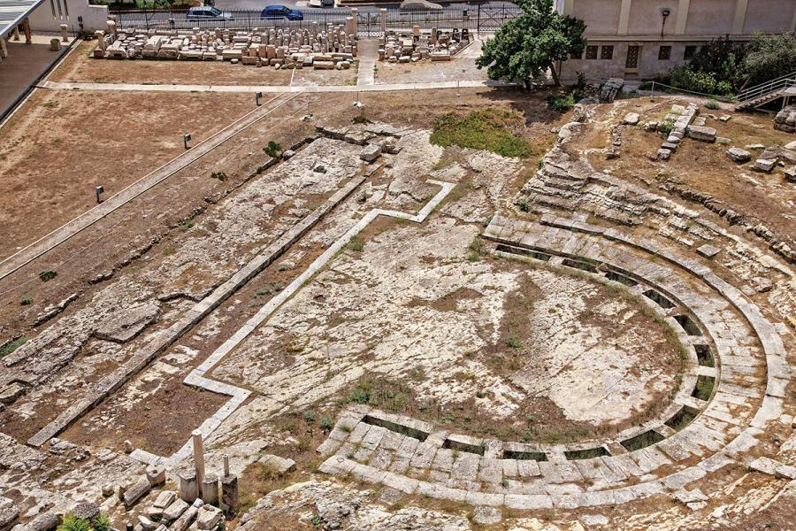

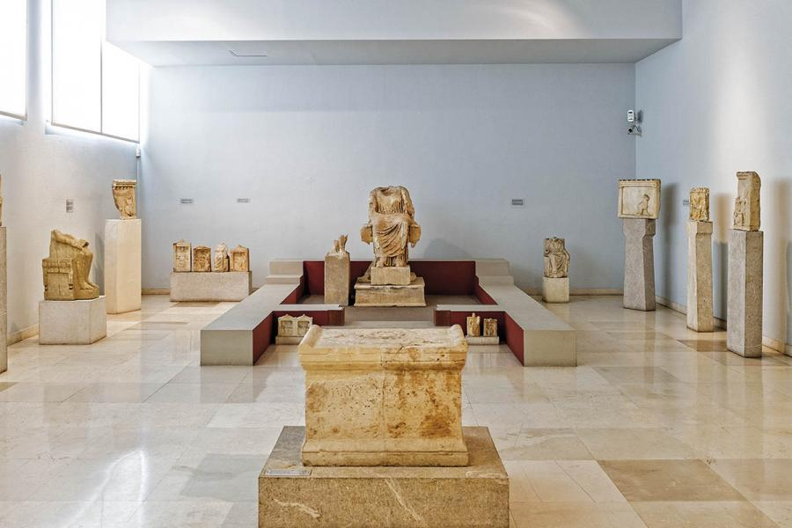

Piraeus
Welcome to Piraeus! A port-city with a fascinating and ancient history, vibrant, with sights worth seeing. A city that grew and gained power, becoming an important commercial, cultural and industrial center throughout the centuries. In its welcoming embrace you will find on a daily basis thousands of people travelling to the Aegean Sea and Crete, and others visiting Piraeus for food, coffee, entertainment, shopping, walks with a sea view, visits to the museums or around the neoclassical buildings that stand as irrefutable evidence of its glamorous past. Wander around Piraeus with us and discover its unforgettable charming corners that will make you visit it again and again!

Architecture
In 1834 the architects Cleanthes and Shaubert drew up the plans for the city of Piraeus. As an important commercial, industrial and shipping center, it acquired impressive buildings. In the early 20th century, with the neoclassical element dominating public and private buildings, Piraeus exuded the strength and the aesthetics of the bourgeoisie and the shipowners who had their shipping offices here. The traditional urban fabric and the architectural identity of the city is still evident in the city center and several of its buildings have been declared listed since the mid 1990s. The architectural development of the historic center of Piraeus is really interesting. Residential buildings, the upper bourgeoisie mansions, shops, offices, workshops, factories, hotels and public buildings exhibit a variety of building solutions. The common denominator, up until the First World War, was neoclassicism in all the phases of its evolution. There also several excellent examples of interwar architecture from the namesake period.

MANSIONS & PUBLIC BUILDINGS
The neoclassical past of the city is revived in the center of Piraeus. The brightest example, the renovated Municipal Theatre, has once again become a reference point for the cultural life of the city. Other characteristic buildings are those of the Hellenic Naval Academy, designed by architect Ziller, the Hatzikyriakio Foundation, the former Navy hospital which was a 1875 mansion etc. A special place is held for the former Patsiadis mansion, as it is the only building remaining from the cluster of seven mansions designed by the famous German architect Ernst Ziller, in the late 19th century. Metaxas mansion (1899) is also attributed to him. An excellent example of eclectic architecture with baroque elements is Vattis mansion. The architecture of the neighborhood of Castella is also of great interest with mansions of the 19th century in colonial style, two-storey neoclassical and old mansions built masterfully in locations with high gradient.

Sightseeing

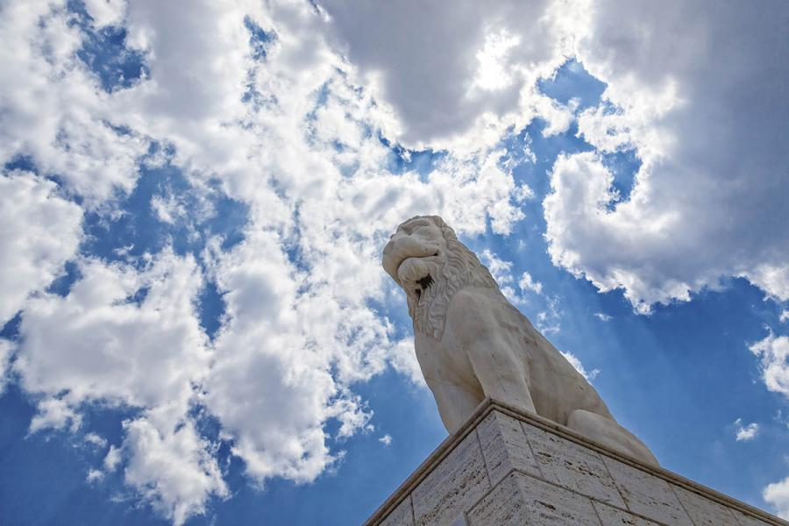

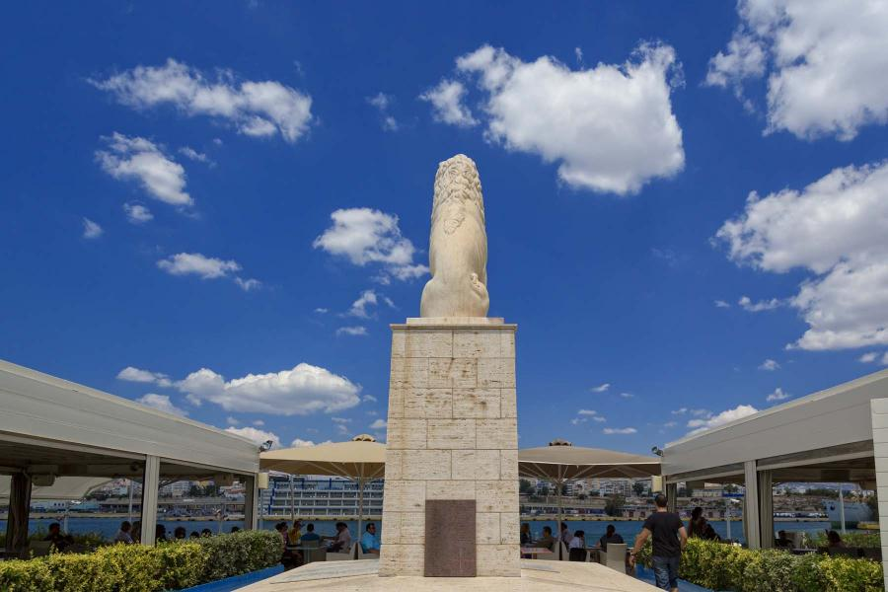

The Lion of Piraeus

The lion that stands today at the end of Xaveriou coast looking at the main port of Piraeus, is a true copy of an older marble statue. The original which was stolen stood for centuries in a prominent position at the port and it was the reason why Piraeus was called Porto Leone by the Latins and Aslan Port by the Ottomans. Bear in mind that Aslan port means in Turkish port of lions. Archaeologists have not come to the construction date of the original lion, but it is very similar to the trophy set up by Macedonians, in Chaeronea. Into the shoulders and flanks of the lion there are runic inscriptions for which there is no specific information. It is said that they were carved by the Varangians, ie Scandinavian soldiers, who found themselves in Piraeus in 1018 by following the Byzantine emperor Vasilios B’ Voulgaroktonos. The statue was looted by the Venetian naval commander Francisco Morozini, in 1687.

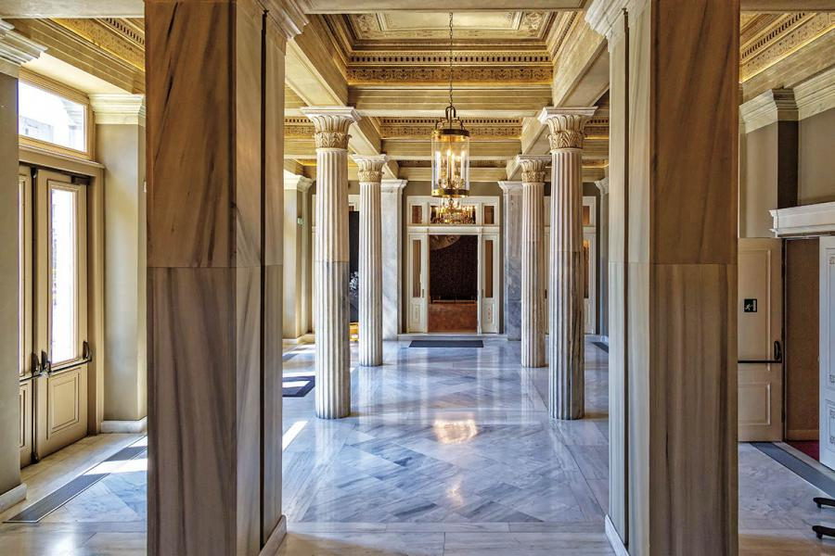

Municipal Theatre
The Municipal Theater is a landmark of the city of Piraeus. It was founded in 1884, according to designs of the architect Ioannis Lazarimos. Its construction took 10 years and it started operating in 1895. It is considered the most important neoclassical building in the city and one of the most important theaters of the country. Many famous Greek directors, such as Karolos Koun, Alexis Solomos, Dimitris Rondiris, Spyros Evaggelatos, have presented their work there. The establishment of the Municipal Theatre of Piraeus expressed the vision of the emerging bourgeoisie and the intellectuals of that time to designate the city as a cultural international centre. Its internal layout followed the standard of the “Theatre d 'Odeon” Paris.
Its main stage is in baroque style, while the square of the theater could accommodate up to 1,300 spectators. In 2008 renovation works began which brought out all of the ornate details of the ceiling. The renovated Municipal theater started its operation during October 2013. Since then the viewers can enjoy an interesting program including theatrical plays, concerts, exhibitions, interactive theater, educational programs and many more.

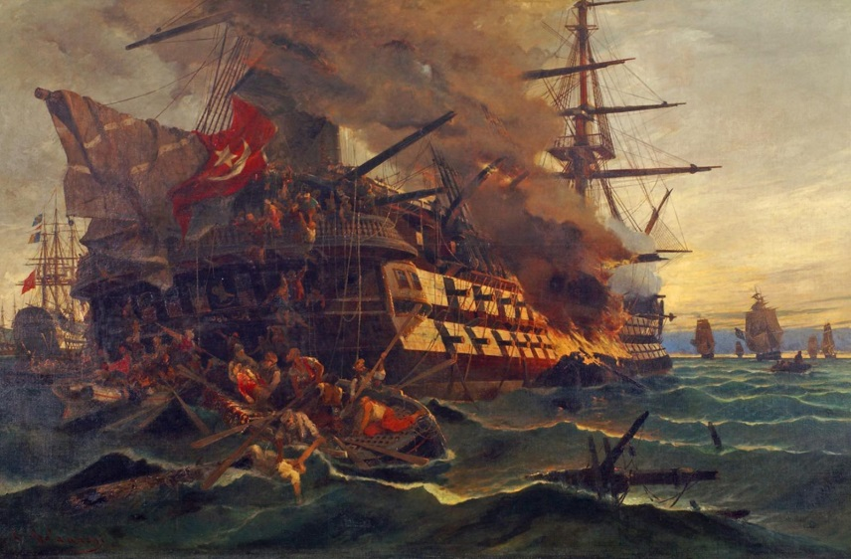

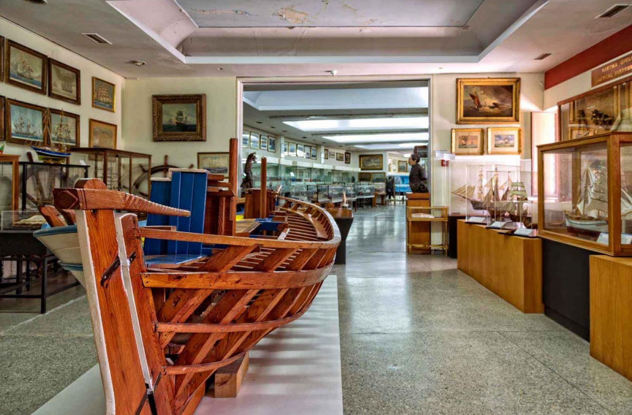

Hellenic Maritime Museum
In the museum the naval history of the Greek nation unfolds before the eyes of the visitors, in consecutive halls. The museum is rich in models of ships, representations of historical events, various objects etc. of the antiquity, the Revolution of 1821, the modern history of the navy and our commercial shipping. You can admire parts of the Cononian wall of Piraeus and the famous shipsheds, where the triremes were repaired and maintained. The museum is considered the largest maritime museum in Greece. Among other exhibits there is a rich collection of 10,000 volumes of rare editions of nautical books and maps, artworks and rich photographic archive. Info
The museum is located at Themistocleous coast, at the entrance of Zea Marina.

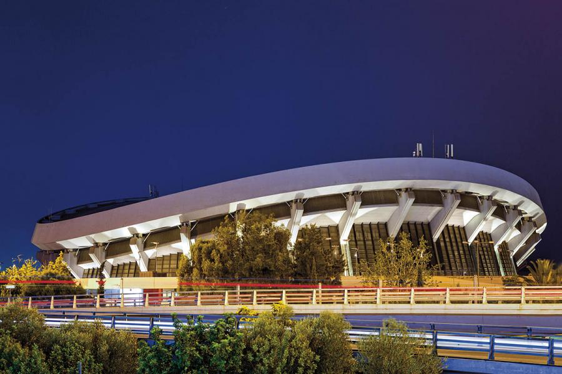

Peace & Frienship Stadium
G. KARAISKAKIS STADIUM
The Peace and Friendship Stadium (SEF) is an integral part of the Greek athletic tradition. It was built between 1981-1984 and it is characteristic of the style of the last 20 year period of the 20th century -in fact it has many similarities to the Arena of Milan and the Palais of Budapest. The stadium was inaugurated in 1985 and in the same year the European
Athletics Indoor Championships were held there. During the 2004 Οlympic Games it hosted all the volleyball games (preliminaries and finals). The stadium is the home court for the basketball team Olympiacos.
Fans from all over the world have attended the following major sporting events at the Peace and Friendship Stadium:
Basketball – World Championship (1998), European Championship (1987)
Champions Cup Final (1985) and Final-4 (1993)
Cup Winners' Cup Final (1989)
Volleyball - World Championship (1994)
European Championship (1995)
Final-4 Champions Cup (1992 & 1993)
Final-4 Cup Winners' Cup (1996) & TopTeams Cup (2005)
Wrestling – World Cup (1988) and Championship (1999)
European Championship (1986)
Gymnastics – World Championship (1991)
European Championship (1990)
Weightlifting – World Championship (1999).
The Peace and Friendship stadium has all the modern systems and equipment. It is the most multi-functional indoor stadium in Greece. It is located in the western corner of Faliro Bay, between Mikrolimano and Kifissos river. It is 4 km from the port of Piraeus.

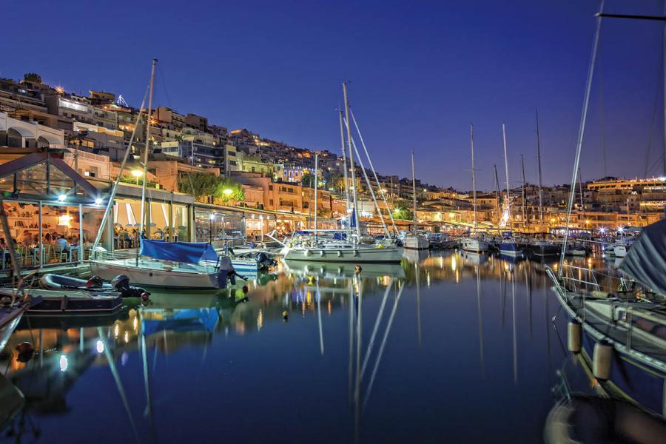

Mikrolimano
It has an oval shape and many names: Mikrolimano, Fanari, Tourkolimano, Koumoundourou port. In ancient times, however, it had only one: Port Mounichia. It belongs to the district of Castella, with which it is connected by the steep streets with modern cafés and bars. It was given the name Fanari during the Byzantine period, probably because there was a lighthouse (fanos) at its entrance. It was called Koumoundourou port because of the namesake mansion that existed in its south end, where the Nautical Club of Greece stands today. It was given the name Tourkolimano during the revolution period, in 1821. Mikrolimano is one of the finest points of Piraeus with many dining and entertainment options. The enclosed bay is crowned by amphitheatrically built homes. The moored boats and the fishing boats swaying gently, the restaurants and cafes, the titillating scents of meze, the people enjoying a walk along the waterfront, are reminiscent Aegean island. The traffic here lasts until late in the evening as dozens of people enjoy a drink or cocktail in the lounge bars and café bars overlooking the sea.
In Koumoundourou coast you will also find some of the best fish taverns and restaurants of Piraeus, which are famous throughout Attica. Sitting on the wooden decks next to the water, enjoying the music, you will enjoy fresh fish, seafood, appetizers, ouzo and fine wines. Most locals have fond memories of this picturesque harbor, which over time has been remodeled and became a cosmopolitan destination for all hours of the day. A social and happy place where summer seems to last forever!

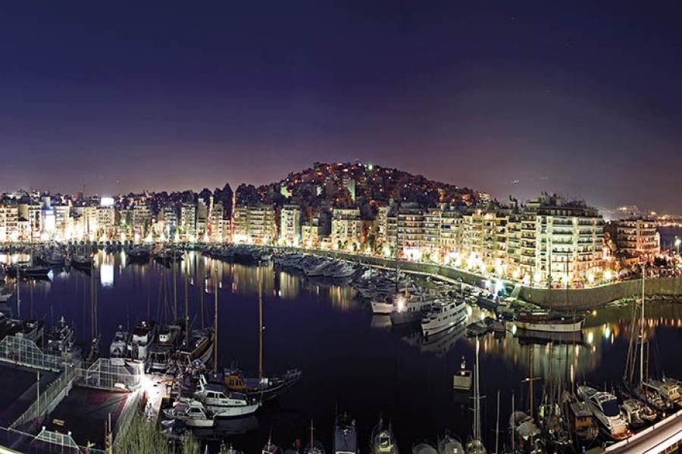

Coast of Zea
The ancient port of Zea, which hosted the symbol of sovereignty of the Athenian state, its great fleet, is the present Pasalimani. The name Pasalimani was established because during the Turkish occupation, pashas of Athens came here along with their harems for swimming. The access to the coast for Christians was prohibited. Zea is the second largest of the three ports of Piraeus. There are still historical cafés here, from a time when the high society of Piraeus went every afternoon for a walk with their children, nannies and dogs. The most historic team in Greek football, Olympiacos, was founded as a club in the café Kyveleia, in Pasalimani, which no longer exists. The older residents of Piraeus didn’t say: “Olympiacos plays with Panathinaikos”, the eternal opponent team of Olympiacos, but they said: “The Champion plays with Panathinaikos”. In the west side there is Zea Marina, which was built by the Piraeus Port Authority, in 1955. At Moutsopoulou coast, where Kaniggos street meets Sirangiou street, you will see the Tzivanioti villa, known as “the house with palm trees”. It is of stone, in neo-Gothic style and built in the late 19th century. Very close to the villa there have been survived interesting ruins of ancient shipyards. Pasalimani ends at the east on a hill, the top of which has formed a square called Alexandras. Certain cafés here offer panoramic view of the urban complex of Athens.

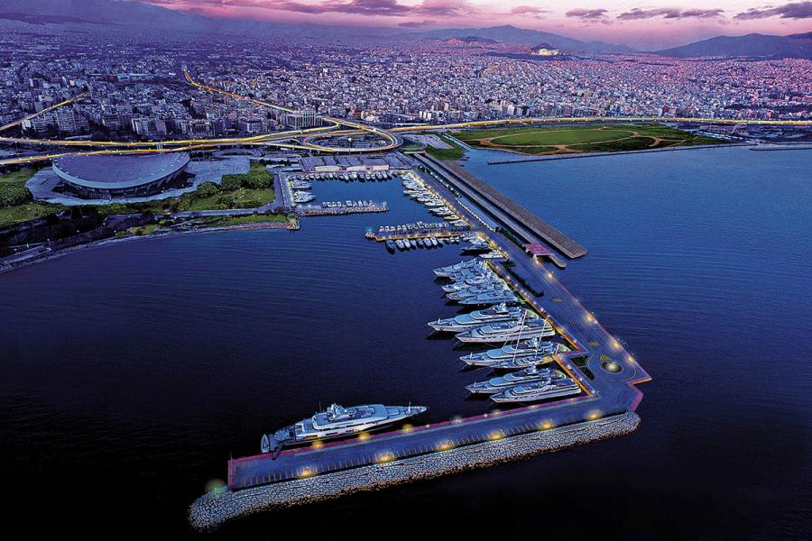

Peace & Frienship Stadium Marina
Ιt was founded in June 2004, to accommodate the yachts of VIP visitors to the 2004 Olympic Games. The marina has a mooring capacity of 130 yachts and can accommodate yachts up to 130m, with over 10 berths for mega yachts of 50m up to 100m and over 25 new berths for super yachts of 30m to 35m. Athens Marina has a large seafront entrance for easy access, along with tender pilot assistance and a unique dock for alongside berthing.

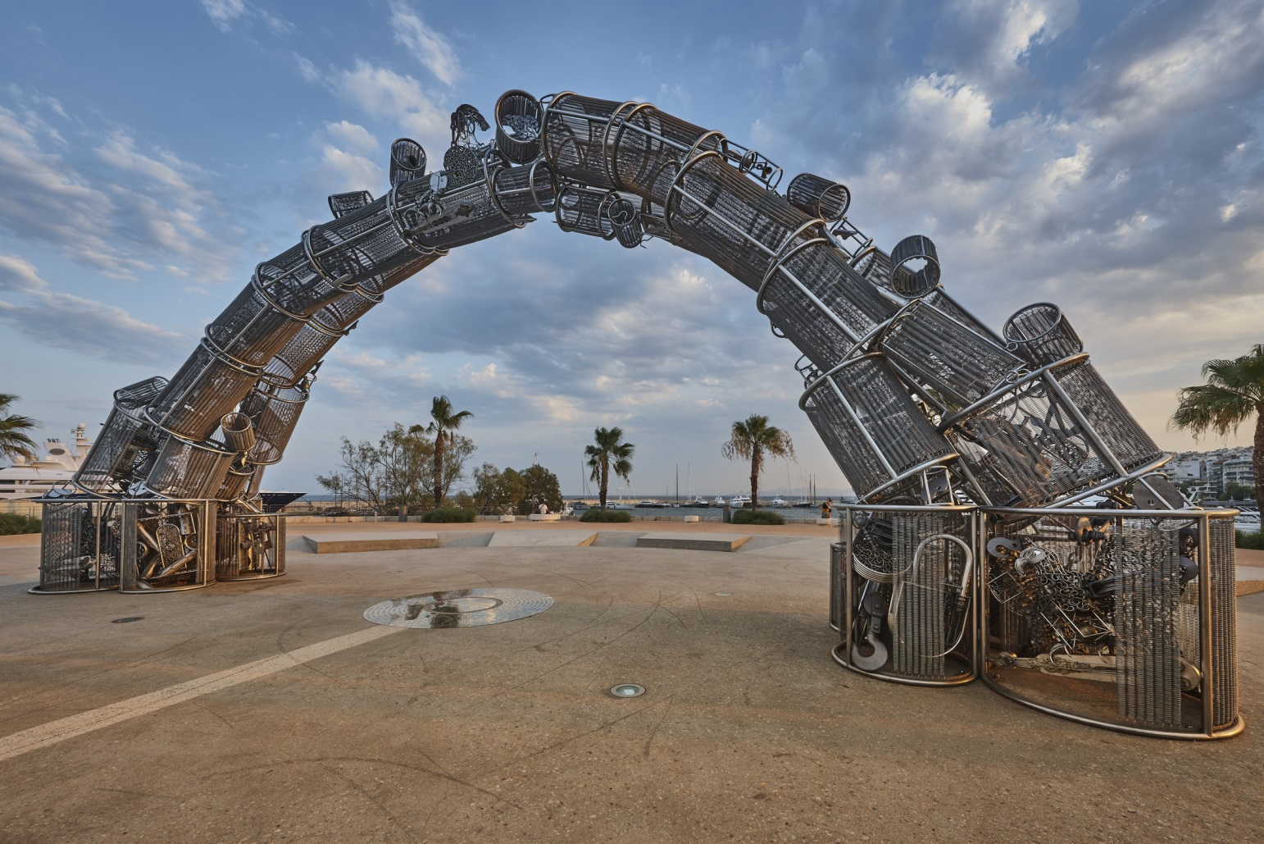

Monument to the Genocide of the Greeks of Pontus
The Monument, created by Panayiotis Tanimanidis, is a tribute to the memory of the 353,000 Greeks of Pontus, who perished during the Genocide of the Hellenism of Pontus. The monumental three-dimensional sculpture, 15.50 m long and 7.10 m high, is made of stainless steel and has brass details. It is a contemporary work of art, presenting an imposing arch called "Pyrrhic Flight". Outwardly, it resembles a huge wave that rises from one homeland, from Pontus, to the other, with everything, memories, traditions, imprints of the ancient presence of the Greeks in Pontus. Inside, the work is adorned with 17 sculptural compositions, successive icons depicting the flight of a "refugee bird" fleeing from Pontus to reach an unprepared homeland that sheltered the refugees' dreams. The construction of the project and the redevelopment of Alexandras Square were carried out at the initiative of Mr Evangelos Marinakis, who is connected with Pontus through ties of family. His mother is a descendant of the well-known Ypsilantis family, whose ancestors played a central role in the 1821 war of Greek liberation.

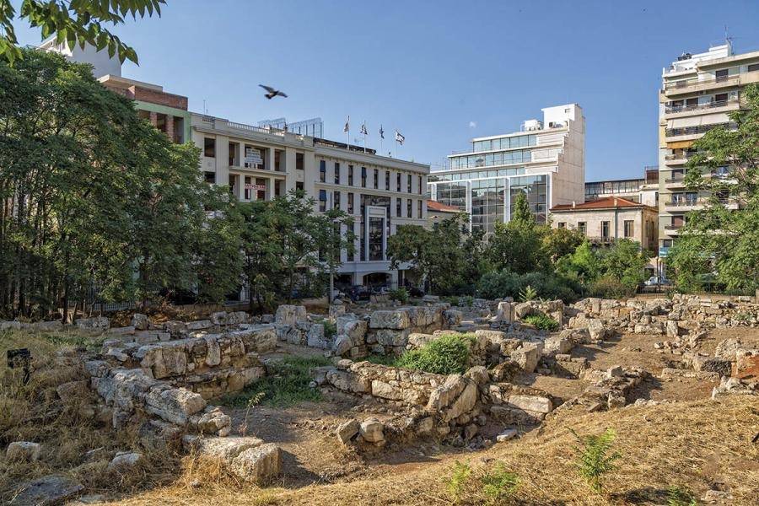

Archaeological Sites
NEOSOIKOI (SHIP SHEDS). These were roofed constructions for the maintenance and repair of the triremes, which were always well-trained to protect the Athens maritime sovereignty. Hundreds of craftsmen and countless slaves were employed in 196 ship sheds at the port of Zea. The length of a ship shed was about 40 meters. One can observe the remains of the ship sheds in the foundations of two neighboring buildings on the east side of Moutsopoulou coast. Specifically, in the building block of Thrasivoulou and Sirangiou streets and Moutsopoulou coast.
SIRANGIO. It is also called the cave of Paraskevas and is situated between Mikrolimano and Zea Marina, at the end of the parking area of Votsalakia beach. In ancient times the place was holy and dedicated to the local hero Sirangos, who probably is Glaucus, son of Poseidon and nymph Naeades. In Roman times, the cave served as a bath. In its entrance it was found a mosaic with the representation of a young man riding aquadriga.
PHILON’S ARSENAL. It was the largest building of Piraeus in antiquity. Its construction began in 346 BC and in order to be completed in 330 BC it was imposed by the state a special contribution of ten golden talents in every wealthy Athenian citizen. The arsenal was named after the architect Philon. It had a length of 135 meters and a width of 18 meters, while its interior was divided into three aisles with rows of Ionic columns. The building housed sails, masts, life jackets, ropes and enough weaponry to equip more than 200 triremes. Philon’s arsenal was razed in 86 BC by the Roman legions.

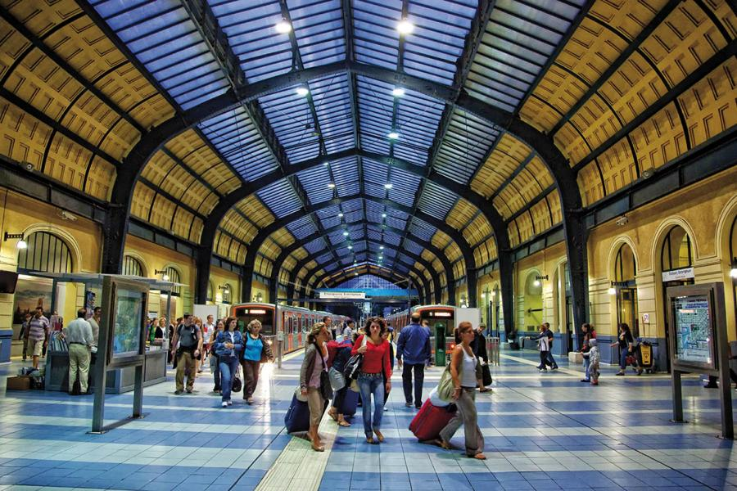

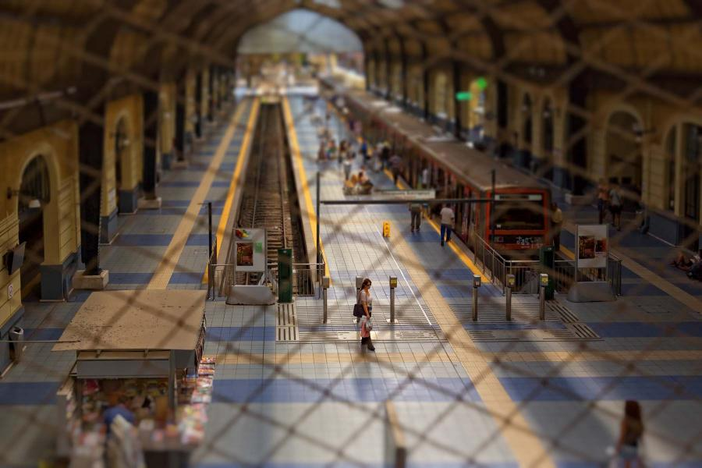

Electric Railway Station
The Piraeus-Athens Electric Railway Station was constructed around 1926-1929 by the architect Ioannis Axelos, replacing the existing station. Its magnificent, eclecticist structure was a creative adaptation of European models to the Greek conditions of the time. This is a metallic, riveted, articulated structure with a transparent roof. Successive frames are held together by horizontal interlinked beams, ensuring their solidity with diagonal wind breaks, while at the same time holding transparent panes of glass. Its main feature is its large domed hall. Initially steam trains connected Athens to its port, Piraeus. The line from Athens to Piraeus was inaugurated on February 27, 1869. Today, besides an attraction, it is one of the most crowded train stations, as thousands of people use it to commute to and from Athens and Kifissia.

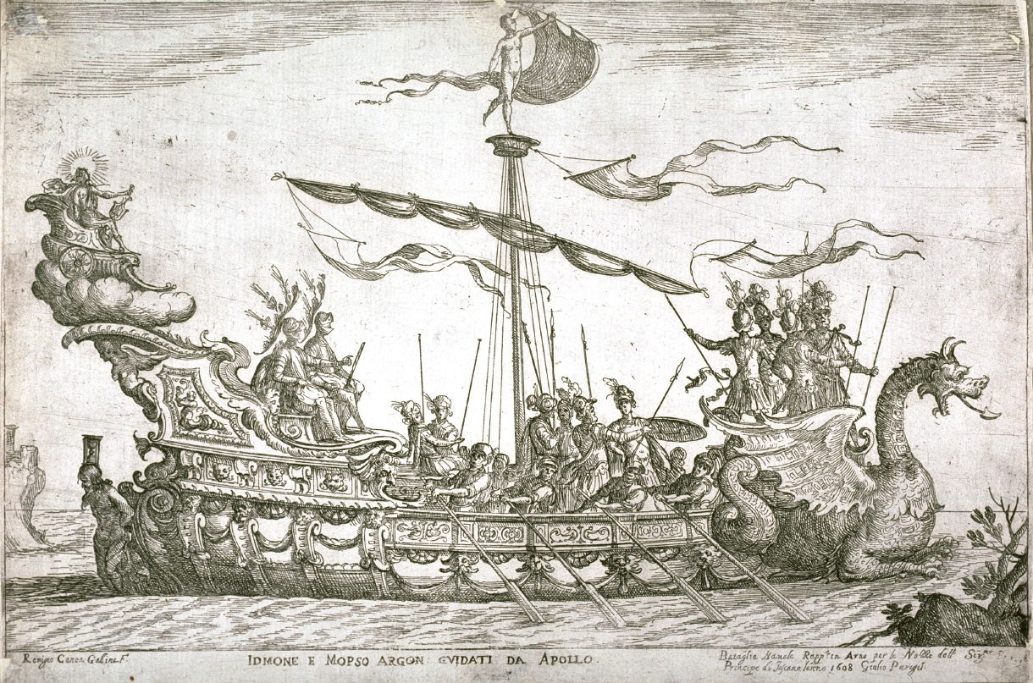

Reviving the legend of Argos and Jason

The name Argonauts from Greek mythology brings to mind Jason’s quest with his ship the Argo, which took him from Iolcos (Volos) to Colchis on the Black Sea, in order to take the Golden Fleece. This myth is an allegory for the second big wave of colonization of the Black Sea by the Greeks. This quest took its name from Jason’s ship, the Argo, which was itself named after its builder, Argus.
In 2004 a Mycenaean tomb came to light in the vicinity of Volos, and in this unexpected way a myth, that of the Argonauts, began to be less of a myth. Recently, four samples of gold found in Georgia on the Black Sea were examined in the Louvre and compared with some of the beads found on a necklace in the Mycenaean tomb of Volos. Both had the same local provenance and both items, the Greek and the Georgian, appear to have been made from alluvial gold that came from a river in Colchis.
In order to confirm these results, the tests will be repeated on more samples. If this further research produces the same results, then this will be a clear indication that the Argonauts knew of the gold of Colchis and that the quest of the Argonauts was not simply a myth. It is the struggle to acquire knowledge of a method for making a profit that influenced world even then.
The Golden Fleece essentially indicates the way in which they collected the gold. It seems that in the region of Georgia they would drop animal skins (fleece means skin) into the rivers in which the gold could be found. They would then collect it by either by burning of drying the fleece, and would collect the gold this way. This is the reason why the Argonauts made their journey to distant Colchis, something that the archaeologists had always suspected…

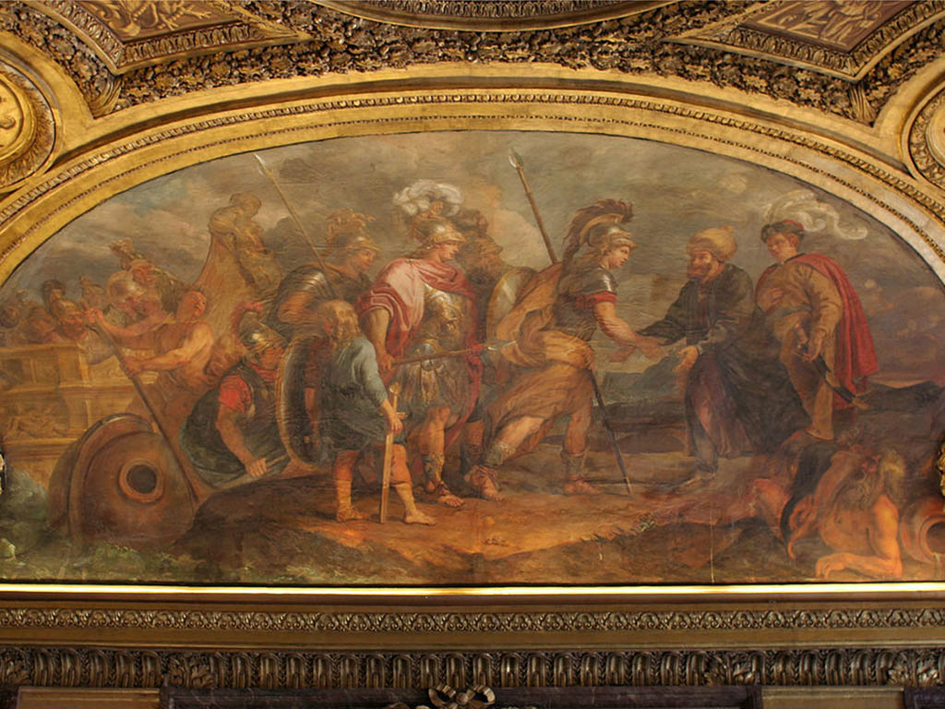

The magical story of Jason and the Argonauts is known worldwide; there have even been films made about the famous journey and adventure he bravely went on with his men.
In 2006 a reconstruction of the legendary “Argo” was built by the initiative of Volos Municipality, so that the city could acquire the symbolic ship-copy of the original one. The reconstruction took place at Pefkakia, in Volos; the same area where according to the legend, the ancient Argo was constructed in ancient time, by the shipbuilder and former paddle man Nikolaos Reppos, who also maintains a modern shipyard in Kato Gatzea, Pelion.
The wood used for the ship’s reconstruction was Pine, Oak and Melia or Despotaki. The trees had always traditionally been picked and prepared two years before a build started, so that the wood would be ready before the ship’s construction, which lasted for about 6 months and was based on traditional shipbuilding techniques and knowledge dating back to the 13th century BC.
This particular type of the ship is called ‘Moniris Penticontoros’, meaning one level of fifty paddles and is known as a type of an ancient sailing ship conducted by fifty men. After its launch in September 2006 and for the next two years, Volos Municipality organised an experimental nautical trip of 1,200 nautical miles in distance – following the trails of the ancient Mythical route – from Volos to Poti, the city of Georgia, where according to archaeologists is the position of ancient ‘Colchis’.
Today in Pelion, apart from the modern Argo ship, usually anchored in summer season at an outstanding position on Volos’s port, one can visit areas and archaeological sites that are directly related to the famous Argonauts’ expedition.
The Palace of ancient “Dimitriada”, has been identified as the possible area and location where the ancient Argo was first constructed. This is where the first seaside settlements in Pagaseticus Gulf were established. Also, according to ancient texts where the original Argo passed by until it sailed off into the Aegean Sea on its way to Colchis.
Afissos is one of the most beautiful tourist resorts in Pelion. It is built amphitheatrically above the beach and seafront, amidst olive groves and beautiful lush trees. It is an ideal place for one to relax and get some rest whilst visiting the Pelion and on holiday. According to the myth, Jason and the Argonauts stopped in Afissos village to get some water for their long journey to Colchis. In an area called ‘’Pyrgos’’, near the delta of Afissos, archaeologists have found ancient ruins indicating that this was once a thriving and big development in ancient times.
According to the myth, the construction of the ancient “Argo” was made upon request of Jason, leader of the expedition, by Argos and his brothers, Kitisouros, Melas and Frodis, at ‘Pagasses’, just a few kilometers outside of Volos city, in Pefkakia.
A small port located at a distance of twenty ‘stadia’ (an ancient unit of counting distances) away from Iolkos. The king of Iolkos, Pelias, commanded Argos not to steer and guide the ship properly so that in a storm it would sink and be lost. Argos, however ignored Pelias’s order. He constructed the beautiful and remarkably strong ship and set off on his journey.
The truth is there are many versions of this magical mythological story. One version explains that the boat was built by Frixos's son. The construction was also attributed to Argos, a hero coming from the city of “Argos”, or to “Argos” from “Thespies” city. In reference to another myth and version of this story, Hercules was said to be the constructor of Argo. Hercules named the ship ‘Argo’ in order to attribute honor to his friend ‘Argos’.
Other references to areas of ancient Iolkos, such as ‘Iolkos’, ‘Pagasses’ or ‘Demetrias’, named after ‘Demetrius the Conqueror’, settler of the region, define the strategical character of the whole region, ideal for a commercial expedition to start, far away to Colchis of the “Efksinos Pontos” Sea.
Nowadays tourists can visit the sites that legend refers to in the wider region of Volos and the Pagaseticus Gulf and combine this visit with references and discoveries related to the “Argo” ship.
For those who prefer an organised tour and want to be led by local expert guides in the field, there are many tours and trips through which one can learn about the famous myth of Argo and the Argonauts’ expedition. At the same time discovering so many of Pelion’s secrets and its beauty as a region. Organised tours take place where people can visit the settlements of ‘Sesklo’ and ‘Dimini’. Today, the archaeological site of Dimini is situated 3 km away from the beach; during the 5th millennium BC the sea was only 1 km away, while Sesklo was first inhabited in the middle of the 7th millennium.
Any architectural remnants of that era are rare; in fact, these are elliptical trenches and segments of walls protruding from the ground, made of tree branches and mud.

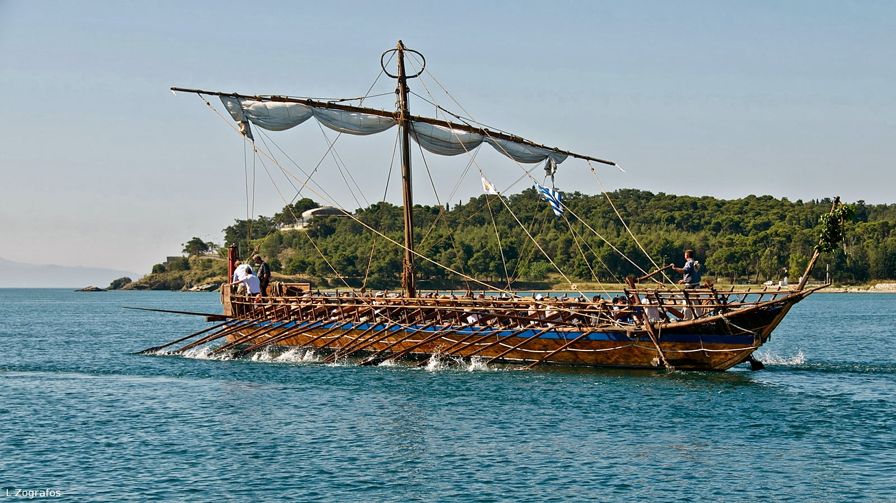

The quest of the Argonauts is not simply a myth…

