Odysseus and the Odyssey
The Myth of Odysseus and the Odyssey
After the Trojan War was ended by the burning of Troy, the Greeks filled their ships with precious things which they had gathered, and set sail for home. It was not a long journey back to Greece, and some of the princes returned quickly and happily to their own land. But one prince, named Odysseus, had more adventures on the journey back than he had met with before the city of Troy itself; and it was not until ten long years had passed that he succeeded in reaching his native land again
Odysseus had been one of the wisest and bravest men in the battles about Troy, and he proved himself wise and brave in his long and perilous journey home. It would be too much to tell of all the adventures that he had, though some time you may read them in a book composed by a great Greek poet named Homer. Here we can tell only a few of the wonderful things that happened to him.
After sailing for a long time, and seeing many strange lands, Odysseus and his men came to the land of the Cyclops. These were a wild and lawless race of giants, each of whom had only one great eye in the middle of his forehead. They neither planted nor plowed the fields, but lived off their herds of sheep and cattle. Odysseus landed here, and went with some of his men to explore the country. Soon they found a great high cave, with much cheese and milk in it. They entered this to wait till the owner should come; and by and by he appeared, driving his herds into the cave with him.
When Odysseus and his men saw how large and fierce he was, they would gladly have run away; but the giant had rolled a huge rock against the mouth of the cave so they could not get out. When the Cyclops saw them, he immediately showed them what they might expect from him, by seizing two of the men and eating them. The next morning he at two more of them, and then drove his flocks out to pasture. But before he left he rolled the rock back before the mouth of the cave, so that Odysseus and his men were still kept prisoners.
Picture of Odysseus and the Cyclops
While he was gone, Odysseus planned a way of escape. He found a long stake in the cave; and the end of this he sharpened into a point, and then hardened it in the fire When the giant had come back, and had again eaten two of the men, Odysseus gave him some wine which they had brought with them when they came to the cave. When he had taken this, and was sleeping drunkenly, Odysseus and his men plunged the sharp stick into his one eye and blinded him.
The Cyclops could not see them now, and so he could no longer catch them. The next morning Odysseus and his men got out of the cave by clinging to the under side of the sheep as the giant let them out to pasture. And though the giant felt the back of each sheep as it went out, to see that none of his prisoners got away, they all escaped safely. But it happened that this cruel giant was the son of Poseidon, the god of the sea; and from this time Odysseus and his companions had to endure the wrath of the sea-god for what they had done to his son.
After leaving the land of the Cyclops, Odysseus came to the island of Aelous, the god of the winds, who entertained them kindly for a whole month. When Odysseus took leave of him, Aeolus gave him a strong sheepskin bag, closely fastened with silver This held all the winds of heaven except the west wind, which was left out to blow him gently home. With this Odysseus sailed for nine days steadily onward, until he was so near his native land that he saw the people on the shore. Then, while he slept, his men secretly opened the bag of the winds to see what great present it was that King Aeolus had given to their leader. All the winds of heaven leapt from the bag; and
storms raged about their heads, and blew them out across the sea, until they reached the very island of King Aeolus from which they had departed After that King Aeolus refused to help them.

Next Odysseus came to the island of an enchantress named Circe. Here some of his men were changed into swine by her. But by his bravery and the help of the god Hermes, Odysseus overcame the enchantress, and forced her to change them back into men again. Then Odysseus and his companions lived pleasantly with her for a whole year; and when at last they were ready to set sail again, Circe told Odysseus what he must do to get safely back home. This was to go down to the world of the dead, and ask concerning his journey. He did this, and there he was told of the wrath of Poseidon because of what he had done to his son. But he was told also that he should reach his home in spite of Poseidon, if he and his men would only leave untouched the oxen of the sun when they should come to them.
Picture of Odysseus | Picture of Circe
Then Odysseus returned to the upper world, and once more he and his men set out on their way. Again they met with many adventures. At last they came to the island where the oxen of the sun fed in the fields. Odysseus did not wish to land here, but his men insisted on spending the night on shore. When Odysseus had made his men promise not to harm the oxen of the sun, he agreed to this, and they landed. That night a great storm came, and for a whole month they could not leave the place. Their good gave out, and though they hunted and fished they could not get enough to eat. At last, while Odysseus slept, his men killed some of the oxen of the sun and at them; and Helios, the sun-god, was angered at them.
When the storm ceased they set sail again. But they had not gone far before Zeus hurled a great thunderbolt at their ship because they had eaten the oxen of the sun. The ship was wrecked, and all the men were drowned except Odysseus. For ten days he swam in the sea supported by the mast of his ship. Then he was thrown on the shore of an island which was ruled by the goddess Calypso. Odysseus was kindly received by the goddess, and he stayed here seven years. But he longed to return to his wife and to his native land. At last the goddess agreed to let him go; and on a strongly built raft he set sail once more - this time alone. For seventeen days he sailed on in safety. But Poseidon had not forgotten his old anger against Odysseus. He sent a great storm which wrecked his raft; but Odysseus once more swam shore and was saved.
This time Odysseus found the daughter of the king of the land washing linen with her maidens in a river which flowed into the sea. When he told her his story, she took him to her father; and at last Odysseus was taken to his own home in one of the ships which belonged to this king.
So, after much suffering and many wanderings, Odysseus reached home. But his troubled were not yet ended, for he found that in his absence evil men had taken possession of his property. With the help of his son and a faithful servant, Odysseus succeeded in overcoming them, and got possession of his house and lands. And at last he lived quietly and peacefully once more in the island kingdom over which he had ruled before he set out for the war against Troy twenty years before.
The stories of the gods, and of the Argonauts, and of the warriors who fought around Troy, are what we call "myths." They tell about things which occurred so very long ago that nobody can tell just when they happened, or how much of the story is true and how much is only what the Greeks imagined about it. Now you are to read about things most of which we are quite sure did happen, and which took place just about at the time and place and in the way that the story says. These we call "history," to distinguish them from the myths.
Odysseus and the Odyssey - A Myth with a Moral
Many of the ancient Myth Stories, like the legend of Odysseus and the Odyssey, incorporate tales with morals that provided the old story-tellers with short examples of exciting tales for kids and children of how to act and behave and reflected important life lessons. The characters of the heroes in this type of fable demonstrated the virtues of courage, love, loyalty, strength, perseverance, leadership and self reliance. Whereas the villains demonstrated all of the vices and were killed or punished by the gods. The old, famous myth story and fable, like Odysseus and the Odyssey, were designed to entertain, thrill and inspire their young listeners...
The Myth of Odysseus and the Odyssey - the Magical World of Myth & Legend
The story of Odysseus and the Odyssey is one of the fantastic stories featured in ancient mythology and legends. Such stories serve as a doorway to enter the world of the Ancient Greeks and Romans. The names of so many of the heroes and characters are known today through movies and games but the actual story about such characters are unknown. Reading a myth story such as Odysseus and the Odyssey is the easy way to learn about the stories of the classics.
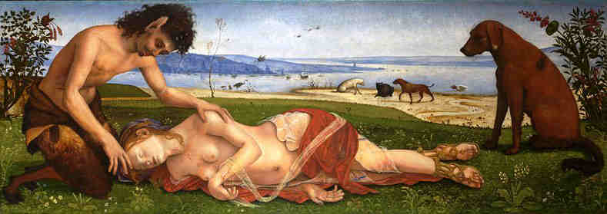

The Magical World of Myth and Legend

The Short Story and Myth of Odysseus and the Odyssey
The myth about Odysseus and the Odyssey is featured in the book entitled Greek Gods, Heroes and Men by Caroline H. Harding and Samuel B. Harding, published in 1906 by Scott, Foresman and Company. Learn about the exciting adventures and dangerous quests undertaken by the mythical characters that feature in the hero myths, fables and stories about the gods and goddesses of Ancient Greece and Rome that are available on this website.
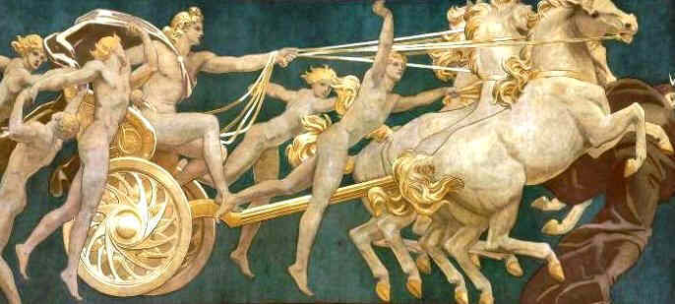

Visiting the Acropolis in Athens: The Essential Guide
Even the most jaded of world travelers cannot approach ancient Greece's most iconic attraction without being awestruck. Crowning a dramatic limestone crag, the Acropolis stands high above modern Athens as a symbol of the city's former glory, recalling the culture that flourished more than two millennia ago. In addition to the Parthenon, you'll find many more things to do among these emblematic ancient ruins. While wandering around the many archaeological remains of the Acropolis, tourists follow in the footsteps of Socrates, Pericles, and Sophocles and discover the building blocks of Western Civilization.

Odeon of Herodes Atticus: A Second-Century Theater
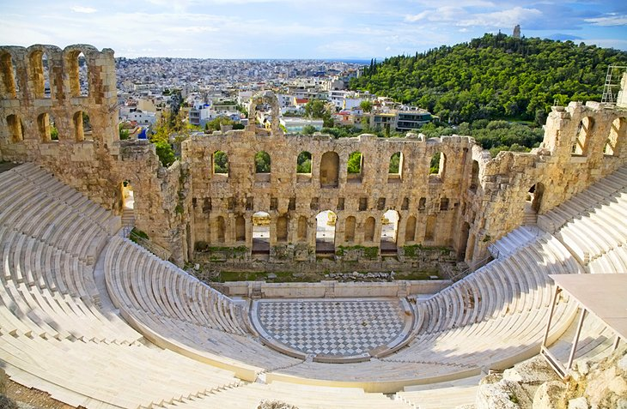
Odeon of Herodes Atticus: A Second-Century Theater

Before entering the ticketed admission area of the Acropolis, tourists may visit the Odeon of Herodes Atticus. This ancient theater is named after Herodes Atticus of Marathon (outside of Athens), who built it in memory of his wife Regilla in AD 161. The theater was designed with an auditorium fitted into a natural hollow. Semicircular rows of seating could accommodate nearly 5,000 people. The orchestra was originally located in the circular space in the center with the low stage (skene) close to it on one side. Between the auditorium and the stage were open passages for the entrance of the choir (parodoi). Live performances are still held at this theater during the summertime. The Athens & Epidaurus Festival presents classical Greek operas as well as musical and dance performances, offering tourists the magical experience of watching two-thousand-year-old drama in the original theater.

Beulé Gate: The Roman-Era Entrance

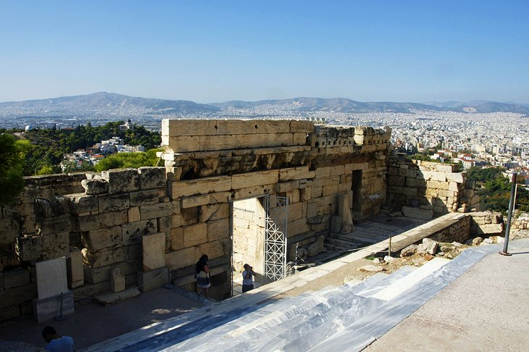
Beulé Gate: The Roman-Era Entrance Gerry Labrijn / photo modified

After passing through the admission area, tourists enter the Acropolis site through the Beulé Gate. This Roman-era doorway was named after the 19th-century French archaeologist who discovered it. The Beulé Gate is below the west side of the Propylaia, the majestic entrance to the Acropolis. Featuring two flanking towers, the gate dates to 280 BC and was originally linked to the Propylaia by a broad marble staircase built during the reign of the Emperor Septimius Severus. Part of the lower section of the staircase has survived.

Monument of Agrippa, First-Century BC

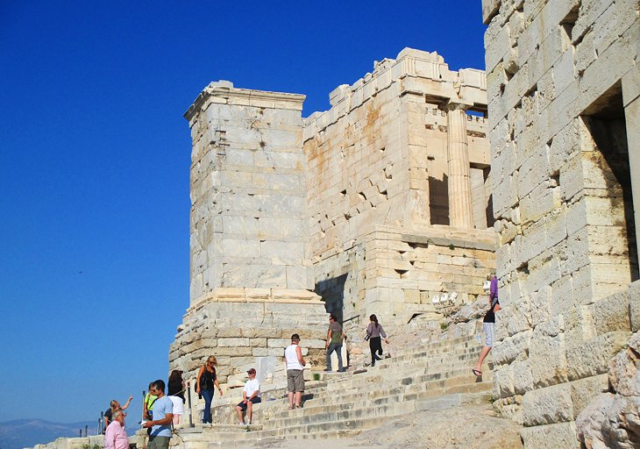
Monument of Agrippa, First-Century BC Gerry Labrijn / photo modified

Beyond the Beulé Gate, on the way up to the Propylaia, tourists come across the Monument of Agrippa. This tall, rectangular two-color marble plinth was built in the second century BC for a benefactor of Athens, perhaps the King of Pergamon, the marvelous ancient city (now part of present-day Turkey). The monument is named after Marcus Agrippa, the son-in-law of Augustus, because a bronze sculptural representation of his four-horse chariot (quadriga) was mounted on the base in 27 BC.

Propylaia: The Magnificent Entrance to the Acropolis

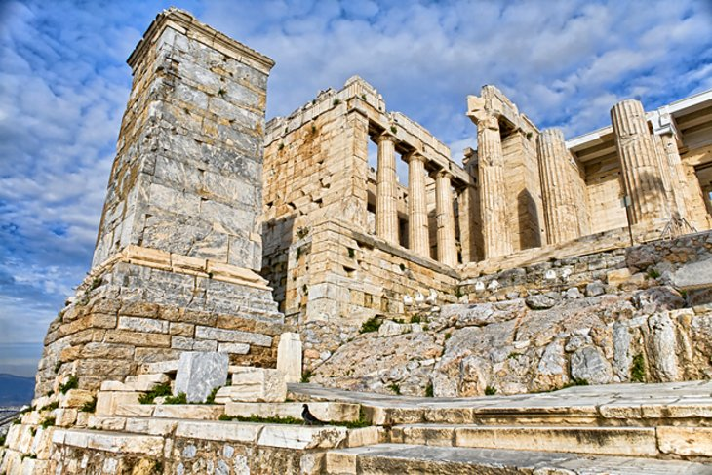
Propylaia: The Magnificent Entrance to the Acropolis

An ordinary entrance gate would not suffice for the glorious ancient city of the Acropolis. This majestic entranceway set the tone for arriving visitors, preparing them for the jaw-dropping site of the Parthenon and the other monumental temples on the rocky hilltop above. The Propylaia was built by Mnesikles in 437 BC to 432 BC. First, a flight of marble steps leads up to a vestibule containing five gateways, which increase in width and height from the sides to the center. To the west is a deep portico, with a central doorway framed in Ionic columns. Along the front of this portico are six Doric columns, which originally supported the pediment. On the east side is a smaller but still impressive portico also with Doric columns. The multifaceted architectural complex, featuring intricate details, contributes to an overall sense of grandeur.

The Beautifully Preserved Temple of Athena Nike

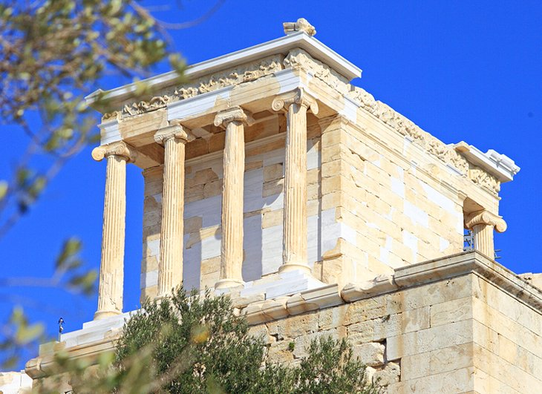
The Beautifully Preserved Temple of Athena Nike

The Temple of Athena Nike is the most elegant and well-preserved of the Acropolis buildings, having been restored in the 19th and 20th centuries. Standing on a spur of rock on the south side of the Propylaia, this ancient sanctuary was dedicated to the Goddess Athena as the bringer of Victory (Nike). The temple was built between 432 BC to 421 BC, after the completion of the Parthenon and the Propylaia. The temple features four delicately carved Ionic columns at the north and south ends. The form of the column bases and capitals was old-fashioned at the time they were built, leading archaeologists to suggest that the architecture was influenced by the earlier design of Kallikrates. The balustrade that once adorned the temple platform is now on display at the Acropolis Museum, along with relief figures of Athena and several representations of Nike (the Goddess of Victory).

The Parthenon: The Most Sacred Site of the Ancient World

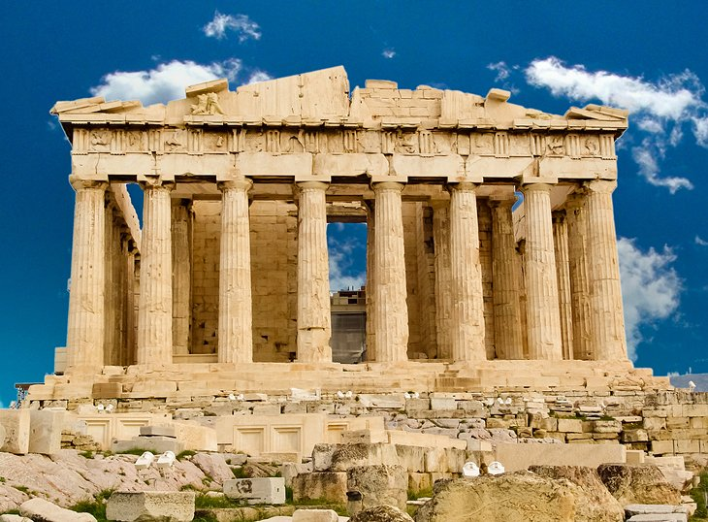
The Parthenon: The Most Sacred Site of the Ancient World

Standing majestically on the highest point of the Acropolis hilltop, this breathtaking temple was the most magnificent temple of the ancient world. For the best views of the Parthenon from a distance, go to Philopappou Hill directly across from the Acropolis. The temple was built from 447 BC to 338 BC during Pericles' construction boom and is a masterpiece of the architect Iktinos and the great sculptor Phidias. As the ultimate sacred shrine in the city, the temple venerated the cult of Athena the Virgin (Athena Parthenos), the Goddess of Wisdom and Warfare and the Guardian of Athens. Exemplifying classical style, the temple features 136 fluted Doric columns (in repeated rows of 8 x 17), creating a sense of harmony and order. Notice how the columns are slightly bulkier at the base and the shape gradually narrows towards the top. Each 10.5-meter-high column has a diameter of 1.9 meters at the foot and 1.5 meters at the top, an ingenious technique, which creates the optical illusion of a perfectly balanced building. Otherwise the temple would appear top heavy.
Although the interior of the Parthenon is off limits, tourists may walk around the exterior to admire the structure from every angle. The temple's monumental scale and remarkable details of craftsmanship are awe-inspiring. At the east end, the pediments depict the Birth of Athena from the head of Zeus. At the west end, the pediments illustrate the conflict between Athena and Poseidon for the land of Attica. Originally,
the temple had a roof that was covered with marble tiles with run-offs for rainwater at its four corners. After serving as a temple for around 900 years, the Parthenon suffered considerable damage in the fifth century when it was transformed into a Christian church dedicated to the Virgin. The Parthenon remained in use as a church for another 950 years before becoming a Turkish mosque in 1456. Unfortunately, the temple, which had stood for more than 2,100 years was destroyed by a bomb during fighting between the Venetians and the Turks in the 17th century. Today, the ruins of this massive structure remain as testimony to its former glory.

Porch of the Caryatids at the Erechtheion

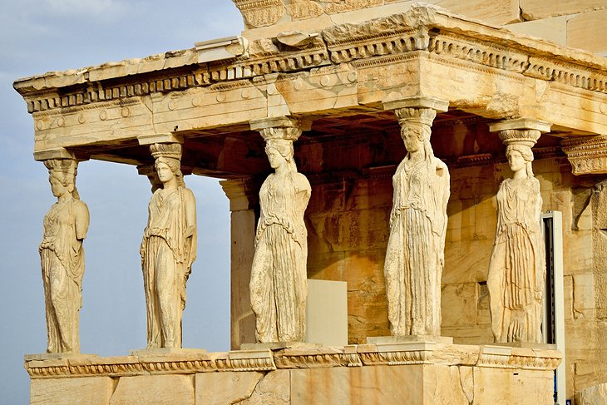
Porch of the Caryatids at the Erechtheion

Built from 421 BC to 395 BC, the Erechtheion complex contains a number of ancient sanctuaries. The eastern part was occupied by a sanctuary built a century earlier, the Temple of Athena Polias. In the western part was the Tomb of King Erechtheus. One of the most famous features of the Erechtheion is the Porch of the Caryatids, six columns sculpted as figures of maidens in place of ordinary columns. The Tomb of Kekrops, the founder of the Athenian royal line, was located under the Porch of the Caryatids. From the north portico, a side doorway leads into the adjoining cult precinct of the Pandroseion.

Old Temple of Athena Polias, Sixth-Century BC

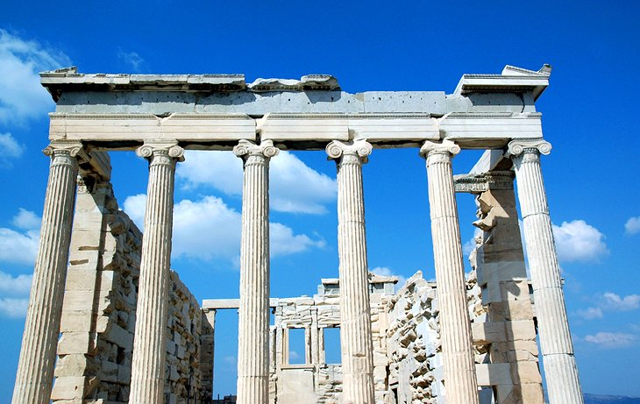
Old Temple of Athena Polias, Sixth-Century BC

Found immediately south of the main Erechtheion sanctuaries, the Old Temple of Athena was built in the early sixth century BC within the precincts of the Mycenaean royal palace of the 14th century BC. (The only remaining architectural elements of the Mycenaean palace are two column bases.) This temple was the sanctuary of Athena Polias (Athena of the City), the patron of the city. The temple held the venerated wooden Cult Image of the Goddess (Xoanon), in a tradition that most likely dated back to Mycenaean times. The Old Temple of Athena was destroyed by the Persians in 480 BC along with all the other buildings of the Archaic period. It was not until the 19th century that the foundations of the temple were uncovered by archaeologists.

The Legendary Olive Tree of the Pandroseion

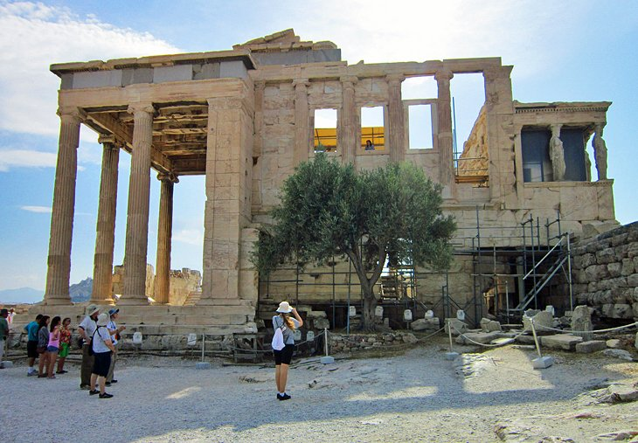
The Legendary Olive Tree of the Pandroseion Shay Tressa DeSimone / photo modified

The Pandroseion lies between the Erechtheion and the Old Temple of Athena Polias. This small temple was named after Pandrosos, the daughter of the first king of Athens. The temple contained the altar of Zeus Herkeios (protector of the hearth) and a shrine to Pandrosos. Scholars believe that the sacred snakes of the Acropolis were kept here. Also, according to legend, Athena presented the sacred olive tree to the city here after her victory over Poseidon in the contest for the land of Attica. The fifth-century BC Greek historian Herodotus tells us that on the day after the destruction of the Acropolis by the Persians in 480 BC, a fresh shoot had sprung from the trunk of the burned tree. This tree became a symbol of Athens' survival. As a tribute to this ancient event, an olive tree was planted here in modern times.

Acropolis Museum

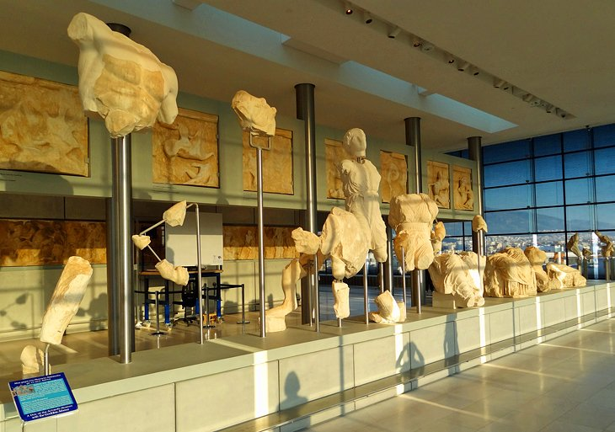
Acropolis Museum Charles Pence / photo modified

The Acropolis Museum is a must-see cultural attraction in Athens that opened in 2009. Below the Acropolis hill, about 300 meters away from the archaeological site, this incomparable museum contains one of Athens' most valuable collections of ancient Greek art. In front of the museum is a designated archaeological site where archaeologists can be seen at work. After walking past this "archeological workshop," tourists arrive at the entrance to the sleek modern building designed by architects Bernard Tschumi and Michael Photiadis. Illuminated by natural light, the extensive exhibition galleries display around 4,000 priceless objects. Most of the items in the collection were uncovered at the Acropolis archaeological sites. The collection spans the Archaic Period, from the seventh century BC to the fifth century BC, and the Classical Period, from the fifth century BC to the second century BC. Highlights are the original Caryatids from the Erechtheion, the sixth-century-BC Moschophoros statue of a young man carrying a small calf, the fifth-century-BC relief of Mourning Athena, and the series of reliefs from the Temple of Athena.

