The migration of refugees from Turkey to Greece

As the drought begins over the water plain along the borders shared by Turkey with Greece, a very intimate outline of the refugees emerges through the mist in the morning ,choosing their way through a road travelling thousands in front of them. 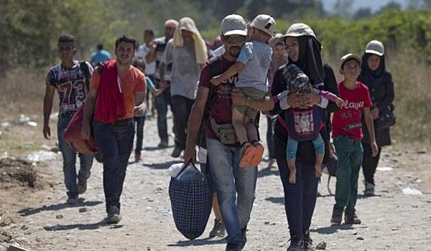
Young parents carrying infants and widows who follow railroad tracks hoping to drive them to a city have become a common sight in the fields in the north-eastern border area of Greece with Turkey. 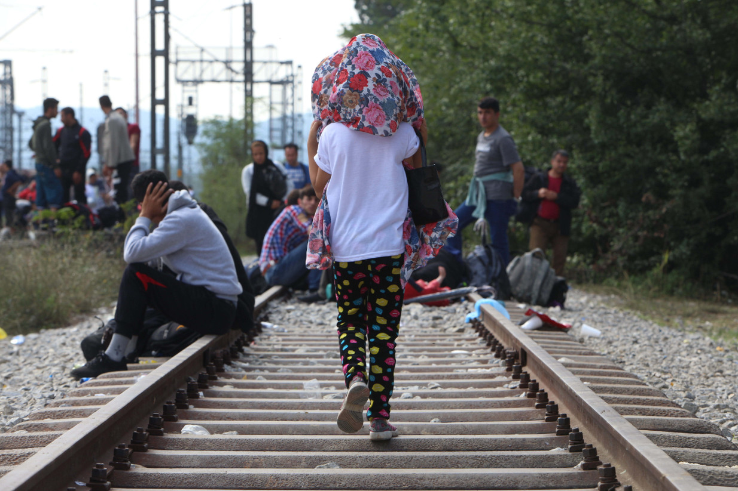
<< Do not send us back because we are out of a war>>admitted Maya,28,from the Syrian city of Aleppo.When a Reuters team brought her with her,her,her father,her sister and her six children were walking for 13 hours.
Two years after the effective sealing of a sea passage used in a massive wave of migration from Turkey to the islands of Greece,more and more refugees are re-discovering an old smuggling route through the watery land border that separates the two countries.
Only in April,at least 2,900 people arrived in Greece through Evros which was the river boundary that separated the two countries.That corresponds to half of the estimated arrivals for 2017 as a whole,UNHCR’s UN refugee ageancy said on April 27th.
Police and local government officials in the region are worried about the trend.An explosion in arrivals, they say,more or less reflects a rise in hostilities in either Iraq or Syria.Nearly one million refugees and migrants crossed Turkey from the greek islands in 2015,but all this was closed after the European Union and Ankara agreed to stop the flow in March 2016.
Under the agreement, anyone crossing the Greek islands should be eligible for asylum or face deportation to Turkey. The deal effectively turned five Aegean islands into concentration camps for more than 15,000 people who can not leave until they are processed.
Terrestrial borders do not appear to be covered by the agreement, but a UNHCR official warned that they actually exported the diversion of migrants elsewhere.
Assistant officers and police officers told Reuters those arriving via the Evros River are considered registered and then received a three-month residence permit. Theoretically, they are free to move to Greece - unlike the islands.
About thirty-five refugees from the besieged Syrian city of Afrina took a provincial road near the Newcastle community early in the morning of May 2nd.
A man ran a month baby, Abdu, into a small blue blanket. A second man passed, a blank look in his eyes, like a sleep asleep, bounced back into the case he had supported on his forehead.
Beyond that, a little blond girl in tresses and pink rubber boots that stumbled like adults pulled her along the street, holding a pink bodice.
It can take about five to six minutes to fly everyone on the River Evros, compared to a terrible trip to the open seas in overcrowded rafts. However, the rapid waters are insidious. 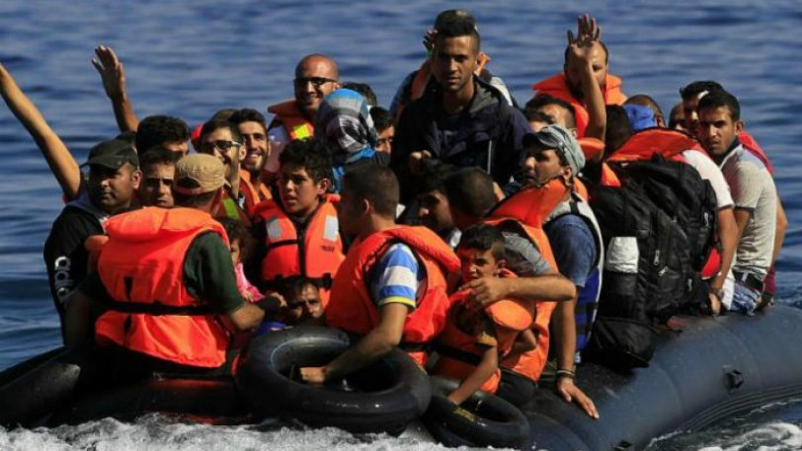
Before the sea corridor between Turkey and the Greek islands became the tomb for hundreds of refugees in 2015, Evros had claimed at least 1,500 lives in the last 18 years.
Twelve deaths in the first quarter of the year exceeded 2017 when eight people drowned, said Deputy Professor of Criminology Pavlos Pavlidis.
"I can only hope that the number will remain there ... but we expect the worst has not yet come because the influx has increased," he told Reuters.

1977 newsreel about the new boat line from Volos to Syria

http://www.avarchive.gr/portal/digitalview.jsp?get_ac_id=3421&thid=9700

Φορτηγά με προϊόντα και εμπορεύματα φορτώνονται στο οχηματαγωγό πλοίο «Falster», το οποίο έχει δρομολογηθεί στη νέα ακτοπλοϊκή γραμμή Βόλου – Ταρτούς Συρίας. Το οχηματαγωγό μπορεί να μεταφέρει 70 φορτηγά, 60 επιβατηγά αυτοκίνητα και 100 επιβάτες. Η διάρκεια του ταξιδιού, το οποίο πραγματοποιείται κάθε 4 ημέρες, υπολογίζεται σε περίπου 40 ώρες.

Trucks with products and commodities are being loaded on the ferryboat named <<Falster>>,which has been routed in the new boat line from Volos to Tartus in Syria .The ferryboat can transfer 70 trucks,60 cars and100 passengers .The duration of the voyage ,which takes place every 4 days ,is estimated to approximately 40 hours.

