Help our World to become a better place

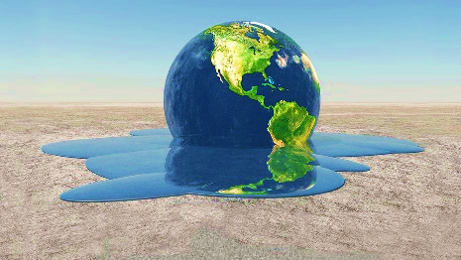

What should we do to help our World?

We should:
1. Recycle
The fact that 75% of people recycle, sadly 75% of plastic generated ends up in landfills and only 9% is actually recycled.

2. Use less plastic stuff (like; plastic straws, plastic cups)
We are producing over 300 million tons of plastic every year, 50% of which is for single-use purposes – utilized for just a few moments, but on the planet for at least several hundred years. More than 8 million tons of plastic is dumped into our oceans every year.

So if You care about our world at least a bit that you could recycle and use less plastic please do. You make a little change at the time, but perfection takes time. Every „useless“ action can make big changes in our world...

