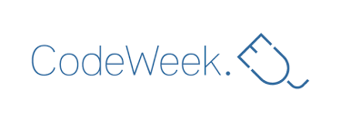
LIGHTBOT APP CODE WEEK
12-18TH MAR 2018
R4S ERASMUS+/eTWINNING PROJECT

Teaching coding to kids, even preschool kids, is the newest trend. Get kids programming in the most fun way, by playing an actual game!
Lightbot App Code Week is meant to introduce kids who have no experience whatsoever programming, and is all-ages friendly! That means anyone anywhere can play, have fun and learn real programming logic!
http://lightbot.com/hour-of-code.html
http://lightbot.com/flash.html
https://twinspace.etwinning.net/44530/
Lightbot is a programming puzzle game: a puzzle game that uses game mechanics that are firmly rooted in programming concepts. Lightbot lets players gain a practical understanding of basic control-flow concepts like instruction sequencing, procedures and loops, just by guiding a robot with commands to light up tiles and solve levels.
Lightbot App Code Week is created specifically for The “Robotics4STEM” E+/eTWINNING project, to introduce students to one hour of computer science and computer programming.

