Programing Hub
https://www.programminghub.io/
Programming Hub gives a new paradigm to how Programming is learned. Most of the computer science students in IIT Mumbai are using this app to brush up their knowledge and learn new concepts. Shibu John. This app is perfect for entrepreneurs like me who want to learn, and try their hands onto programming.

Programming Hub is your one-stop solution to learn all the top programming languages - anywhere, anytime!
With a huge collection of programming examples, complete course material and compiler for practice, all your programming needs are bundled in a single app for your daily practice.
What all programming languages you can learn?
★C Programming:C programming is a powerful general-purpose language.If you are new to programming then C Programming is the best language to start your programming journey.In practical C programming is used in Embedded stuff, Systems programming.
★C++: C++ is used nearly everywhere for everything from systems programming,numerical and scientific computing,web development,writing compilers, console games, desktop applications and so on.
★Java: Java is an object-oriented, general purpose,high-level programming language.Today Java is being used to develop a range of software like web applications, J2ME Apps, Embedded Space, Android, Big Data analytics, etc.
★HTML: HTML is the standard markup language for creating web pages and web applications.HTML is most commonly used as the format for online documents i.e web pages.
★Javascript: JavaScript is a programming language that is run by most browsers.
★R Programming: R is a programming language and software environment for statistical analysis, graphics representation and reporting.
Other Languages Include
★CSS
★VB.net
★C# (C Sharp)
★Python 2.7
★Python 3
★Linux Shell Scripting
★R Programming
★Swift
★SQL
★Jquery
★Assembly 8086
What features do we have?
★ EXAMPLES: over 1800+ programs in 17+ languages and counting, programming hub has one of the largest collection of pre-compiled programs with output for practice and learning. We update the program repository regularly based on user's feedback.
★ COMPILER: HTML, CSS, Javascript have an offline compiler for learning and practicing without needing any internet connection. And for other languages like Java, C programming, C++ we have online console compiler which will help you enhance your coding skills from your smartphone anytime, anywhere.
★ COURSES: To make your learning more interesting and less boring, our experts have created precise and to the point course material which will help you learn the language in a better way. It's the best place to understand concepts and start coding using the compiler.This section is the best place to revise before your exams.
Other Features to improve your learning experience includes:
1. Share Programs with Friends.
2. Offline Use(once a language is downloaded, the app works offline).
3. Quick Search for programs.
4. Categorized View for programs.
5. No Harmful Permissions required.
6. Periodic Updates with new programming examples and course content.
7. UI translated into 13 regional languages.
8. Feedback and new program addition request.

LightBot : Code Hour
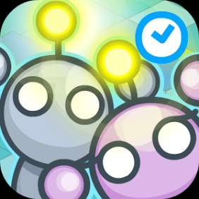
lightbot.com/hoc.html
Program Lightbot to light up all of the blue squares! How does Lightbot teach 'real' programming? The 'Hour of Code' is nationwide initiative by Computer Science Education Week [csedweek.org] and Code.org [code.org] to introduce millions of students to one hour of computer science and computer programming.

The 'Hour of Code' is nationwide initiative by Computer Science Education Week [csedweek.org] and Code.org [code.org] to introduce millions of students to one hour of computer science and computer programming. We hope you enjoyed your first taste of Lightbot! There are many more puzzles to be solved!
Get kids programming in the most fun way: by solving puzzles in a videogame!
Lightbot - Code Hour is meant to introduce kids who have no experience whatsoever programming, and is all-ages friendly! That means anyone anywhere from K to 12 can play, have fun and learn real programming logic!
Lightbot is a programming puzzle game; it uses game mechanics that are firmly rooted in programming concepts. Lightbot lets players gain a practical understanding of basic concepts like instruction sequencing, procedures and loops, just by guiding a robot to light up tiles and solve levels.
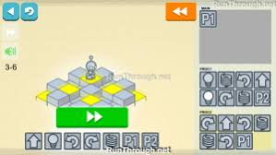

Teachers worldwide are choosing Lightbot first when introducing their students to programming.
Lightbot - Code Hour features 20 levels. The full version of Lightbot features 50 levels for when you want more of a challenge!

Coding for Kids | codeSpark Academy with The Foos
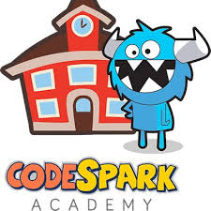
www.codespark.org/
codeSpark Academy is the fun and effective way to learn the ABCs of coding. Kids ages 4+ learn basic coding concepts to design and build their own 3D games.

What is codeSpark Academy?
http://blog.thefoos.com/story/codespark-academy-with-the-foos/
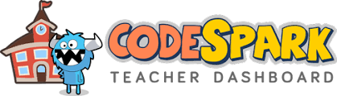
In late Summer The Foos app will become codeSpark Academy. All users must update or the app won't work.

CodeSpark Academy will have several exciting NEW features:
- Blueprints - Kids learn to code seriously cool games with simple "paint-by-numbers" tutorials.
- Daily Activities - Every kid learns differently, so codeSpark Academy has custom daily activities for your child. For example, if your child needs more practice with loops, the daily activities will include several loop exercises, ordered by level of difficulty.
- Brand New Menu and Map - Our new menus are super easy to use and make kids to feel like they're in downtown Fooville! Your child can now see where each Foo lives before diving in and helping solve their problems.
- Teacher Dashboard - The #1 request from teachers was a dashboard for tracking student progress. The codeSpark Academy dashboard is easy to set up, tracks each student and lets teachers control what parts of the app are accessible.
Regular updates + More computer science = more learning! We will release new content every two weeks:
- New curriculum based games and puzzles - New games and puzzles that teach variables and more...
- New characters - Fun new Foos are in the works, including Dr. Foo, Adventure Foo and Superhero Foo!
- Global challenges - Several times a year contests will be organized by age group for game design, story telling and more.
- Expansion of our creative tools - New commands, new coding templates, new programmable objects and more!

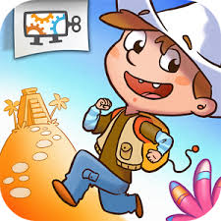
Run Marco! - Allcancode

https://www.allcancode.com/web
Learn how to code, build your own apps and games and publish them to the world!
Play an adventure game and have fun while learning to code i.e. program computers. Use visual instructions to guide Marco or Sophia through a series of levels as they try to discover themsevles. In this journey you will learn how to think as a software developer one step at a time! Instructions are in the form of the standard visual programming language "Blockly", which is the same used by the official Hour of Code tutorials.
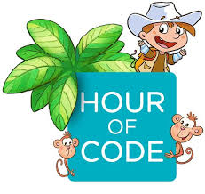
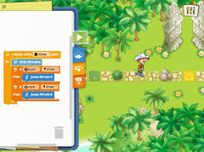

Based on an original story, this is so fun to play that you will forget it's an educational game from level one! Designed for 6 to 12 y.o. kids by a team of experts in engineering, arts and education.
Run Marco is recommended in the official website for the Hour of Code.
The first level set in the Jungle, teaches basic instructions and sequence of commands, different types of iteration and conditional logic.
The game is translated in 26 languages and more are coming soon.
