WHY LEARN PROGRAMMING?
(Age 4-7)

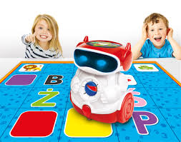
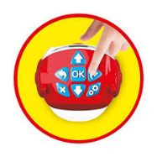
Children are incredibly creative. If they are asked to imagine a new machine, who knows what they will come up with. In this age, we are surrounded by powerful tools and we can ask a computer to do practically anything for us. However, for this to happen, we need to be able to translate our ideas into a language that is comprehensible to the machine. It is therefore necessary to learn to simplify complex concepts in order to describe them in a clear and ordered manner.

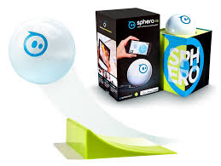
The first step in exploring this new world of possibilities requires knowledge of how machines assimilate commands, in other words, learning to program. All the devices around us, from the cell phone to the PC, the vacuum cleaner to the electric toothbrush, have a series of sequencing commands at the basis of their functioning that somebody wrote and sent to the machine in order for it to know how to function once the user presses the button. Knowing how the devices we use function, allows for greater awareness of both the world around us as well as an understanding of the potential of the tools at our disposition.

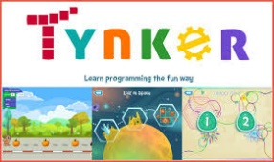
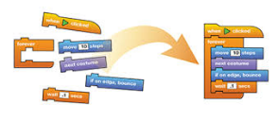
Children who have learnt the basic concepts of programming are able to apply this logic to far more advanced projects such as the creation of animation and even programming their own videogames. The possibilities are infinite!

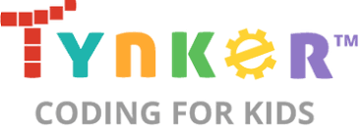
RESOURCES:
INTERESTING ARTICLES:
Computing at School:
Northern Ireland Curriculum Guide for Post Primary Schools
http://ccea.org.uk/sites/default/files/docs/subsites/digitalskills/post-primary/computing-at-school/Computing_at_Schools_P_PP_Combined.pdf
STEM Works!
http://www.nicurriculum.org.uk/STEMWorks/resources/futures/ict/profiles/

http://time.com/2881453/programming-in-schools/
https://www.theguardian.com/technology/2014/sep/04/coding-school-computing-children-programming
https://www.irishnews.com/news/educationnews/2016/12/10/news/free-science-resource-aims-to-help-pupils-in-north-prepare-for-digital-world-829726/
http://www.niassembly.gov.uk/globalassets/documents/raise/publications/2015/education/3715.pdf
https://code.org/student/elementary
https://www.oxfordowl.co.uk/for-home/at-school/subject-guides/computer-science-at-primary-school/

WEBSITES TO VISIT:
https://code.org/
https://www.kodable.com/
https://www.tynker.com/
https://www.lifewire.com/kids-programming-languages-4125938
https://www.playcodemonkey.com/
https://www.udemy.com/programming-for-kids-how-to-make-coding-fun/

