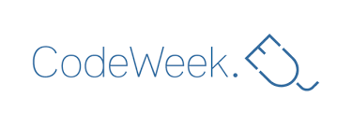
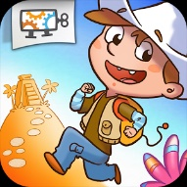
RUN MARCO! APP CODE WEEK
26-31ST MAR 2018
R4S ERASMUS+/eTWINNING PROJECT

Teaching coding to kids, even preschool kids, is the newest trend. Get kids programming in the most fun way, by playing an actual game!
Run Marco! App Code Week is meant to introduce kids who have no experience whatsoever programming, and is all-ages friendly! That means anyone anywhere can play, have fun and learn real programming logic!

https://chrome.google.com/webstore/detail/run-marco/objdeaibfajdoeikopmgincdhjifjfle?hl=en
https://play.google.com/store/apps/details?id=com.allcancode.runmarco&hl=en_GB
https://twinspace.etwinning.net/44530/

Play an epic adventure game and have fun while learning to code i.e. program computers. Use visual instructions to guide Marco or Sophia through a series of levels as they try to discover themselves. In this journey you will learn how to think as a software developer one step at a time!

Run Marco! Code Week is created specifically for the “Robotics4STEM” E+/eTWINNING project, to introduce students to one hour of computer science and computer programming.

An adventure game that kids play and learn to code for Chrome on Windows, Mac and Linux

