Dear Parents,

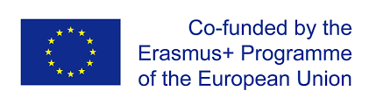
St Brigid`s Primary School, as you may know, has successfully applied for a 3 years project, funded by the ERASMUS+ (European Fund), called ROBOTICS4STEM. For its second year, we are running this project in our P6 class, where various new activities we introduce to promote STEM (Science, Technology, Engineering and Mathematics) and Robotics. Taking part in this International Project with 4 partner schools from 3 countries, offers great benefits for our pupils and teachers alike.

Please read our short project description below:

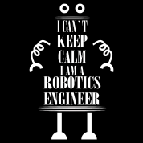
The aim of the project is to develop children's STEM skills by introducing them to Robotics. The project activities involve staff exchange between the participating organisations, with the aim of exchanging experiences and good practice. The partners share materials and resources, and develop units of cross-curricular work in STEM, that are tested in primary schools.

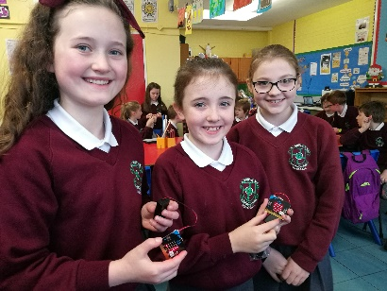
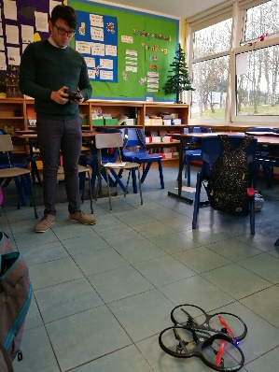
Robotics fits all ages and all learning types. Our students can experience that they actually have a greater talent for science and engineering than they expect. This is a unique Robotics for STEM Erasmus+ project, because it allows us to teach science and technology/robotics in a very rewarding way. It also allows our children to investigate, plan, test and implement their ideas. You see them enjoying themselves, getting results that they are happy with, and answering problems we have set them.
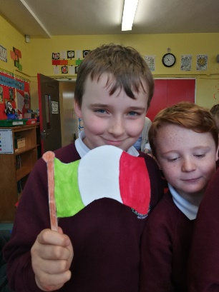
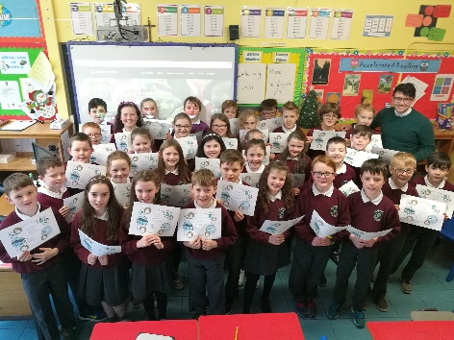
There are 4 partners in the project:
3 Transnational meetings (UK, ITA, TUR)
1 Training activity (UK) is planned.

Project objectives:
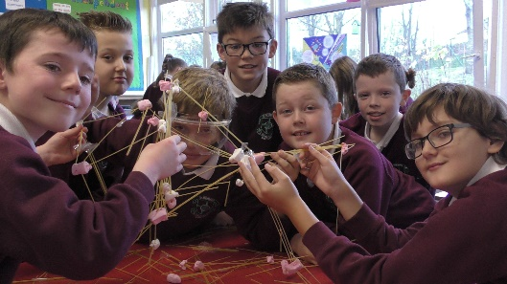
* To increase students’ interest in STEM education and careers and introduced them to all available new trends in technology.
* To provide tools and methodologies to facilitate the acquisition of STEM skills.
* To develop collaborative partnership between schools and the wider community in formal, non-formal and informal learning.
* To tackle the shortfall in women in the STEM sector at European level.

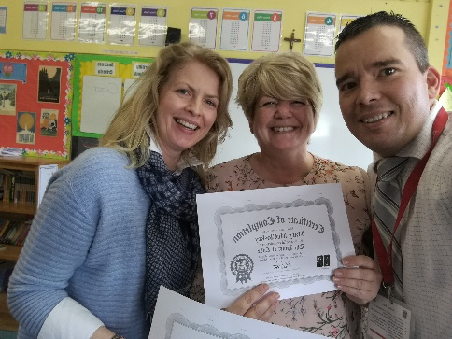
The participant teachers will become active participants in a team within an international framework which will give them a unique experience on reflecting, comparing, evaluating logical thinking issues from different perspectives. Also, they will develop ICT/CODING skills and experience the school systems of the partners.

Please support our effort in promoting STEM and Robotics by following our progress on
- eTwinning (https://twinspace.etwinning.net/44530/home),
- Padlet (https://padlet.com/bkecskemeti/R4S)
- or our school`s FB page (https://www.facebook.com/stbrigidspsmayogall )

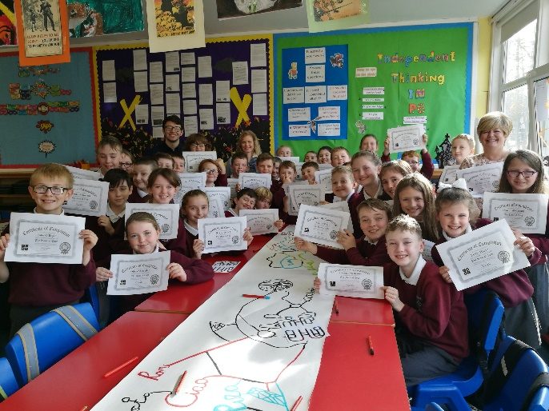
Thank you for your help and support in advance.

Best regards,

Balazs Kecskemeti
Project Co-ordinator
Erasmus+

