

My name’s Tom White.
I go to Clenvel High School in Brighton.
I’m in Year 11.
John Striter is our History teacher.
He has a lot of classes at our school but he’s never tired. He’s always helpful, patient and funny.
Mr Striter likes his job very much. He explains all – even boring – topics simply and understandably.
He is in the beginning of his forties and he’s very sporty. Every morning he runs five miles and after the lessons he goes swimming every day! At the weekends he plays tennis with his sons.
His wife, Susan is a Maths teacher at our school. She doesn’t like her job because the students don’t usually like her subject.
Sometimes students don’t like History either, but I think it’s very interesting. We do a lot of interesting things in the class and Mr Striter always helps us.
He comes with us to our school trips and he knows a lot about castles, churches, historical places, even about animals, plants etc.
I think he’s very clever and knows everything!
I admire him and I like his subject, too!
Are the statements true (✓), false (✗) or doesn’t it say (∅)?
1 The History teacher doesn’t like his job.
2 The Maths teacher’s name is Susan Striter.
3 A lot of students like Maths.
4 All the students think History is interesting.
5 Mr Striter is about 50 years old.
6 He has got two children.
7 He runs every morning.
8 The History teacher and his family live in a big house.
9 He plays table tennis at the weekends.
10 He likes gardening.
MY FAVOURITE TEACHER

Answer the questions.
1 How old is the History teacher? ____________________________
2 Is he married? ____________________________
3 What personality has he got? ____________________________
4 Where does he go with Tom’s class? ____________________________
5 Why does Tom like him? ____________________________

Complete the sentences about Tom White.
1 Tom goes to school in _________________.
2 He’s _________________ in History.
3 His class often goes to school __________.
4 He likes Mr Striter’s lessons because they _____ interesting things.

Match the pictures to the names of school subjects.
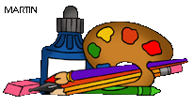1 | 2 | 3 | 4 | 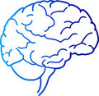5
6 | 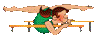7 | 8 | 9 | 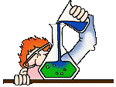10
 11 |  12 | 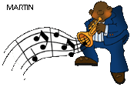13 | 14 | 15
Religious Education / Physics/English/Music/History/Games/Art/Maths
Spanish/Chemistry/Literature/Computer Studies/Physical Education/Grammar/Biology

